Michigan Local Public Health Accreditation Program Tool 2018
The Michigan Accreditation Process
A Reviewer’s User Guide

Table of Contents

Overview 4
1.1 History 4
1.2 Process 4
1.3 Governance 5
1.4 Standards 5
1.5 Evaluation 5
1.6 Conclusion 5
Customer Service 6
2.1 A Customer Service Approach 6
Technical Assistance 7
Self-Assessment 8
Pre-Materials 9
5.1 On-Site Review Schedule 9
5.2 Exit Conferences 9
5.3 Contact Information 9
5.4 The On-Site Review Report 10
5.5 Indicator Designations 10
Met 10
Not Met 10
Not Applicable 10
Met with Conditions 11
5.6 Program Specific Met with Conditions Language 11
Powers and Duties 11
Food Service 11
General Communicable Disease Control 12
Hearing 12
Immunization 12
Onsite Wastewater Treatment Management 12
HIV/STD 13
Vision 13
Breast and Cervical Cancer Control Navigation Program (BCCCNP) 13
Family Planning 13
Women, Infants, and Children (WIC) 13
Children’s Special Health Care Services (CSHCS) 13
5.7 Suggestions for using Met with Conditions effectively 14
5.8 Inquiry Policy 14
Exit Conferences 16
6.1 Purpose of an Accreditation Exit Conference 16
6.2 Reviewer Preparation Prior to an Exit Conference 16
6.3 Reviewer Opening an Exit Conference 16
6.4 Reviewer Conducting an Exit Conference 17
6.5 Reviewer Closing an Exit Conference 17
Annual Reviewer and Manager Meeting 18
Navigating the Accreditation Web Module 19
8.1 Getting Started: Accreditation Overview 19
8.2 Accessing Accreditation 19
9.2.1 Login Page 19
8.3 Changing Your Password 19
9.3.1 Forgot Password 19
8.3.2 Change Password 21
8.4 Home Page 22
8.5 Health Department Evaluation 22
8.6 Activities 23
8.7 Important Dates 23
Reports in the Accreditation Web Module 24
9.1 Total Site Visit Report 24
9.2 Sectional Status Report 24
9.3 Section Summary Report 24
9.4 Summary Indicators Report 24
9.5 Totals by Health Department Report 24
9.6 Cycle Totals by Program Area to Date Report 24
9.7 Cycle Totals by Indicator to Date Report 25
Minimum Program Requirement (MPR) Evaluation 26
10.1 Evaluation: Program Area Details 26
10.2 Evaluation: MPR Details 27
10.3 Evaluation: Indicator Details 27
Health Department Profile 28
Review Schedule 30
Corrective Plans of Action (CPAs) 32
13.1 The Reviewer’s Role in the CPA Process 32
13.1 CPA Status 33
13.2 Corrective Plan of Action (CPA) 33
13.3 Response Form 36
13.4 Follow-Up Form 37
Appendix I 38
Scheduling Guidelines 38

Overview

1.1 History

The State of Michigan has a mature, organized, and institutionalized local public health accreditation program. The timeline begins with the establishment of the Public Health Code in 1978, followed by the State/local development of Minimum Program Requirements (MPRs) in 1980. During 1989, with State technical assistance, Local Health Departments (LHDs) used the Assessment Protocol for Excellence in Public Health (APEXPH) tool as a means to assess and enhance the core capacities. During 1989 – 1992, Established Committees One and Two (comprising State/local public health leaders) recommended pursuing accreditation. These early collaborative efforts defined the attributes of a LHD and served as the basis for the Michigan Local Public Health Accreditation Program (MLPHAP).

The mission of this living program is to assure and enhance the quality of local public health in Michigan by identifying and promoting the implementation of public health standards for LHDs and evaluating and accrediting LHDs on their ability to meet these standards. The Program’s goals are to:
- Assist in continuous quality improvement;
- Assure a uniform set of standards that define public health;
- Assure a process by which the State can ensure local level capacity to address core functions;
- Provide a mechanism for accountability.

1.2 Process

The Accreditation Program assesses the ability of a LHD to meet minimum administrative capacity requirements. The Accreditation Program also conducts performance reviews for contractual local public health operations services and some categorical grant funded services provided by a LHD. The review process requires a team of approximately 50 State agency Reviewers, of which about 15 are used for each On-Site Review. The review cycle is three years.

There are three steps to the Accreditation process:
- Self-Assessment
- On-Site Review
- Corrective Plans of Action (CPA)

Following the On-Site Review, and CPA processes, there are three Accreditation status options. These are:
- Accredited
- Accredited with Commendation
- Not Accredited

1.3 Governance

The governing authority for the MLPHAP is the Michigan Department of Health and Human Services. Three State agencies comprise the accrediting body:
- Michigan Department of Health and Human Services (MDHHS)
- Michigan Department of Agriculture and Rural Development (MDARD)
- Michigan Department of Environmental Quality (MDEQ)
An Accreditation Commission maintained by the Michigan Public Health Institute (MPHI) serves as the advisory body for Michigan’s Accreditation Program.

1.4 Standards

The State health department is responsible for establishing minimum standards of scope, quality, and administration for the delivery of required and allowable services as set forth under the Public Health Code. The current model is based on Minimum Program Requirements (MPRs)
- MPRs are constructed through a formal process (Policy 8000)
- MPRs must be based in law, rule, department policy, or accepted professional standards

1.5 Evaluation

MPHI will conduct regular evaluations of the MLPHAP and its components at the conclusion of each three year Cycle. Evaluation results and data will be used to improve the quality of the program.

1.6 Conclusion

The work that has been undertaken in Michigan to achieve the goals of building capacity and infrastructure development began with the creation of the Public Health Code (Act 368 of 1978), specifically Section 24, which begins to define the role of LHDs in Michigan. Without this framework, Michigan would have been challenged to establish an Accreditation Program with the depth and breadth present today. Continued commitment and collaboration by the Michigan Departments of Health and Human Services, Agriculture and Rural Development, and Environmental Quality; the Michigan Public Health Institute; Michigan’s 45 local public health departments; and the Michigan Association for Local Public Health will enhance Michigan’s Accreditation Program, improve the quality of local programs and services, and shape the future of public health in Michigan.

Customer Service

2.1 A Customer Service Approach

MLPHAP is a service program. Examples of services include resources and information received prior to the On-Site Review, at the On-Site Review, and post review. The success and quality of the program is dependent on these services, but also on interactions that occur between those who supply the services - Reviewers - and those who receive the services - members of the public health community including LHD employees and ultimately Michigan citizens. Our approach to service delivery includes the interface and relationship between Reviewers (suppliers) and the public health community (customers). It also includes a quality service approach when establishing collaborations and communications between suppliers and customers. Since the customers’ voice within the Accreditation Program is central to what is done and how it is done, the development of good customer relations between Reviewers and LHDs is essential. This relationship will assist to maintain and nurture increased quality of public health services provided.

In addition to Reviewers, both MDHHS Local Health Services and MPHI are also service suppliers. Their responsibilities as suppliers are to provide Reviewers with timely, accurate, and appropriate information to facilitate quality services.

One mechanism for supporting quality service is through all Reviewers/Managers meetings. Through meetings, Reviewers experience improved communication and receive timely information and support. LHD representatives are invited to all of these meetings and often attend and actively participate. Sharing their experiences with On-Site Reviews, Exit Conferences, and Accreditation in general has been valuable in improving Accreditation processes and increasing customer satisfaction.

The Michigan Local Public Health Accreditation Program website is available for Local Health Department staff and Reviewers. The website consist of a wealth of information about the Michigan Accreditation process and includes supporting resources such as User Guides, MPR Indicator Guide (for all or individual programs), and links to Quality Improvement resources and the Accreditation Web Module . To visit the site use the following link: https://accreditation.localhealth.net/.

The Accreditation Program will continue to be a customer-oriented program. This will be demonstrated by utilizing comments from Reviewers; integrating feedback from LHD customers; improving and enhancing communication through Reviewer updates; and maintaining and upgrading the Michigan Local Public Health Accreditation Program website and Accreditation Web Module.

Technical Assistance

LHDs are advised to contact Reviewers for Technical Assistance when program (section) specific questions arise. The contact should ensure that every Reviewer in that section is informed about incoming Technical Assistance questions and answers. Please keep MPHI up-to-date on who the Technical Assistance contact for your program should be.

Self-Assessment

LHDs receive the Accreditation Tool four months before their On-Site Review. The interim period is known as the Self-Assessment period and serves as an internal review of the department’s ability to meet requirements for the delivery of administrative capacity, local public health operations, and categorical grant-funded services. The Self-Assessment assists LHDs in identifying deficient areas and prepares the department for the On-Site Review.

There are several important pieces that need to be completed by the LHD and delivered to MPHI to officially complete the Self-Assessment phase. All materials will be submitted via the Accreditation Web Module.

Pre-Materials

5.1 On-Site Review Schedule

The LHD will create the schedule for the five-day review while adhering to the Scheduling Guidelines provided in Appendix I of this Reviewer Users’ Guide. Please note that if your program has any special scheduling needs, e.g., the program cannot conduct reviews on a certain day of the week, these needs must be communicated to MPHI to ensure integration into future updates of the scheduling guidance. In the event that either a Reviewer or the LHD need to make changes to this schedule after it is submitted to MPHI, due to extenuating circumstances or unforeseen events, it is critical that either a reviewer or the LHD be contacted as soon as it is evident that a change to the schedule is needed. Either a Reviewer or the LHD will then coordinate the process to arrive at a revision that is mutually acceptable. Any modifications to this schedule must be approved by both the Reviewer and LHD prior to the week of the On-Site Review. Please also notify MPHI of the changed schedule once an agreement is reached.

Upon receipt of the schedule from the LHD, MPHI staff will review for any inaccuracies or omissions. Reviewers will receive an e-mail when a LHD’s pre-materials are ready to view.

5.2 Exit Conferences

LHDs are strongly encouraged to participate in Exit Conferences. They are an opportunity to share findings, strengthen local and State Reviewer partnership, answer final questions, and bring closure to the section reviewed.

If the LHD would like assistance in facilitating opportunities for program-specific Exit Conferences with State agency Reviewers, the LHD’s preferences will be communicated to State agency Reviewers via e- mail before the On-Site Review. The following will be submitted:
- Accreditation sections for which an Exit Conference is requested, and
- Identification of LHD representatives to be included in the conference (e.g., Health Officer, Program Director, etc.).
Please note that Reviewers are required to conduct an Exit Conference if requested by the LHD. More
about Exit Conferences may be found on pages 16-17 of this Reviewer Users’ Guide.

5.3 Contact Information

Each LHD will complete a form containing names and contact information for key personnel, including the Health Officer, Accreditation Coordinator, and Local Governing Entity. This document will be viewable on the Accreditation Web Module.

On-Site Review

5.4 The On-Site Review Report

Within 30 days of the last day of the week-long review, notification of the On-Site Review Report’s completion and access instructions are sent to LHD (the Health Officer and/or the Accreditation Coordinator) and LHD’s Local Governing Entity Chairperson.

5.5 Indicator Designations

Four designations may be utilized by Reviewers in evaluating indicators of the MPRs for a given section:
  - Met
  - Not Met
  - Met with Conditions
  - Not Applicable

Met
Indicators that are marked “Met” meet all of the necessary requirements as described in the guidance document.

Not Met
Indicators that are marked “Not Met” do not fully meet all of the requirements as described in the guidance document. LHDs that do not fully meet all requirements for a specific indicator must develop and submit a CPA specifying actions to be developed and implemented in order to achieve the requirements for this indicator. If an indicator is not met, it is the Reviewer’s responsibility to communicate clearly and effectively why the indicator is not met. There must be a clearly articulated Statement for the “Reason Not Met” field when an indicator is not met.

Once the CPA is reviewed, the LHD will be notified if the plan of action is:
  - Not accepted and will need to be resubmitted,
  - Accepted, no further action required,
  - Accepted with further action required. The type of action required will be dependent on the section, State agency involved, and will be communicated to that LHD. (A follow up review by the State agency may be conducted to verify implementation of the plan.)

Not Applicable
The “Not Applicable” status is used when an indicator is not applicable to a LHD, e.g., they do not participate in a component of the program being reviewed.

Please note: Important indicators should be marked only “Met” or “Not Applicable.” They may not be assessed as “Not Met” or “Met with Conditions”.

Met with Conditions
Each program has the option of awarding a “Met with Conditions” designation for an indicator reviewed during the Accreditation process. This designation serves as an alternative to giving a “Not Met” when a minor, non-critical deviation is discovered in a review that does not warrant the preparation of a formal CPA. An explanation for the decision to mark an indicator “Met with Conditions”, will be included under the heading “Met with Conditions” on the Accreditation On-Site Review Report.

The follow-up for each indicator given a “Met with Conditions” will occur at the next Cycle review. If the indicator remains unmet by the next Cycle review, it will be marked “Not Met”. However, at the Reviewer’s discretion, a “Met with Conditions” may be given on consecutive reviews only when:

- An MPR/indicator has multiple elements
- The originally cited issue(s) has been corrected, and
- A different issue now results in a “Met with Conditions” rating

Due to the variation among the sections, State agencies conducting the reviews, and varying program requirements, it is the responsibility of each program to clearly describe in their guidance document the criteria that will be used for designating an indicator “Met with Conditions”.

5.6 Program Specific Met with Conditions Language

Powers and Duties
A designation of “Met with Conditions” for an indicator within the Local Health Department Powers and Duties Section (Section I) may be used at the discretion of the Reviewer in cases where minor deviations exist. Any indicator marked “Met with Conditions” will be addressed during the Exit Conference and in the On-Site Review Report. Recommendations for improvement will be offered and must be implemented before the next accreditation cycle to prevent the subsequent designation of “Not Met.”

Food Service
A Met with Conditions may be granted if the department overall meets the minimum program requirements, but occasionally minor deviations or clerical problems might indicate that the requirement is not met. Based on the requirements specified in the guidance document, a Met with Conditions may be given with the understanding that this MPR will be required to be met at the next scheduled evaluation. Failure to meet this indicator would result in a Not Met.

General Communicable Disease Control
A designation of “Met with Conditions” for an indicator within the General Communicable Disease Control Section will be used at the discretion of the Reviewer and based upon importance of the deviation. When multiple components are needed to fulfill an indicator and the deviation is determined to be a non-critical issue by the Reviewer (i.e., will not affect daily operations, investigations, or reporting of the LHD), the indicator will be marked as “Met with Conditions” and recommendations for improvement will be offered. Corrections to the indicator will be made before the next yearly internal review of policies and procedures and the change will be confirmed at the next accreditation cycle review to avoid being marked “Not Met”.

Hearing
A designation of “Met with Conditions” for an indicator within the Hearing Program may be used at the discretion of the Reviewer in cases where minor deviations that can be immediately addressed exist. This will be discussed at the Exit Conference and the Local Health Department agrees that their current protocol may be changed immediately to reflect the written indicator. The change in protocol will be confirmed at the next accreditation On-Site Review.

Immunization
A designation of “Met with Conditions” for an indicator within the Immunization Section may be used at the discretion of a joint consensus between the technical manager and the Reviewer in cases where minor deviations exist. All of the indicators under the individual Minimum Program Requirements in the Immunization Accreditation tool are associated with program requirements outlined in the Omnibus Reconciliation Act of 1993, section 1928 and Part IV- Immunizations, Sec. 13631, as well as requirements in the 2007 Vaccines for Children (VFC) Operations Guide; Immunization Program Operations Manual (IPOM, 2013-2017) and Michigan’s Resource Book for VFC Providers.

Indicators must be met in order for the program to be in compliance with the state and federal program requirements. Because some indicators require that report submissions are documented on designated dates, it is difficult to base compliance on a 90 consecutive days timeframe. In those cases, a “Met with Conditions” mark would apply until the next date for compliance arrives. At this point the LHD is expected to submit timely reports, or the indicator will result in a Not Met.

Onsite Wastewater Treatment Management
The appropriateness and basis for granting of “Met with Conditions” will be communicated for each indicator in the guidance document. Where a “Met with Conditions” rating is awarded, the specific conditions required to be met at the next scheduled evaluation will be clearly communicated in the Accreditation report. Where specific conditions have not been satisfied at the time of the next review, a “Not Met” rating will result.

HIV/STD
A designation of “Met with Conditions” for an indicator within the HIV/STD programs will be used at the discretion of the Accreditation Reviewer On-Site and based upon the significance of the deviation.

When multiple components are needed to fulfill an indicator and the components have not all been met, the indicator may be marked as “Met with Conditions” provided that the deviation is determined to be a non-critical issue by the Reviewer (i.e., will not affect daily operations, investigations, reporting of the local health department, or does not violate state law). When a “Met with Conditions” mark is being considered, it will be discussed with the Accreditation Reviewer’s management prior to making this determination.

The Reviewer will state the rationale for this designation in the Accreditation report and recommendations for improvement will be clearly stated verbally and in the report. Any further action that is required will occur outside the Accreditation process and in conjunction with recurring quality improvement and program monitoring activities conducted by the state HIV/STD programs. Corrections to the indicator will need to be demonstrated during the On-Site review or scheduled within four weeks after the On-Site review to avoid being marked “Not Met” or becoming a “Corrective Plan of Action.”

Vision
A designation of “Met with Conditions” for an indicator within the Vision Program may be used at the discretion of the Reviewer in cases where minor deviations that can be immediately addressed exist. This will be discussed at the Exit Conference and the LHD agrees that their current protocol may be changed immediately to reflect the written indicator. The change in protocol will be confirmed at the next Accreditation On-Site Review.

Breast and Cervical Cancer Control Navigation Program (BCCCNP)

BCCCNP is not evaluated as a part of the Accreditation program beginning in 2019

Family Planning
All of the indicators under the individual Minimum Program Requirements in the Family Planning accreditation tool are linked to program requirements as they appear in the Federal and State Title X Program Requirements (42 CFR Part 59, Subpart A). Family Planning Program Reviewers do not have the option of using a “Met with Conditions” designation, which would not assure correction of the failed requirement until the next review cycle (or an additional three years). Title X Guidelines require that programs are reviewed every three years for compliance with the guidelines.

Women, Infants, and Children (WIC)
A designation of “Met with Conditions” is not applicable for the WIC program.

Children’s Special Health Care Services (CSHCS)
A designation of “Met with Conditions” for an indicator within the CSHCS program will be used at the discretion of the Reviewer On-Site and based upon the importance of the deviation. When multiple components are needed to fulfill an indicator and the deviation is determined to be a non-critical issue by the Reviewer (i.e., will not affect daily operations, investigations, or reporting of the LHD), the indicator will be marked as “Met with Conditions” and recommendations for improvement will be offered. Corrections to the indicator will need to be demonstrated during the On-Site Review at the next cycle to avoid being marked “Not Met”.

5.7 Suggestions for using Met with Conditions effectively

- What are the conditions? Provide the LHD with suggestions or resources that will help them meet the indicator fully. Simply naming or listing errors or insufficiencies for that indicator is insufficient.

- What is the time period? Communicate clearly to the LHD that in the event the same or corresponding indicator is found to be in the same State during the following Cycle’s review, it will be designated as “Not Met”.

- Follow-up materials post-review: Should materials, such as documentation, be needed to further determine the status of an indicator after the On-Site Review, the use of “Met with Conditions” field is inappropriate. The indicator should be determined “Not Met” so that the LHD may follow up with a CPA.

5.8 Inquiry Policy

LHDs that disagree with On-Site Review findings or their Accreditation designation may request an Inquiry. If the findings in question relate to Reviewer findings (as opposed to the Accreditation status designation), the LHD is encouraged to first contact the Reviewer to seek a resolution before submitting in writing a request for an Inquiry. The first opportunity for this to occur is at the Exit Conference. However, the Inquiry may be submitted at any time during the three year Accreditation Cycle.

The purpose of the Inquiry is to convene the LHD and relevant State agency with a third party (Accreditation Commission Chair) to share information, discuss the issue, and reach an agreement.

If a mutually agreeable solution is not reached during this meeting, the Accreditation Commission Chair will render a decision in the form of a recommendation to the State agency with copies to the

LHD. In all cases, final disposition is the responsibility of the State agency responsible for the program under question.

To begin the process, the LHD submits in writing a request for Inquiry with a short explanation that concisely describes what findings occurred and their reasons for taking exception to those findings. The request concludes with the LHD recommending an alternative finding. The request is submitted to the Chair of the Accreditation Commission, and in the case of an Inquiry for an On-Site Review finding(s), copies are sent to the State agency that performed the On-Site Review.

Within two weeks of receipt of the Inquiry request, the State agency that made the original findings will submit to the Accreditation Commission Chair a written summary of their rationale for the findings and an explanation as to why the LHD’s position is not supportable.

Two weeks from receipt of the State agency written summary, the Accreditation Commission Chair will convene a meeting (usually by telephone) of the LHD and the State agency(s) involved, plus the MPHI Accreditation Coordinator and a representative from the lead State agency, MDHHS. Both the LHD and State agency(s) will present their positions to the Chair. If consensus cannot be reached by all parties during this meeting, within five business days the Chair will provide a recommendation and advise both the LHD and State agency(s). In all cases the decision to act upon the Accreditation Commission Chair’s recommendation is up to the involved State agency(s).

Additional actions subsequent to the Inquiry shall be by and between the LHD and State agency(s) only.

Exit Conferences

6.1 Purpose of an Accreditation Exit Conference

An Accreditation Exit Conference is primarily an opportunity for Reviewers to discuss findings with a LHD. These discussions may reflect indicator comment headings (Met with Conditions, Reason Not Met, Additional Information Provided, Special Recognition, Recommendations for Improvement, and Additional Comments) and highlight areas of strengths and weaknesses. The LHD should leave an Exit Conference understanding what indicators they met and where they need to improve.

Exit Conferences are also an occasion to discuss Reviewer findings. To meet an indicator, it is critical that thorough and comprehensive discussions will have taken place during the On-Site Review between a Reviewer and LHD. However, during an Exit Conference, additional information or added clarification may occur, which could change a previous finding from “Not Met” to “Met”.

During the Exit Conference LHDs will have another opportunity, besides the On-Site Review, to ask questions and respond to Reviewer findings. An Exit Conference also provides a forum to close an On- Site Review and thank the LHD for their participation.

6.2 Reviewer Preparation Prior to an Exit Conference

During the On-Site Review, Reviewers and the LHD should establish an approximate time when the Exit Conference will occur. This will allow the LHD time to invite appropriate personnel to attend. If Reviewers observe existing and re-occurring problems they may want to suggest that the Health Officer attends the Exit Conference. As the On-Site Review discussions will be thorough, any unmet indicators will have already been discussed with the LHD prior to the Exit Conference.

Reviewers should prepare comments prior to the Exit Conference. Before convening the Exit Conference, take a few minutes to prepare your thoughts, summary notes, paperwork, and approach to be taken.

6.3 Reviewer Opening an Exit Conference

Facilitation of an Exit Conference is conducted by Reviewers and they should open with introductions of unknown participants, as needed. This time may be used to explain and clarify the overall purpose of the Exit Conference and what will be covered. You may consider asking the LHD about desired Exit Conference expectations and work jointly to meet both parties' needs.

6.4 Reviewer Conducting an Exit Conference

Reviewers should provide an overview of findings relevant to the Accreditation On-Site Review Report and be prepared to answer specific LHD questions. Summarize findings of indicators met, not met, or met with conditions. You may also wish to explain that in some sections (possibly yours), findings made during the On-Site Review are preliminary and subject to management approval.

Discussion of CPA development, timelines, and logistics should follow. Reviewers may wish to review CPA components needed to meet indicators. This is a good time to remind LHDs of their 60 day due date for CPA implementation, and that Reviewers have a 30 day approval deadline. The Reviewer may want to offer assistance with CPA development at a later date after the On-Site Review week. Reviewers may wish to refer LHDs to the online Accreditation Tool and Local Health Department Users’ Guide located at https://accreditation.localhealth.net/, for specifics.

6.5 Reviewer Closing an Exit Conference

The Reviewer may want to summarize Exit Conference discussion and answer any final LHD questions. Extend appreciation for LHD assistance during the On-Site Review and the opportunity to visit the agency.

Annual Reviewer and Manager Meeting

In the Fall of each year, MPHI convenes all State Reviewers and Section Managers for the Annual Reviewer and Manager Meeting. At this meeting, State Agency staff and MPHI discuss emerging issues and trends, and Reviewers may be asked to present on a topic of interest to the group. If Reviewers identify a topic they would like discussed at this meeting, they should contact Jessie Jones at jjones@mphi.org or 517-324-8387

Navigating the Accreditation Web Module

8.1 Getting Started: Accreditation Overview
The Web Report Accreditation application provides users with the ability to record and report against Health Department accreditation standards.

The four possible roles are:
Administrator – Users with the Administrator role are part of the MPHI Office of Accreditation and Quality Improvement team. They have access to all sections of the application and oversee the health department evaluation process.
Reviewer – Users with the Reviewer role enter their findings through the health department evaluation section of the Accreditation Application. They also review Corrective Plans of Action (CPAs) and fill out response forms to indicate whether the CPA is approved.
Health Department – Users with the Health Department role are local health department staff with the ability to update Corrective Plans of Action (CPAs), but not the ability to publish them.
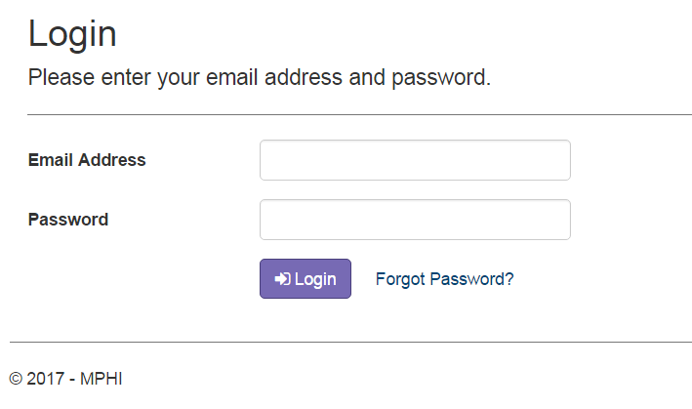
Health Officer – Users with the Health Officer role are local health department staff with the ability to update and publish Corrective Plans of Action (CPAs).

8.2 Accessing Accreditation

9.2.1 Login Page
A user must first log in on the Login page before using the Accreditation application. To log in, the user must select the Login button after entering their account email address in the Email Address field and their account password in the Password field.

8.3 Changing Your Password

9.3.1 Forgot Password
When a user has forgotten their account password, the user can reset it on the Forgot Password page. Users can access the Forgot Password page by selecting the “Forgot Password?” link on the Login page. A user can complete the Forgot Password process by following the steps listed below:

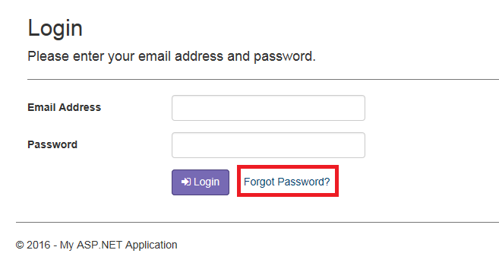
Step 1: Select the “Forgot Password?” link on the Login page

Step 2: Enter the email address associated to your account in the Email Address field

Step 3: Select the Email Link button to send yourself a reset password email

Step 4: Follow the URL provided in the email
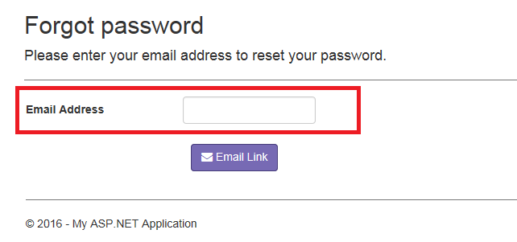
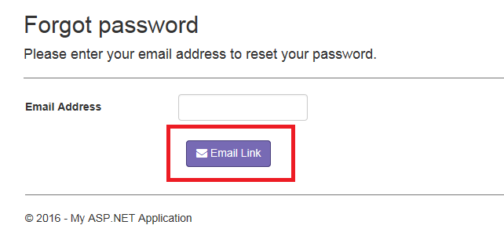
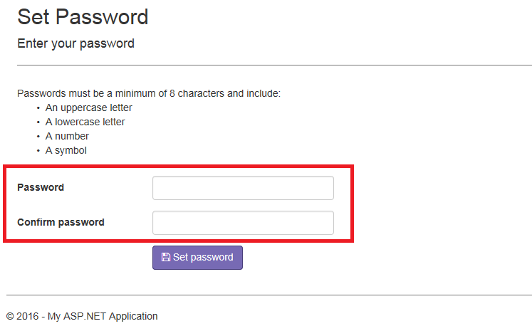
Step 5: Enter your new password in both the New Password and Confirm New Password fields. The new password must be different than your current password, be a minimum of 8 characters, and include:
- An uppercase letter
- A lowercase letter
- A number
- A symbol

Step 6: Select the Set password button

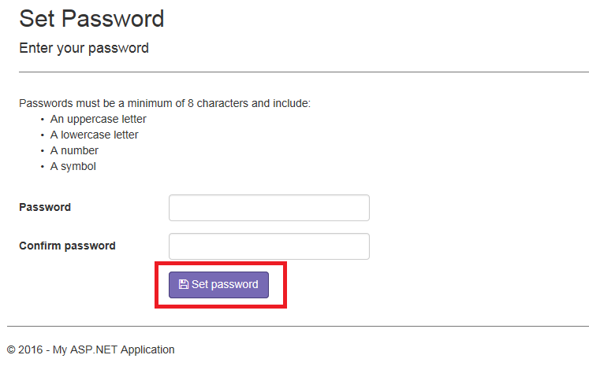
Note: A user’s password will expire every 120 days. Upon login, a user with an expired password will be prompted to create a new one.

8.3.2 Change Password
When a user would like to change their account password, the user can do so on the Change Password page by following the steps listed below:

Step 1: Select the Change Password link on the Home page
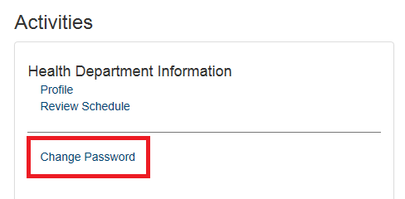

Step 2: Enter your current password in the Current Password field

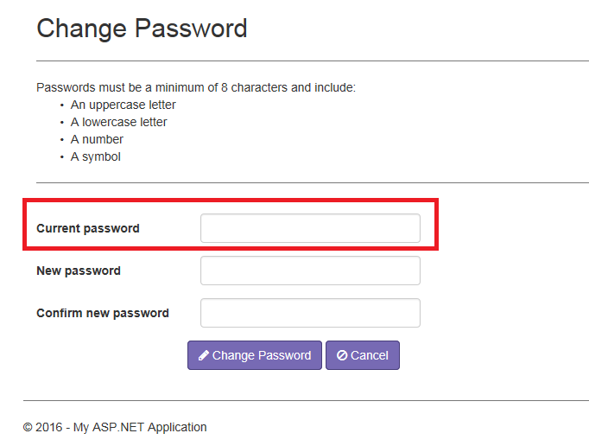

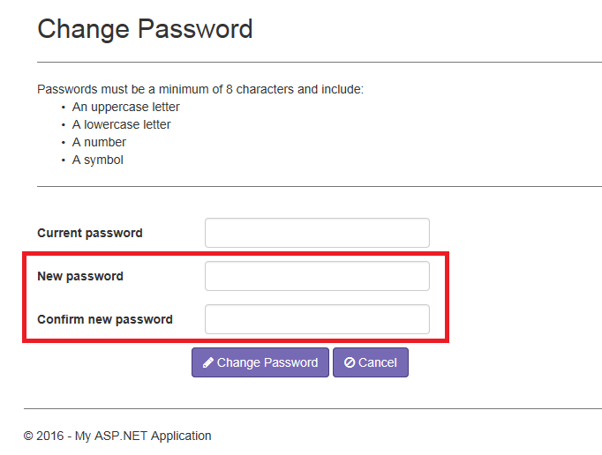
Step 3: Enter your new password in both the New Password and Confirm New Password fields. The new password must be different than your current password, be a minimum of 8 characters, and include:
- An uppercase letter
- A lowercase letter
- A number
- A symbol

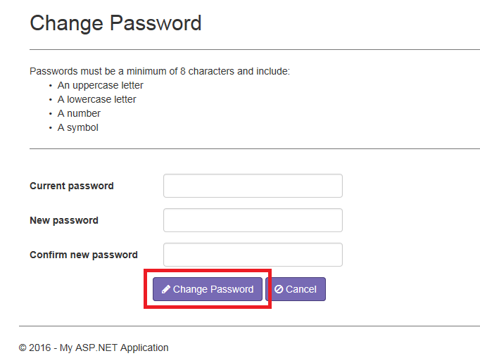
Step 4: Select the Change Password button

Note: A user’s password will expire every 120 days. Upon login, a user with an expired password will be prompted to create a new one.

8.4 Home Page
The Home page is the default landing page for users when they first log into the Accreditation application. There are 4 sections on the Home page: Health Department Evaluation (see Health Department Evaluation), Activities (see Activities), Reports (see Reports), and Important Dates (see Important Dates).

8.5 Health Department Evaluation
The Health Department Evaluation section of the Home page drives which Health Department’s information is shown and for which Program Area. Users with the Administrator and Reviewer roles can select both a Health Department and Program Area from the dropdowns. For users with the Health Department and Health Officer roles, the Health Department dropdown is defaulted to the user’s assigned health department and cannot be changed.

When a user with the Administrator or Reviewer role selects the Submit button, the user is taken to the Evaluate Program Area details page (see Evaluation: Program Area Details).

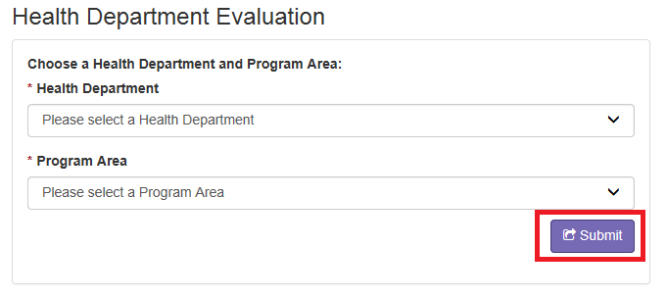

8.6 Activities
The Activities section of the Home page lists links to additional sections of the Accreditation Web Module. Available activities include:
Health Department Information
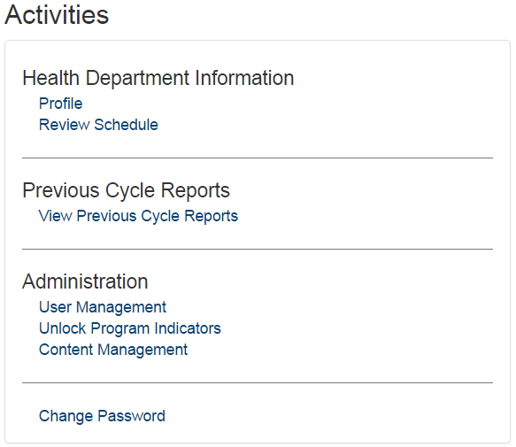
- Profile – This link takes a user to the Health Department Profile page. See Health Department Profile
- Review Schedule – This link takes a user to the Review Schedule page for the Health Department selected in the Health Department Evaluation section of the Home page. See Review Schedule
Previous Cycle Reports
- View Previous Cycle Reports – This link takes the user to the Previous Cycle Reports page where the user can view reports from Cycles 3, 4, and 5 for the selected Health Department.
Other
- Change Password – This link takes a user to the Change Password page. See Change Password

8.7 Important Dates
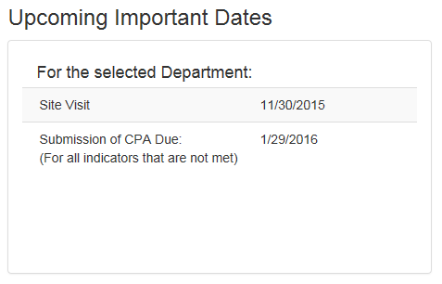
The Important Dates section of the Home page displays important upcoming dates for the Health Department selected in the Health Department Evaluation section of the Home page. The Important Dates include the date the onsite review of the Health Department is scheduled to start and the date Corrective Plans of Action are due for the Health Department.

Reports in the Accreditation Web Module
The Reports section of the Home page displays a list of available reports based on the user’s role and which Health Department and Program Areas they have selected.

9.1 Total Site Visit Report
The Total Site Visit Report is available to users with the Administrator, Health Officer, or Health Department roles when a Health Department is selected from the Health Department Evaluation section of the Home page. For users with the Health Officer or Health Department roles, the selected Health Department is restricted to the Health Department associated with their account. Similar to the On-Site Review Report, the Total Site Visit Report shows the number of indicators that were Met, Not Met, and Not Applicable, broken down by Program Area, for the selected Health Department. The Total Site Visit Report also contains the Health Department Evaluation details, including the information entered on the Evaluation: Indicator Details page (see Evaluation: Indicator Details).

9.2 Sectional Status Report
The Sectional Status Report is available to all user roles when a Health Department and Program Area are selected from the Health Department Evaluation section on the Home page. For users with the Health Officer or Health Department roles, the selected Health Department is restricted to the Health Department associated with their account. The Sectional Status Report contains the Health Department Evaluation details for the selected Program Area, including the information entered on the Evaluation: Indicator Details page (see Evaluation: Indicator Details).

9.3 Section Summary Report
The Section Summary Report is available to all user roles when a Health Department and Program Area are selected from the Health Department Evaluation section on the Home page. For users with the Health Officer or Health Department roles, the selected Health Department is restricted to the Health Department associated with their account. The Section Summary Report displays which indicators were Met, Not Met, and Not Applicable for the selected Program Area.

9.4 Summary Indicators Report
The Summary Indicators Report is available to users with the Administrator or Reviewer roles when a Health Department is selected from the Health Department Evaluation section on the Home page. For each published Health Department, this report displays how many applicable indicators were Met and Not Met.

9.5 Totals by Health Department Report
The Totals by Health Department Report is available to users with the Administrator or Reviewer roles when a Health Department is selected from the Health Department Evaluation section on the Home page.

9.6 Cycle Totals by Program Area to Date Report
The Cycle Totals by Program Area to Date Report is available to users with the Administrator or Reviewer roles. This report displays how many indicators were Met or Not Met for each Program Area. It also shows how many Health Departments the Program Area is applicable to.

9.7 Cycle Totals by Indicator to Date Report
The Cycle Totals by Indicator to Date Report is available to users with the Administrator or Reviewer roles. This report displays how many Health Departments met or did not meet each indicator. It shows how many met the indicators at the Program Area level, the Minimum Program Requirement level, and the Indicator level.

Minimum Program Requirement (MPR) Evaluation

10.1 Evaluation: Program Area Details
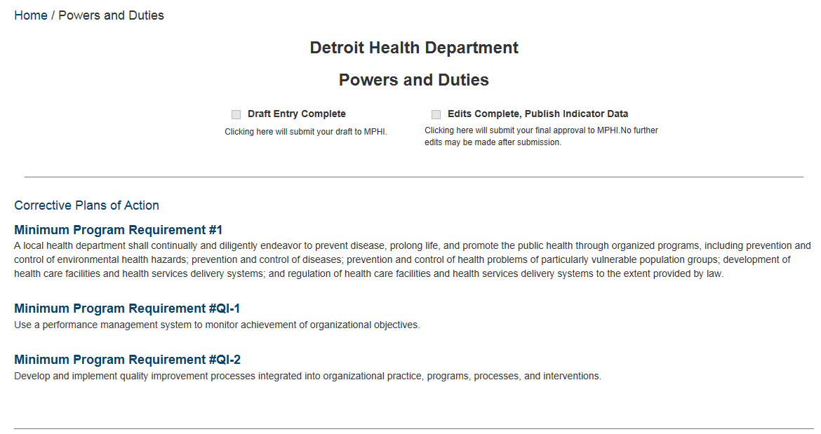
When a user with the Reviewer role or the Administrator role selects the Submit button on the Home page, the user is taken to the Program Area Details page for the selected Health Department and Program Area on the Home page. The Program Area Details page lists the Minimum Program Requirements that are required for the Program Area. When a user selects a Minimum Program Requirement’s name, the user is taken to the Minimum Program Requirement Details page (see Evaluation: MPR Details).

Once Reviewers have completed all of the Indicators for the selected Program Area, they can mark it as Draft Entry Complete. Doing so will send an email to the MPHI Administration staff, prompting them to begin their review. Once the MPHI staff have completed their review and all edits are complete, MPHI will send an email to the reviewer and the program Manager (designated ahead of time to MPHI) . The Manager may then check the Edits Complete, Publish Indicator Data checkbox. Once the indicator data is published, a Corrective Plan of Action will be created for any indicators marked as “Not Met”. See Corrective Plans of Action (CPAs).
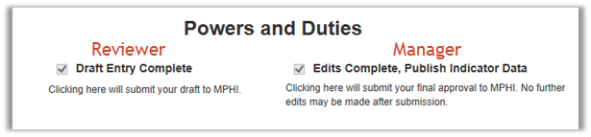

10.2 Evaluation: MPR Details
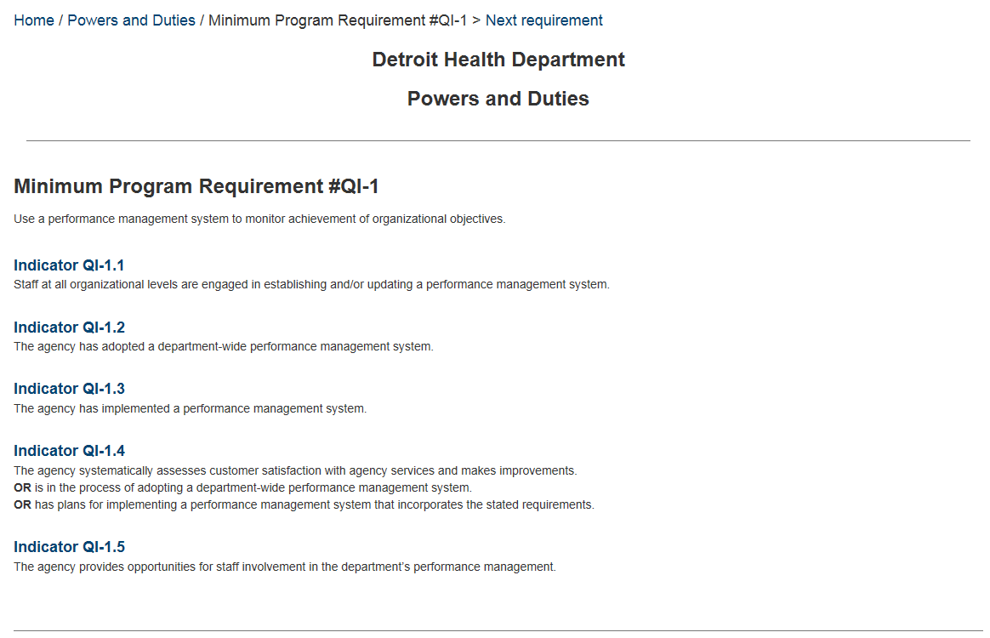
The Minimum Program Requirement (MPR) Details page lists the indicators that are required for the selected MPR. When a user selects an indicator’s name, the user is taken to the Indicator Details page (see Evaluation: Indicator Details). A user may navigate to the next Minimum Program Requirement in the Program Area by selecting the “Next requirement” link in the breadcrumbs at the top of the page.

10.3 Evaluation: Indicator Details
The Indicator Details page displays details regarding the conditions necessary for a Health Department to meet the selected indicator. A user may navigate to the next Indicator in the Minimum Program Requirement by selecting the “Next Indicator” link in the breadcrumbs at the top of the page.

While not required, users can check the check boxes next to each condition to indicate which conditions were met. To save the page, one of the following combinations of fields must be completed:

Indicator is Met – the “Met” radio button option is selected and nothing is entered in the Reason Not Met field.
Indicator is Not Met – The “Not Met” radio button option is selected, there is a value entered in the Reason Not Met field, and nothing is entered in the Met with Conditions field.
Indicator is Not Applicable – The “Not Applicable” radio button option is selected.

Health Department Profile

All users can view information about a Local Health Department (LHD) on the Health Department Profile page. Users with the Administrator, Health Department, and Health Officer roles can update the information on the Health Department Profile page. The information shown includes the following:

Local Health Department Contact Information – This section includes the Local Health Department’s name, address, phone number, and website.

Health Officer – The Health Officer section includes the Local Health Department’s Health Officer’s name, phone number, and email address.

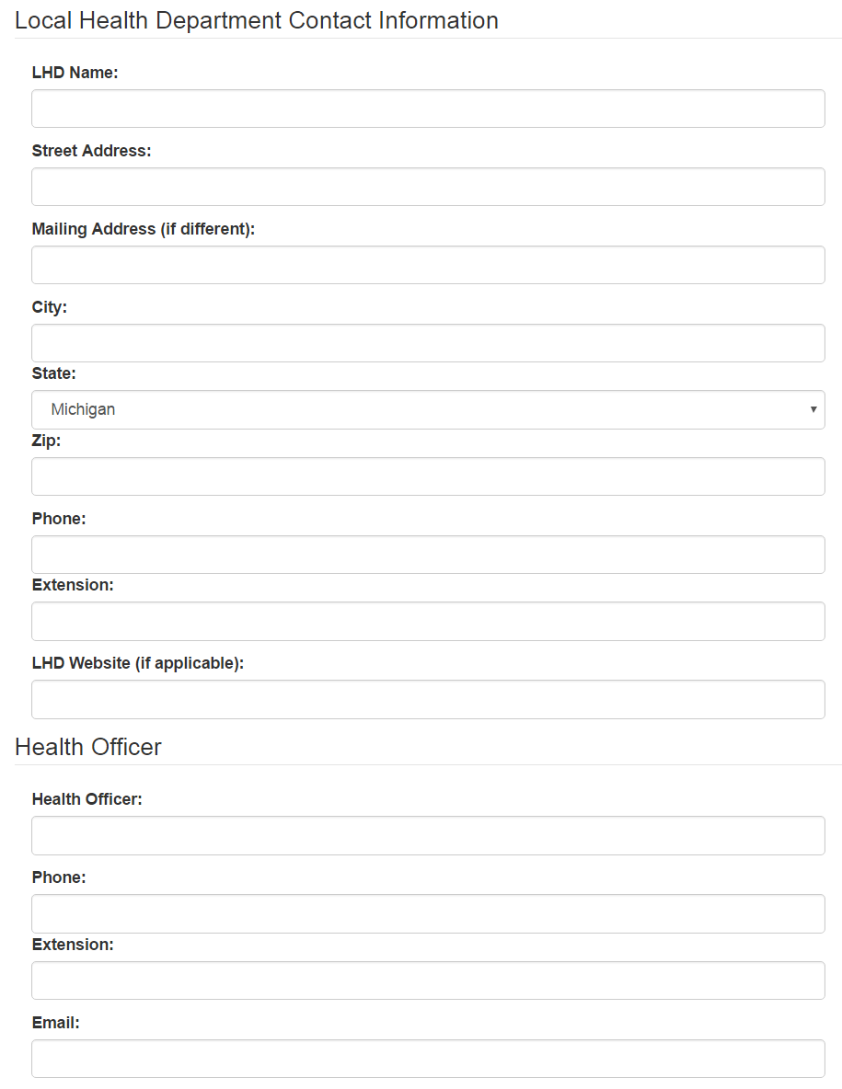

Accreditation Coordinator – The Accreditation Coordinator section includes the Local Health Department’s Accreditation Coordinator’s name, phone number, and email address.

LHD Local Governing Entity – This section includes the Local Health Department’s Local Governing Entity’s (LGE) name, the name of the LGE’s Chairperson, when the Chairperson’s appointment ends, and the Chairperson’s mailing and email addresses.

Onsite Review – The Onsite Review section lists important dates for the selected Local Health Department. The date in the Onsite Review Week field indicates the first day of the week that the Local Health Department’s onsite review will take place. The date in the 1 Year Post-Review Deadline field indicates the date Corrective Plans of Action are due and need to be fully implemented for the Local Health Department. The Final Report Date field indicates when the final report will be available for the Local Health Department.

Review Schedule

Users can access the Review Schedule page by selecting the Review Schedule option from the Activities section of the Home page (see Activities). The Review Schedule page has three main sections: Reports, Setup, and the Schedule.

Reports
Users can access the On-site Review Schedule Report and the Complete Pre-materials Report from the Reports section of the Review Schedule page. The On-site Review Schedule Report provides the user with a printable version of the Schedule section of the Review Schedule page. The Complete Pre-materials Report provides the user with the same printable version of the Schedule section, but also includes the selected health department’s profile information and Exit Conference details.
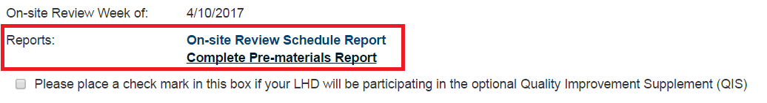
Additionally, users can indicate whether the selected health department will be participating in the optional Quality Improvement Supplement by marking the checkbox in the Reports section.
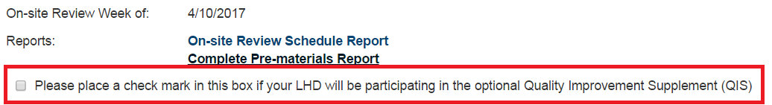

Setup
The Setup section of the Review Schedule page is only available to users with the Health Officer, Health Department, and Administrator roles. From the Setup section, users can indicate which local health department (LHD) staff (separated by comma) will be involved in the review and exit conference for the Program Area selected in the Program Area Dropdown and when the LHD has availability for the review. Selecting the Submit button will add the completed schedule information to the Schedule section of the Review Schedule page.

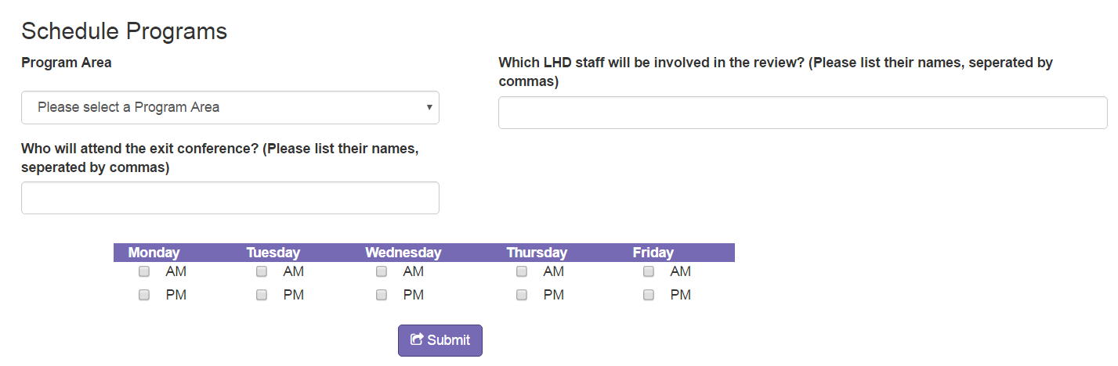
Schedule
The Schedule section of the Review Schedule page lists the information that was entered for each Program Area in the Setup section. Users with the Health Officer, Health Department, or Administrator roles can modify the schedule information for a Program Area by selecting the Edit option in the Actions column. Users with the Administrator role can delete the schedule information for a Program Area by selecting the Delete option in the Options column. Administrators can indicate which users with the Reviewer role will be completing the On-Site Review for each Program Area by selecting the Add Reviewer option in the Action column.

Once the Review Schedule is complete, a user with the Administrator role can publish the Review Schedule by marking the Publish checkbox in the bottom left corner of the page.

Corrective Plans of Action (CPAs)

13.1 The Reviewer’s Role in the CPA Process
LHDs that do not fully meet all essential requirements must develop CPAs for missed indicators. MPHI serves as the conduit for the CPA process, utilizing a tracking mechanism to ensure consistency. LHDs must submit CPAs to the Accreditation Program within 60 days of the last day of their On-Site Review (e.g., if On-Site Review ends August 4th, CPAs would be due October 4th). All CPAs will be submitted via the Accreditation Web Module, and supplemental materials (if applicable) will be sent directly to applicable Reviewers.

Upon receipt of the CPAs, MPHI staff will record the date of submission and send a notice via e-mail to applicable Reviewers that the CPAs are ready for review. The State agency Reviewer(s) has 30 days from MPHI’s date of receipt to respond to the CPA. Options for responses are as follows:

  - The plan may be approved with no further action by either party required.

  - The plan may be approved with further action required, such as an On-site Revisit or submission of materials to the State agency contact. Please note that all CPA and follow-up reviews must occur within one year from the last day of the LHD’s On-Site Review. Deviation from this timeline would only occur in extenuating circumstances when the Local Governing Entity and the State agencies have approved a LHD request for extension to implement the CPA.

  - The plan may be rejected in which case information will be included instructing the LHD on what revisions to the plan are needed and when those revisions are due (usually within 30 days).

In the event CPA negotiation is ongoing between the State and LHD (and exceeds the 30 day requirement), the LHD shall have the implementation period extended accordingly. Implementation of approved plans must be in place for 90 days from the date of State agency approval before a LHD may be considered for Accreditation. It is the responsibility of the State agency Reviewer(s) to update the online submission system as changes in status are made and follow-up reviews are scheduled and/or conducted. All correspondence with the LHD outside of the system regarding CPA implementation should be copied to MPHI. As with draft report submission, MPHI Accreditation staff will generate and distribute reminder e-mails to all recipients shortly before CPA responses are due.

13.1 CPA Status
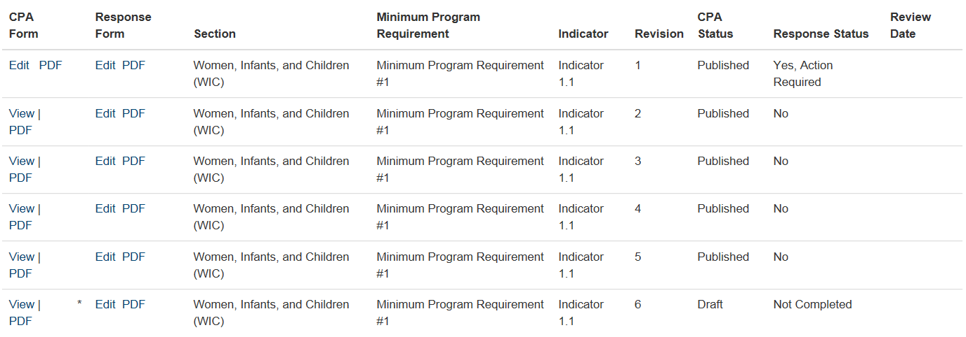
Users can view the status of CPAs for a Health Department on the CPA Status page. The CPA Form column of the CPA Status page provides options for editing or viewing a CPA: selecting the Edit option takes the user to the Corrective Plan of Action page (see Corrective Plan of Action (CPA)), selecting the PDF option opens a read-only PDF version of the CPA. The Response Form column provides options for editing or viewing the Response and Follow-up forms: selecting the Edit option takes the user to the Response Form or Follow-Up Form (see Response Form and Follow-Up Form), selecting the PDF option opens a read-only PDF version of the form.

The CPA Status page also includes the following information about each CPA:
Section – The Program Area the Not Met indicator is part of.
Minimum Program Requirement – The Minimum Program Requirement the Not Met indicator is part of.
Indicator – The indicator that was Not Met, resulting in the CPA.
Revision – The revision number of the CPA. Each CPA has its own set of revision numbers.
CPA Status – The status of the CPA, Response Form, or Follow-Up Form shown reference in the row.
Response Status – How the Reviewer responded to the CPA.
Review Date – The date of the review.

13.2 Corrective Plan of Action (CPA)
New Corrective Plans of Action (CPAs) are created for a Health Department/Program Area Combination when a reviewer publishes a Health Department’s Minimum Program Requirement Evaluation for a Program Area and an indicator was marked as Not Met. CPAs can be completed by users with the Health Department role or the Health Officer role, but can only be published by users with the Health Officer or Administrator roles. The fields listed below are required on the CPA form.

Required Fields
Your Name – The name of the Health Officer or Health Department user filling out the CPA.
Title – The job title of the Health Officer or Health Department user filling out the CPA.
Name – The name of the local health department staff responsible for implementing the CPA.
Title – The job title of the local health department staff responsible for implementing the CPA.
Phone – The phone number of the local health department staff responsible for implementing the CPA.
Fax – The fax number of the local health department staff responsible for implementing the CPA.
Describe Corrective Plan of Action – A description of how the local health department intends to rectify the issues that caused the indicator to be marked as Not Met.
Projected Completion Date – The date the local health department plans to complete the changes described in the Describe Corrective Plan of Action field.
Please Explain how the Corrective Plan of Action will correct the deficiency – An explanation of how the changes described in the Describe Corrective Plan of Action field will correct the deficiency that caused the indicator to be marked as Not Met.
Are there additional materials accompanying this CPA? – Yes/No field
When “Yes”, the following is required:
Additional Material – A description of the additional material being provided.
Reviewer – Which reviewer the material is being sent to.
Date Sent – The date the additional material is being sent.
Electronic Signature – The publishing user’s electronic signature.
To publish the CPA, a user with the Health Officer or Administrator role must mark the Publish checkbox found in the bottom left corner of the CPA page. When the CPA is published, an email is automatically sent to the Reviewer assigned to review the Program Area for the selected health department.

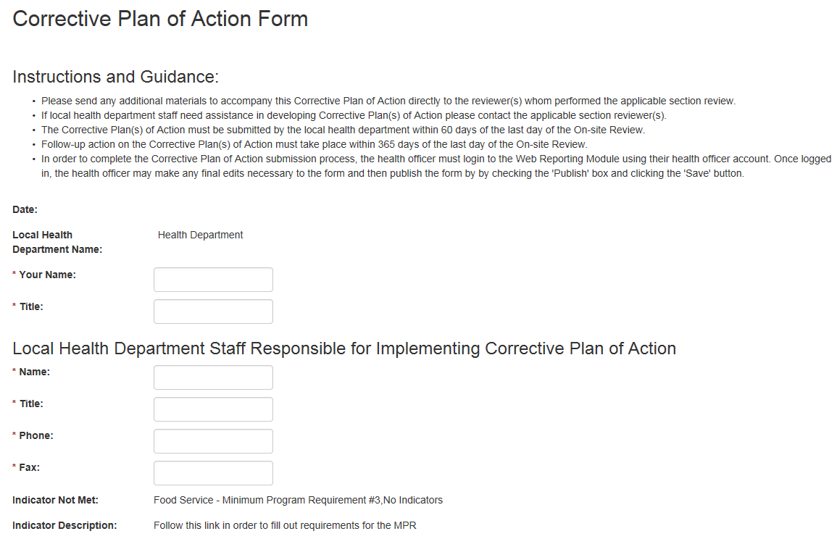
CPA Screenshots

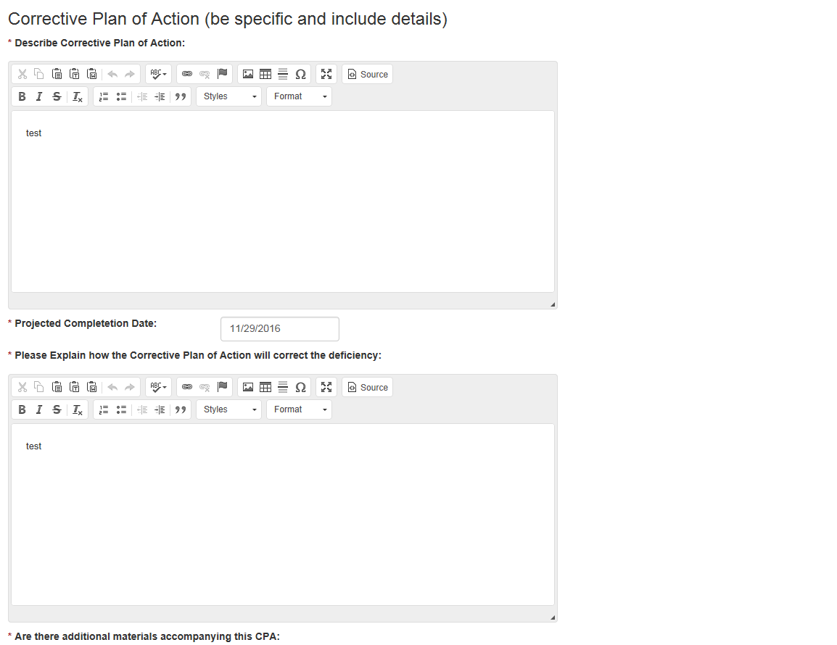

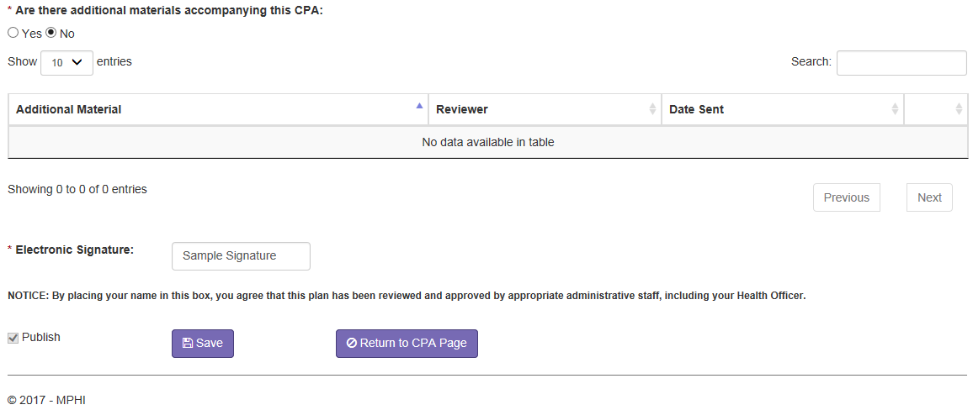

13.3 Response Form
Users with the Reviewer role fill out a Response Form in reaction to a published Corrective Plan of Action (CPA). The fields required on the Response Form page are based on the Reviewer’s response to the CPA Approval Granted field:
- When “Yes, with no future corrective action required” is selected, the following are required:
  - Reviewer Name
- When “Yes, with further action required” is selected, the following are required:
  - Site Revisit By
  - Materials required for review by
  - Please detail actions necessary for compliance
  - Reviewer Name
- When “No” is selected, the following are required:
  - Please Explain
  - Reviewer Name
Once the required fields have been completed and saved, a Reviewer can publish the Response Form by marking the Publish checkbox in the bottom left corner of the page. When published, the Health Officer users for the health department are emailed to inform them that the Response Form is available. Additionally, when the Approval Status was marked as “Yes, with further action required” or “No”, a Follow-Up Form is generated (see Follow-Up Form).

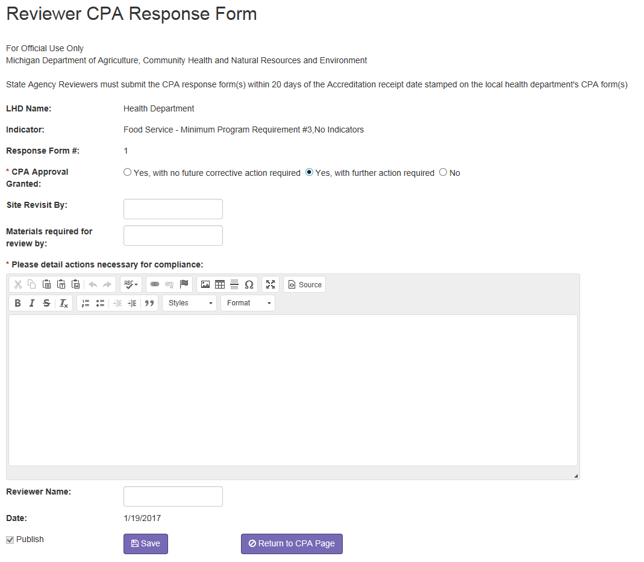

13.4 Follow-Up Form
Follow-up forms are created when a Response Form is published with a CPA Approval status of “Yes, with future action required” or “No”. The fields required on the Follow-Up Form page are based on the Reviewer’s response to the “Was the LHD successful in its CPA implementation” field:
- When “Yes, this is my final sign-off for this indicator” is selected, the following are required:
  - Reviewer Name
- When “No, further action is needed to implement the CPA” is selected, the following are required:
  - Please explain the action that the LHD needs to take for successful implementation
  - Date by which LHD needs to complete this action
  - Reviewer Name

Once the required fields have been completed and saved, a Reviewer can publish the Follow-Up Form by marking the Publish checkbox in the bottom left corner of the page. When published, the Health Officer users for the health department are emailed to inform them that the Response Form is available. Additionally, when the “Was the LHD successful in its implementation?” field was marked as “No, further action is needed to implement the CPA”, another Follow-Up Form is generated for the indicator.

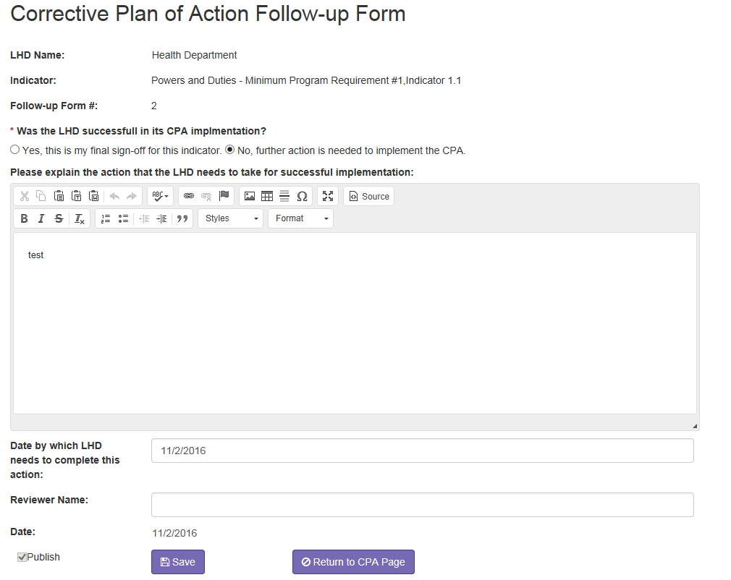

Appendix I

Scheduling Guidelines
- Section I (Local Health Department Powers and Duties) and the optional Quality Improvement Supplement (if applicable) on Monday. The optional Quality Improvement Supplement is reviewed remotely.

- Section III (General Communicable Disease) will be reviewed remotely. Guidance for the remote review begins on page 45 of the LHD User’s Guide. Please to be sure to indicate a day and time for the reviewers to contact your health department to discuss their review of your materials. Your Reviewer will verify the day and time selected prior to conducting the Exit Interview.

- Section IV (Hearing), as a single half-day review. Please schedule separately from Vision, if possible. Please avoid scheduling this review on Fridays.

- Section V (Immunization), schedule one day for the review at the main local health department clinic (no visits to off-site clinics) on a day when the IAP coordinator and immunization clerk are available for interaction with the Reviewer.

- Section VI (Onsite Wastewater Treatment Management) requests a minimum of two (2) days for the review of a single county health department. District health departments typically require additional days. Consultation with the Reviewer is suggested for confirmation of the actual number of days that are needed to complete the review.

- Section VII (HIV/STD) is a single, full day review in most cases. At the discretion of the Accreditation Reviewer, remote reviews will be permitted. If a remote review is granted, all required materials must be sent within a week of the On-Site Review. There must also be video capabilities to conduct the half-day review.

- Section VIII (Vision) is a single, half-day review. Please contact the Reviewer to arrange for scheduling of the site visit prior to completing the Review Schedule in the Cycle 7 Web Module.

- Section IX (Breast and Cervical Cancer Control Navigation Program) Note: BCCCNP is not evaluated as a part of the Accreditation program beginning in 2019

- Section X (Family Planning) Schedule a family planning clinic on the first day of the two-day review. Agencies should schedule a full clinic with a variety of visit types, especially initial and annual visits.

SECTION | TIME  REQUIRED
Section I – Local Health Department Powers and Duties and optional Quality Improvement Supplement (if applicable) | 1day
Section II – Food Service | 5 days
Section III - General Communicable Disease Control | ½ day Reviewed remotely
Section IV – Hearing | ½ day
Section V – Immunization | 1 day
Section VI – Onsite Wastewater Treatment Management | 2 days
Section VII – HIV/STD | 1 day  (½ day if Reviewed remotely)
Section VIII – Vision | ½ day
Section IX – Breast and Cervical Cancer Control Navigation Program | BCCCNP is not evaluated as a part of the Accreditation program beginning in 2019
Section X – Family Planning | 2 days
Section XI – Women, Infant, and Children (WIC) | N/A no on-site review required
Section XII – Children’s Special Health Care Services (CSHCS) | 1 day

