Michigan Local Public Health Accreditation Program
Local Health Departments – Users’ Guide

Table of Contents

1- Introduction 5
2- Overview 6
2.1 History 6
2.2 Governance 6
2.3 Standards 6
2.4 Process 7
2.5 Evaluation 7
2.6 Conclusion 7
3- The Michigan Local Public Health Accreditation Process 8
4- Self-Assessment 9
4.1 What to expect 9
4.2 Pre-Materials to MPHI: 9
4.3 Requested Program Pre-materials: 10
4.4 Technical Assistance Contacts: 10
4.5 Tips to facilitate the process: 10
5- Navigating the Accreditation Web Module 11
5.1 Logging in to the Accreditation Web Module 12
5.2 Changing Your Password 12
Forgot Password 12
Change Password 13
5.3 Home Page 15
5.4 Submitting Pre-materials in the Accreditation Web Module 15
Review Schedule 15
Update your local health department’s contact information 18
Completed pre-material reports 21
5.5 Exiting the Accreditation Web Module 21
6- On-Site Review 22
6.1 What to Expect 22
6.2 Suggestions 22
6.3 Exit Conferences 22
6.4 The On-Site Review Report 22
6.5 Indicator Designations 22
Met Designation 23
Not Met Designation 23
Not Applicable Designation 23
Met with Condition Designation 23
6.6 Program specific Met with Conditions language 24
LOCAL HEALTH DEPARTMENT POWERS & DUTIES 24
FOOD SERVICE PROGRAM 24
GENERAL COMMUNICABLE DISEASE CONTROL 24
HEARING & VISION 24
IMMUNIZATION 25
ONSITE WASTEWATER TREATMENT MANAGEMENT 25
SEXUALLY TRANSMITTED DISEASE and HIV/AIDS 25
BREAST AND CERVICAL CANCER CONTROL NAVIGATION PROGRAM (BCCCNP) 26
FAMILY PLANNING PROGRAM 26
WOMEN, INFANTS, AND CHILDREN (WIC) 26
CHILDREN’S SPECIAL HEALTH CARE SERVICES (CSHCS) 26
7- Reports 27
7.1 On-Site Review Report 27
7.2 Total Site Visit Report 27
7.3 View and Track CPA Status 27
7.4 Sectional Status Report 27
7.5 Section Summary Report 27
8- Corrective Plan of Actions (CPAs) 28
8.1 Create/Edit a CPA in the Accreditation Web Module 28
8.2 Next Steps 32
9- Procedure for Conducting Accreditation Re-evaluations of Local Health Departments 33
9.1 Purpose 33
9.2 Background 33
9.3 Policy/Procedure 33
9.4 Evaluation 33
9.5 Extension Policy 33
10- 180 and 90 Day CPA Process Emails 34
10.1 - 180 Day Email 34
11- Accreditation Review Evaluation 36
11.1 Procedure & Results 36
12- Accreditation Commission 36
12.1 Initial Commission Review 36
12.2 Inquiry Policy 36
13- Becoming Accredited – What’s Next 38
13.1 Accreditation with Commendation 38
13.2 Next steps 38
Appendix I: Scheduling Guidance 39
Appendix II: Quality Improvement Supplement Specific Guidance 41
Quality Improvement Supplement (QIS) Review Process 41
QIS Documentation 41
QIS Cover Sheet Staff Contact Information 43
Appendix III: Communicable Disease Control Specific Guidance 45
General Communicable Disease Control Remote Accreditation Guidance 45
General Communicable Disease Control Accreditation Evidence Crosswalk 51
Appendix IV: Breast and Cervical Cancer Control Navigation Program Specific Guidance 55
Breast and Cervical Cancer Control Navigation Program Remote Accreditation Guidance Document 55
BCCCNP Remote Accreditation Guidance Document 56
Appendix V: Family Planning Specific Guidance 64
Family Planning Pre-materials: 64
Appendix VI: Children’s Special health Care Services (CSHCS) Specific Guidance 66
Children’s Special Health Care Services Pre-materials: 66
Appendix VII: Technical Assistance Contacts 71
Appendix VIII: Accreditation Review Evaluation 72
Appendix VIIII: CPA Status 74

Introduction
Developed in direct consultation with the Program’s participants, this Users’ Guide is intended to systematically outline, clarify, and explain all relevant policies, procedures, and processes integral to successful participation in the Accreditation Program. This document is also interactive, meaning that text which appears in blue and is underlined may be followed to another destination in the document or on the Internet by holding down the CTRL key and then clicking on the text with a mouse.

This document is part of a continuous quality improvement process. It is fluid and fully expected to change as local public health departments provide input regarding points that contribute to its usefulness. To retain consistency regarding the application of responses, please contact one of the individuals below.

Orlando Todd
Director, Local Health Services Division
Michigan Department of Health and Human Services Population Health Administration
Phone: (517) 284-4021
Email: toddo@michigan.gov

Jessie Jones, MPA
Program Coordinator
Center for Healthy Communities Michigan Public Health Institute 2342 Woodlake Drive
Okemos, MI 48864
Phone: (517) 324-8387
Email: jjones@mphi.org

Kristy Medes
Program Assistant
Center for Healthy Communities Michigan Public Health Institute
2342 Woodlake Drive
Okemos, MI 48864
Phone: (517) 324-6072
Email: kmedes@mphi.org

Overview

2.1 History
The State of Michigan has a mature, organized, and institutionalized local public health accreditation program. The timeline begins with the establishment of the Public Health Code in 1978, followed by the state/local development of Minimum Program Requirements (MPRs) in 1980. During 1989, with state technical assistance, local health departments used the Assessment Protocol for Excellence in Public Health (APEXPH) tool as a means to assess and enhance the core capacities. During 1989 – 1992, Established Committees One and Two (comprising state/local public health leaders) recommended pursuing accreditation. These early collaborative efforts defined the attributes of a local health department and served as the basis for the Michigan Local Public Health Accreditation Program (MLPHAP).
The mission of this living program is to assure and enhance the quality of local public health in Michigan by identifying and promoting the implementation of public health standards for local public health departments and evaluating and accrediting local health departments on their ability to meet these standards. The Program’s goals are to:
- Assist in continuous quality improvement;
- Assure a uniform set of standards that define public health;
- Assure a process by which the state can ensure local level capacity to address core functions;
- Provide a mechanism for accountability.

2.2 Governance
The governing authority for the MLPHAP is the Michigan Department of Health and Human Services (MDHHS). Three state agencies comprise the accrediting body:
- Michigan Department of Health and Human Services
- Michigan Department of Agriculture and Rural Development
- Michigan Department of Environmental Quality

An Accreditation Commission maintained by the Michigan Public Health Institute (MPHI) serves as the advisory body for Michigan’s Accreditation Program.

2.3 Standards
The state health department is responsible for establishing minimum standards of scope, quality, and administration for the delivery of required and allowable services as set forth under the Public Health Code. The current model is based on Minimum Program Requirements (MPRs).
- MPRs are constructed through a formal process (Policy 8000).
- MPRs must be based in law, rule, department policy or accepted professional standards.

2.4 Process
The Accreditation Program assesses the ability of a local health department to meet minimum administrative capacity requirements. The Accreditation Program also conducts performance reviews for contractual local public health operations services and some categorical grant funded services provided by a local health department. The review process requires a team of approximately 50 state agency Reviewers, of which about 15 are used for each On-Site review. The review cycle is 3 years.

There are three steps to the Accreditation process:
- Self-Assessment
- On-Site Review
- Corrective Plans of Action (CPA)

Following the On-Site Review, and CPA processes, there are three Accreditation status options. These are:
- Accredited
- Accredited with Commendation
- Not Accredited

2.5 Evaluation
MPHI conducts regular evaluations of the Michigan Local Public Health Accreditation Program and its components at the conclusion of each 3-year cycle. Evaluation results and data are used to improve the quality of the program.

2.6 Conclusion
The work that has been undertaken in Michigan to achieve the goals of building capacity and infrastructure development began with the creation of the Public Health Code (Act 368 of 1978), specifically Section 24 which begins to define the role of local health departments in Michigan. Without this framework, Michigan would have been challenged to establish an Accreditation Program with the depth and breadth present today. Continued commitment and collaboration by the Michigan Departments of Health and Human Services, Agriculture and Rural Development, and Environmental Quality; the Michigan Public Health Institute; Michigan’s 45 local public health departments; and the Michigan Association for Local Public Health will enhance Michigan’s Accreditation Program, improve the quality of local programs and services, and shape the future of public health in Michigan.

The Michigan Local Public Health Accreditation Program website is available for Local Health Department staff and Reviewers. The website consist of a wealth of information about the Michigan Accreditation process and includes supporting resources such as User Guides, MPR Indicator Guide (for all or individual programs), and links to Quality Improvement resources and the Accreditation Web Module . To visit the site use the following link: https://accreditation.localhealth.net/.

The Michigan Local Public Health Accreditation Process
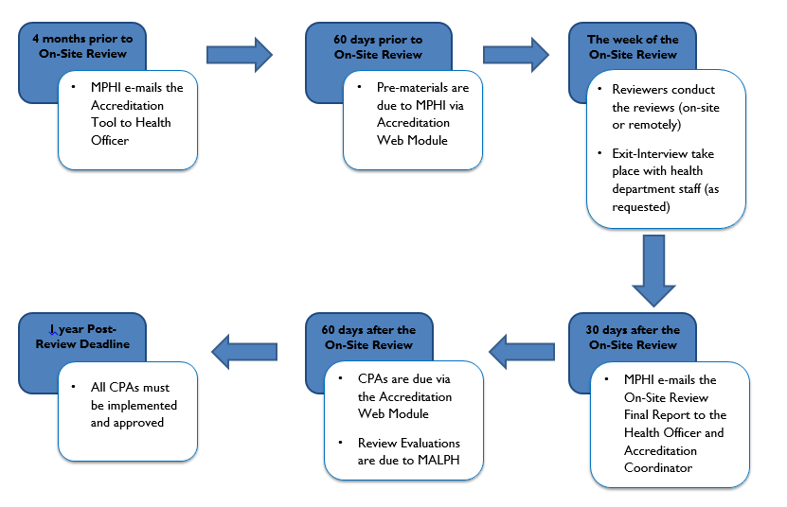

Self-Assessment

4.1 What to expect
The Self-Assessment is the first step in the Accreditation process. A local health department completes the self-assessment, which serves as an internal review of the department’s ability to meet the minimum program requirements. The Self-Assessment phase begins four (4) months before the On-Site Review, when MPHI sends the local health department’s Health Officer (and Accreditation Coordinator, if applicable) an email with a link to the Tool and accompanying files that will aid in constructing a binder/print version of the Tool, if desired, which includes electronic files for divider tab labels, a cover, and a spine. The email also highlights pertinent dates in the process as they apply to the each health department. The Tool is located on the Michigan Local Public Health Accreditation Program website (https://accreditation.localhealth.net/).

The Self-Assessment should be completed using the MPR Indicator Guide for each section on which the local health department will be reviewed. The MPR Indicator Guide presents detailed information on the documentation a local health department provides in order to fully meet the indicators.

4.2 Pre-Materials to MPHI:
In order to facilitate the flow of information between the local health department and MPHI during all phases of the Accreditation process, the local health department should appoint an Accreditation Coordinator and identify that person to MPHI on the Profile Information area of the Accreditation Web Module and/or on the Module User Account Request form. This form is submitted to the MPHI Program Assistant via email at least two weeks prior to the pre-materials due date. Unless otherwise notified, MPHI will consider this person the single point of contact during the process.
There are several important pieces that need to be completed by the local health department and delivered to MPHI to officially complete the Self-Assessment phase. All materials will be submitted via the Accreditation Web Module (https://webreport.accreditation.localhealth.net/). These pre-materials (Profile Information, Exit Conference information, and the On-Site Review Schedule) are due to MPHI 2 months prior to the On-Site Review. For more information about submitting pre-materials and step-by-step instructions in Section 5 - Navigating the Accreditation Web Module..
The local health department will create the schedule for the 5-day review while adhering to the Scheduling Guidelines provided in Appendix I. It is understood that staff members will often be responsible for multiple programs. This and other factors should be taken into consideration as the schedule is being prepared. MPHI and the Accreditation Reviewers will receive the local health department’s schedule as final. In the event that either a Reviewer or the local health department needs to make changes to this schedule after it is submitted to MPHI due to extenuating circumstances or unforeseen events, it is critical that MPHI be contacted as soon as it is evident that a change to the schedule is needed. The Reviewer and local health department should work together to find a mutually acceptable new date within one week before or after the scheduled On-Site Review week to complete the review, then contact MPHI staff to inform them of the new date.

Within two weeks of submission, MPHI will email the Health Officer or appointed Accreditation Coordinator to notify them that their schedule, modified to include Reviewer contact information, is available to view on the Accreditation Web Module. This schedule will identify the Reviewer(s) responsible for each section and that individual’s phone number and email address to assist in pre-review communication.
The three-year On-Site Review calendar has been established well in advance. Due to the complex nature of the Accreditation cycle, changes to the review dates will not be customarily considered. However, in unusual instances the local health department may request a schedule change.
If a local health department needs to reschedule its On-Site Review, they must request a scheduling change, in writing, at least three months prior to the start of the scheduled Self-Assessment period. The request must be mailed to MPHI and include the rationale for the schedule change. MPHI will collaborate with MDHHS, MDARD, MDEQ, and the MLPHAP Accreditation Commission regarding the feasibility of accommodating the request. All parties will be notified of the outcome.

4.3 Requested Program Pre-materials:
Some services/programs administered by a local health department require separate pre-materials; the table below outlines the programs that have separate pre-materials and where to find additional information related to those.

Program | Where to find pre-material information
Powers and Duties – Quality Improvement Supplement | Appendix II
General Communicable Disease | Appendix III
BCCCNP | Appendix IV
Family Planning | Appendix V
CSHCS | Appendix VI
Powers and Duties – Plan of Organization | Link to Document
HIV/AIDS & STD *Optional Program Companion Guide | Link to Document

4.4 Technical Assistance Contacts:
Local health departments should contact relevant state agency staff in the event that clarification is needed regarding minimum program requirements and/or indicators. Appendix VII has a list of state agency Technical Assistance Contacts that includes names, email addresses, and phone numbers.

4.5 Tips to facilitate the process:
- Be certain to allow enough time for the Self-Assessment phase by beginning upon receipt of your Accreditation Tool, 4 months before On-Site Review date.
- Assemble a management team comprising the Health Officer, Medical Director, Finance Director, Personal Health Services Director, and the Environmental Health Director (or equivalents). Remember to include the designated Accreditation Coordinator if not already identified above. Regular meetings for progress reports are beneficial.
- Keep all staff and other relevant entities informed about the Accreditation process, including the local governing entity (Board of Health, County Commission, etc.).
- Fresh eyes looking at programs in the local health department can often make a positive impact in preparation. Utilize and involve your staff by having them review programs other than their own. For example, the immunization staff could review the food service sanitation program; the food service sanitation program could review the immunization program and so on.

Navigating the Accreditation Web Module
Open your Internet browser (this user manual will assume that you are using Microsoft Internet
Explorer 8.0 or higher), follow this link by holding the Ctrl Key and clicking this underlined link: https://accreditation.localhealth.net/ or by copying it into the address bar of the browser.

On the left side of the screen, there is a purple bar. Click the “Local Health Departments” link. On the Local Health Department Tools page, click the “Cycle 7 Web-based Reporting Module” link.

You may want to create a bookmark for this website so that you can easily access it in the future without having to remember the text you would need to type in the address bar. Follow your browser’s directions to add the website to your favorites.

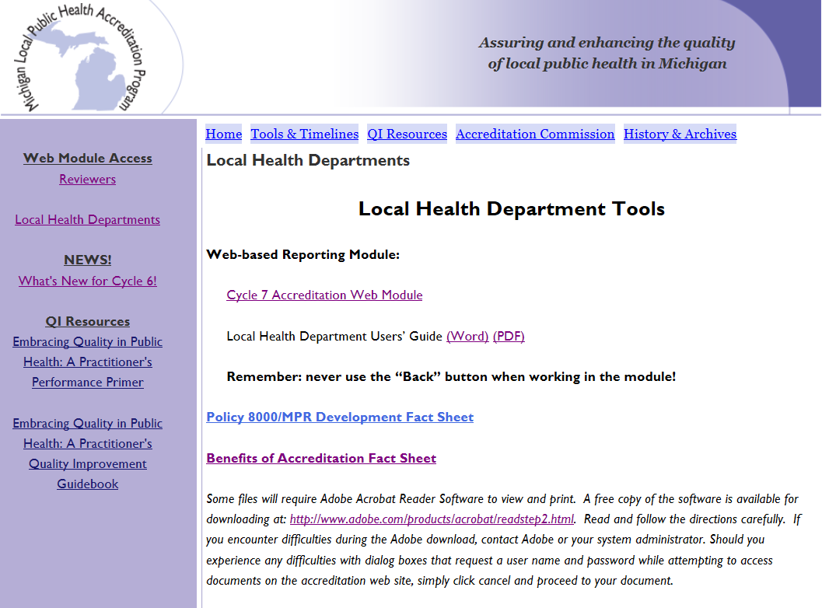

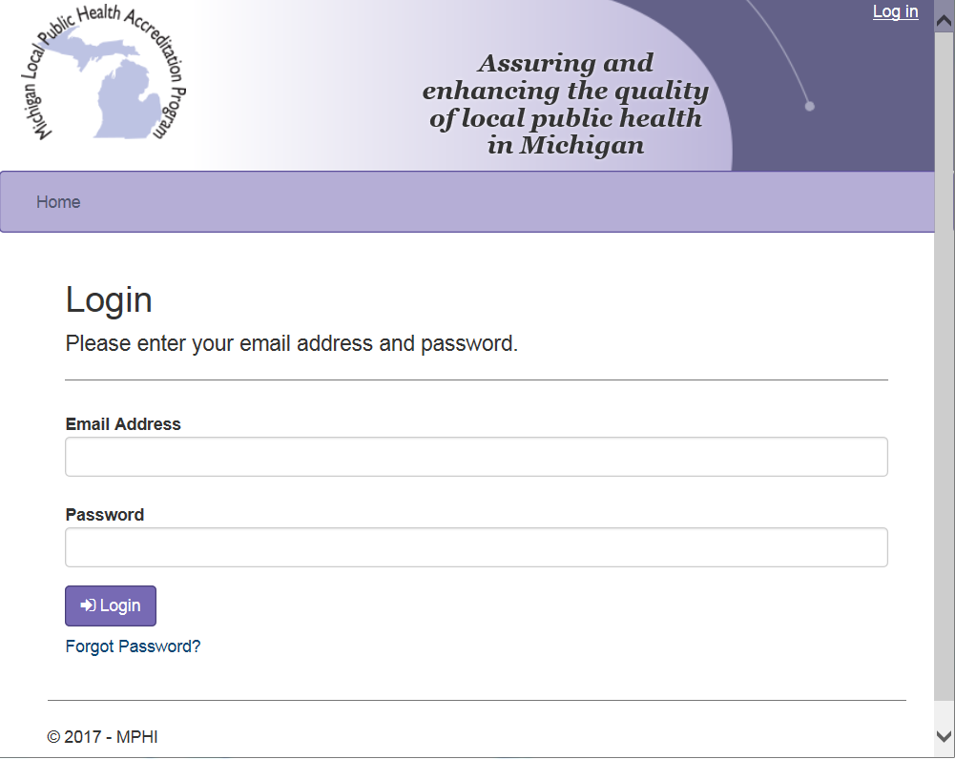

5.1 Logging in to the Accreditation Web Module
A form to request Accreditation Web Module user accounts is sent with your local health department’s Tool letter. Please submit this form by email to Kristy Medes kmedes@mphi.org no later than 2 weeks prior to your pre-materials due date. MPHI will create user accounts for each person listed on the form when it is submitted. The first time a new user logs in to the Accreditation Web Module they will be required to set a password.

Health Officers’ accounts have special permissions that allow them to sign-off on and submit the local health department’s Corrective Plans of Action. All other accounts will have standard local health department access to the Accreditation Web Module.

Important! We must request that you absolutely refrain from using your browser’s “Back” button to navigate within the module. Because of the dynamic nature of web programming, the system does not function as ordinary websites do. Using the “Back” button at any time instead of using the navigational links provided within the module can cause multiple issues with reading or printing your reports. In short, never use the “Back” button; always use the navigational links that are liberally distributed throughout the module.

5.2 Changing Your Password

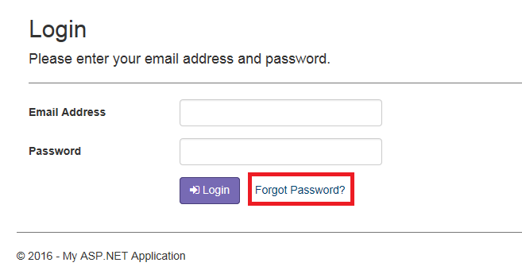
Forgot Password
When a user has forgotten their account password, the user can reset it on the Forgot Password page. Users can access the Forgot Password page by selecting the “Forgot Password?” link on the Login page. A user can complete the Forgot Password process by following the steps listed below:

Step 1: Select the “Forgot Password?” link on the Login page

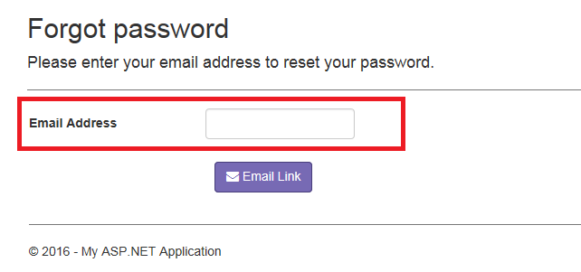
Step 2: Enter the email address associated to your account in the Email Address field

Step 3: Select the Email Link button to send yourself a reset password email

Step 4: Follow the URL provided in the email

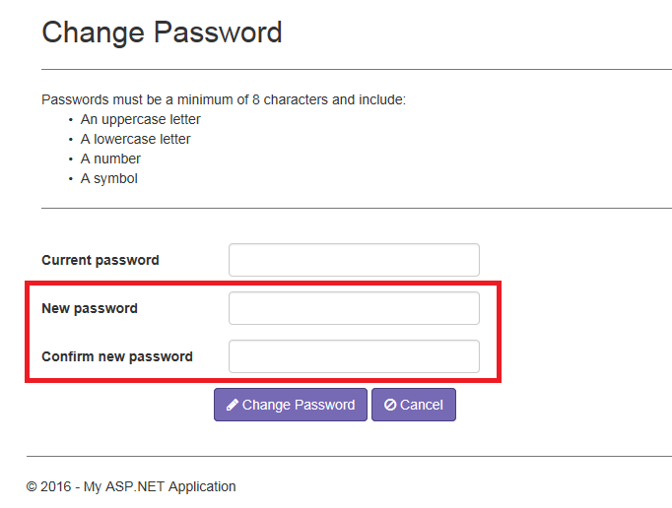
Step 5: Enter your new password in both the New Password and Confirm New Password fields. The new password must be different than your current password, be a minimum of 8 characters, and include:
- An uppercase letter
- A lowercase letter
- A number
- A symbol

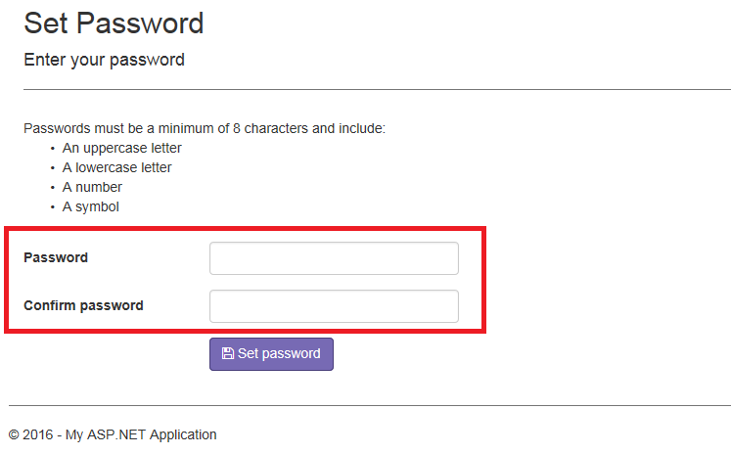
Step 6: Select the Set password button

Note: A user’s password will expire every 120 days. Upon login, a user with an expired password will be prompted to create a new one.

Change Password
When a user would like to change their account password, the user can do so on the Change Password page by following the steps listed below:

Step 1: Select the Change Password link on the Home page
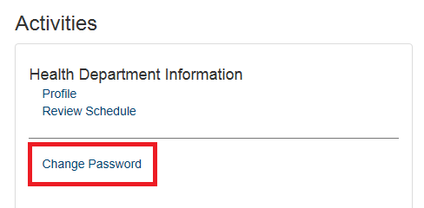

Step 2: Enter your current password in the Current Password field
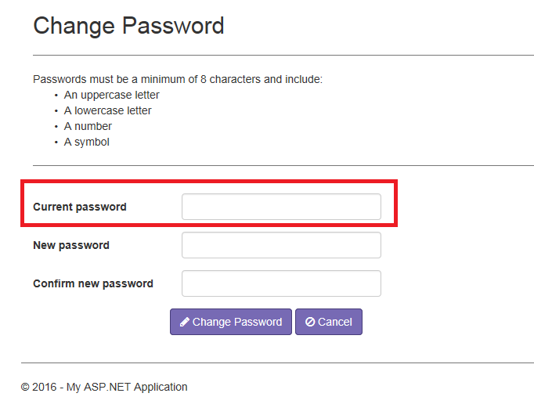
Step 3: Enter your new password in both the New Password and Confirm New Password fields. The new password must be different than your current password, be a minimum of 8 characters, and include:
- An uppercase letter
- A lowercase letter
- A number
- A symbol

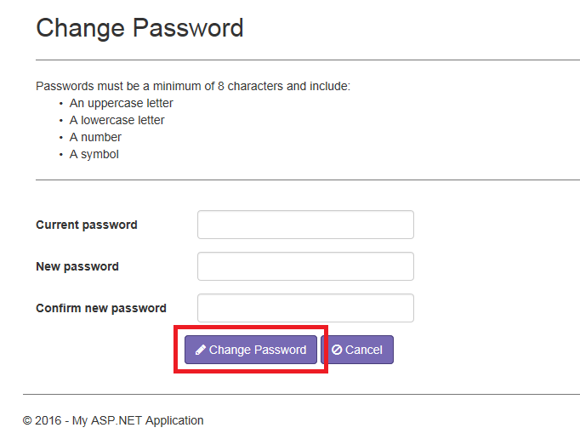
Step 4: Select the Change Password button

Note: A user’s password will expire every 120 days. Upon login, a user with an expired password will be prompted to create a new one.

5.3 Home Page
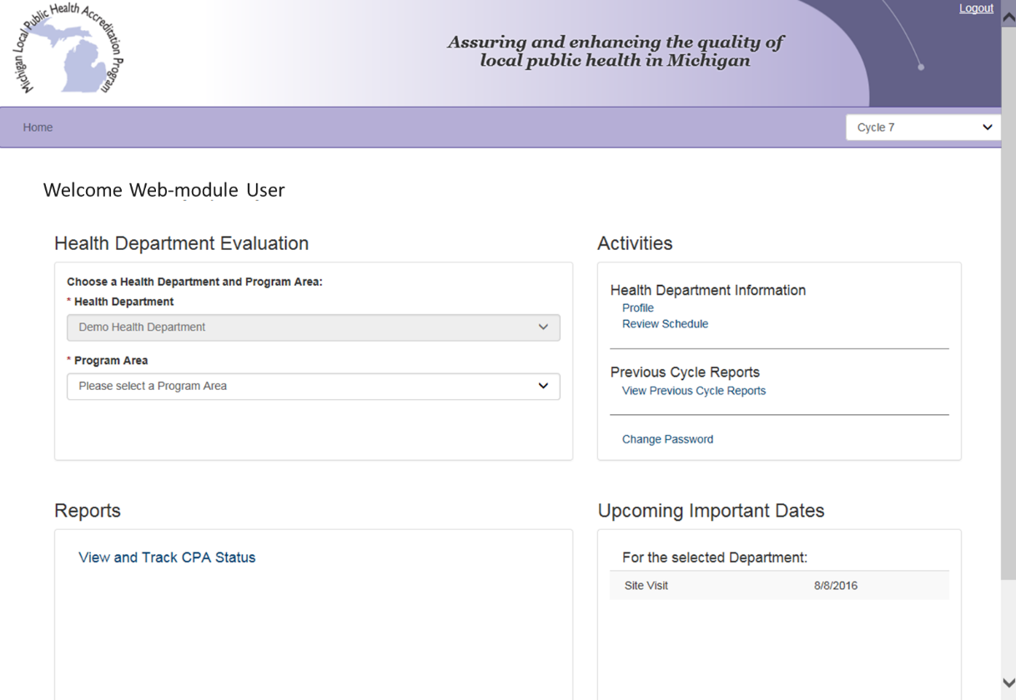
The Home page is the default landing page for users when they first log into the Accreditation Web Module. There are 4 sections on the Home page: Health Department Evaluation, Activities, Reports, and Upcoming Important Dates.

5.4 Submitting Pre-materials in the Accreditation Web Module
All local health department pre-materials are submitted via the Accreditation Web Module, including the On-Site Review Schedule, Exit Conference requests, and updating the LHD’s profile. Some programs require materials be sent in advance of the On-Site Review. Please see Appendix II – VI for further information.

Review Schedule
To enter your schedule, click the “Review Schedule” under the Activities menu on the Accreditation Web Module Home page. You will be taken to a screen that looks like this:
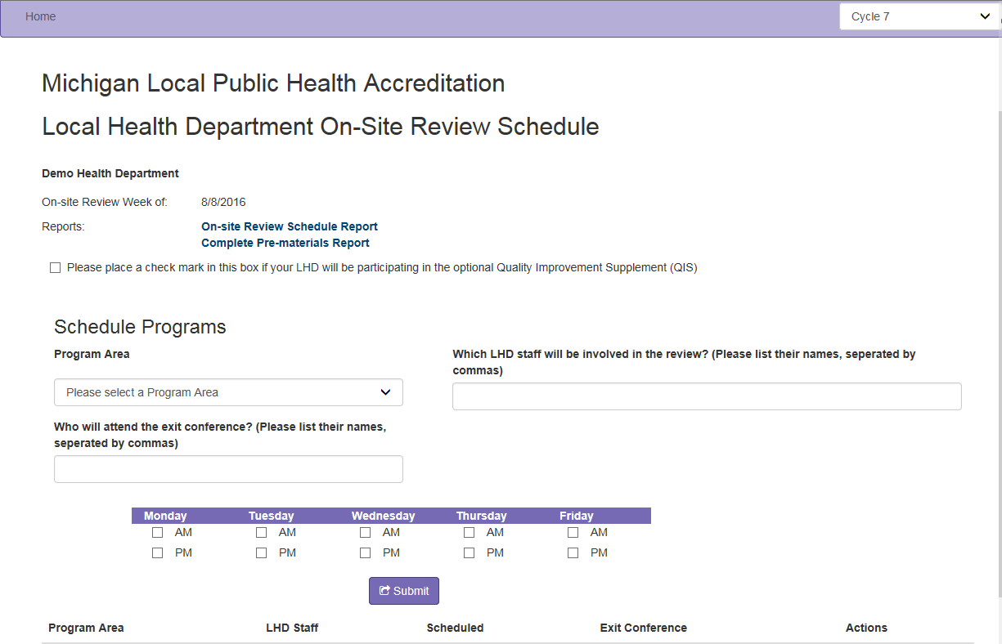
First, place a checkmark in the box on top of the page if your local health department will be participating in the optional Quality Improvement Supplement (QIS).

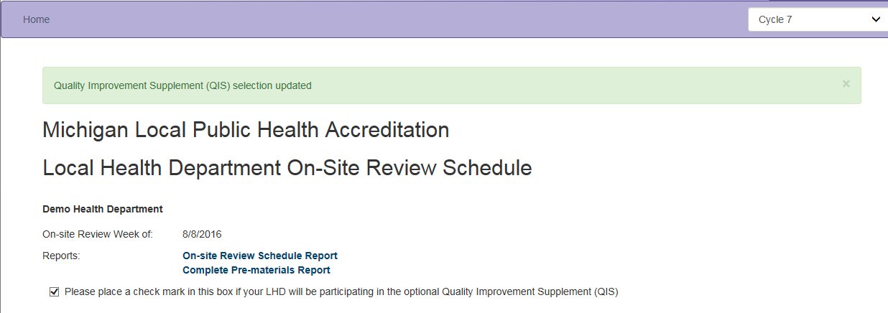

To schedule a program, choose the section you wish to schedule from the drop down box on the far left.

Once the program is selected, click in the box under “Which LHD staff will be involved in the review?” and enter names of the local health department staff who will be participating in the review. Then, choose the timeslots the program is to be scheduled (e.g., Monday AM, Friday PM, etc.) by checking the appropriate boxes. Refer to Appendix 1 for scheduling guidance.
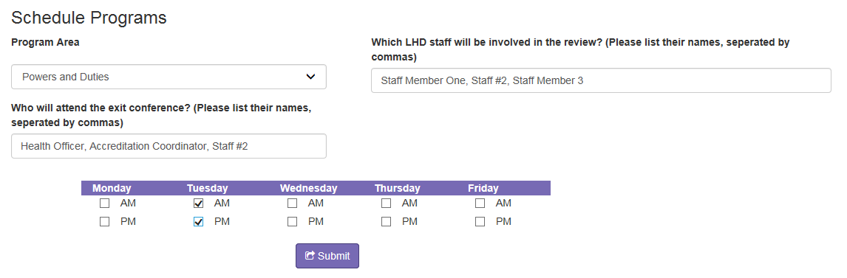

After you have made your selections, click the “Submit” button and the program will add to the schedule. Below the “Submit” button will be a table with the program Area, LHD staff, Scheduled, and Ext Conference information that has been submitted.

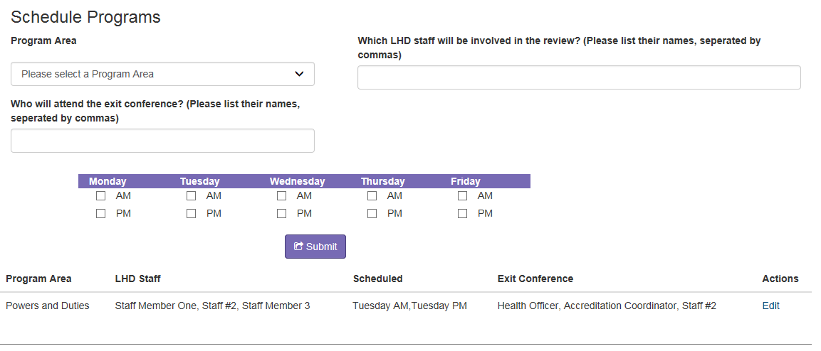

If you make a mistake in scheduling, you may click the “Edit” link under the Actions section to remove or edit an existing entry from the schedule.

Update your local health department’s contact information
To edit your local health department’s contact information, click the “Profile” link on the Home page.
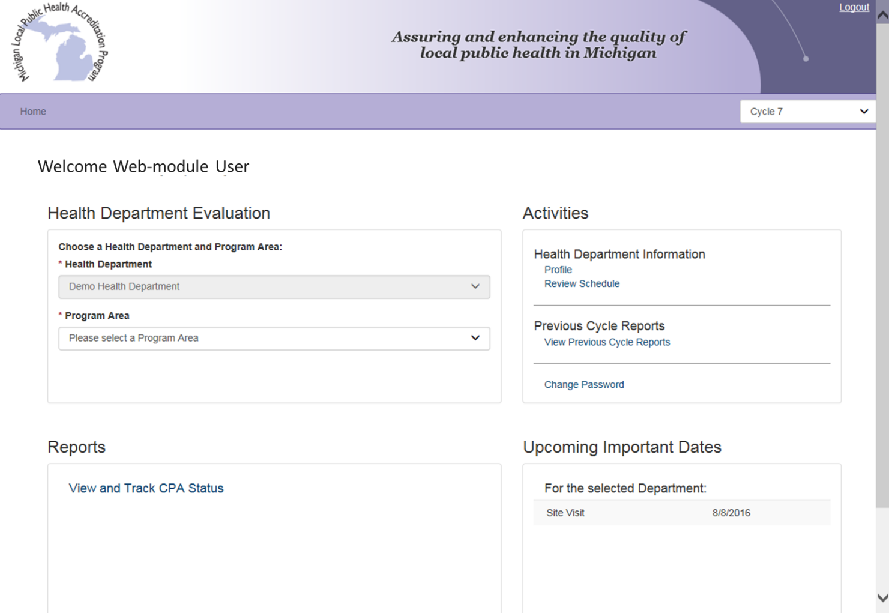

On the bottom of the Local Health Department Contact Information page, click the “Edit” button.
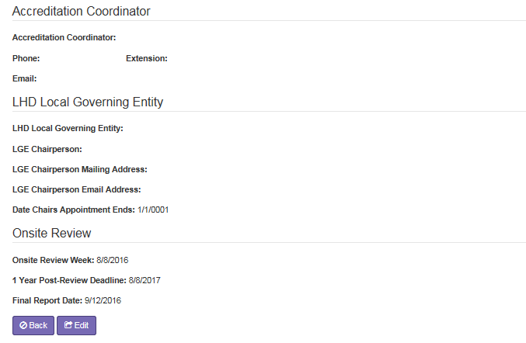

Clicking the “Edit” button will allow you to complete and update any information about your health department.

Local Health Department Contact Information – This section includes the Local Health Department’s name, address, phone number, and website.

Health Officer – The Health Officer section includes the Local Health Department’s Health Officer’s name, phone number, and email address.

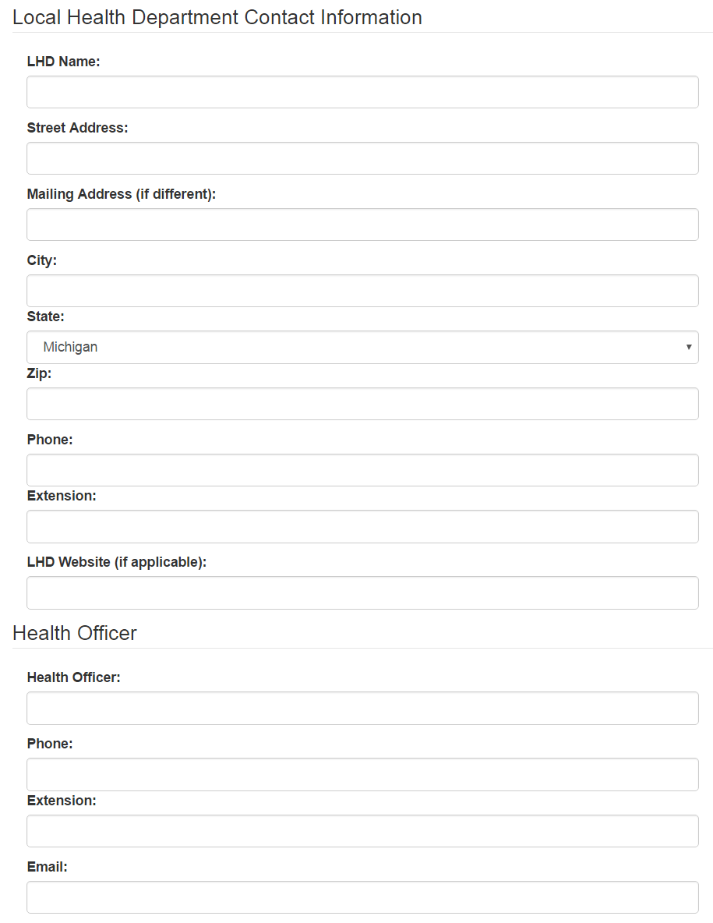

Accreditation Coordinator – The Accreditation Coordinator section includes the local health department’s Accreditation Coordinator’s name, phone number, and email address.

LHD Local Governing Entity – This section includes the local health department’s Local Governing Entity’s (LGE) name, the name of the LGE’s Chairperson, when the Chairperson’s appointment ends, and the Chairperson’s mailing and email addresses.

Onsite Review – The Onsite Review section lists important dates for the selected local health department. The date in the Onsite Review Week field indicates the first day of the week that the local health department’s On-Site Review will take place. The date in the 1 Year Post-Review Deadline for CPA Implementation field indicates the date Corrective Plans of Action (CPAs) are due, any re-reviews that are scheduled and CPAs need to be implemented by the local health department. The Final Report Date field indicates when the final report will be available for the local health department.
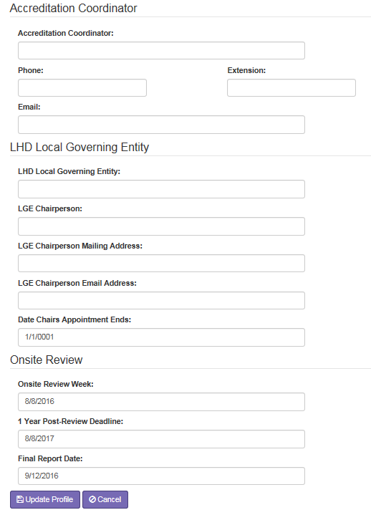

Once you have entered your local health department’s current contact information, click the “Update Profile” button.

The most crucial piece of information to capture accurately is the Accreditation Coordinator’s e-mail address, as this person will be receiving auto-generated e-mails from the website related to Corrective Plans of Action responses.

Completed pre-material reports
Once you have finished entering your pre-materials, MPHI staff will review them for accuracy of scheduling and contact you with any questions. MPHI staff will also add Reviewer names and contact information to the schedule and notify you once it is available for viewing. You will receive an automatic email when pre-materials are published.

To view the completed pre-materials, click the “Review Schedule” link on the Home page. On the Review Schedule page, click the “Complete Pre-materials Report” link to view a PDF of your health department’s pre-materials. If you wish to access a PDF of the schedule only, click the “On-Site Review Schedule Report” link.

5.5 Exiting the Accreditation Web Module
Important! A “Log Out” hyperlink is located at the bottom of the main local health department home page. We ask that you use this hyperlink to exit the Accreditation Web Module before closing your Internet browser. The reason for this again has to do with the nature of Web programming. When you simply close your Internet browser, the website cannot detect this type of exit and thinks that you are still logged in.

On-Site Review

6.1 What to Expect
Every local health department’s experience with the On-Site Review will be different, but if the local health department takes full advantage of all resources available to them during the Self-Assessment phase, the week-long review should progress smoothly.

6.2 Suggestions
- Spend your Self-Assessment period (and beyond) asking questions ask the; state agency reviewers, Technical Assistance Contact or MPHI. The more your local health department knows about the entire process, the better your On-Site Review experience.
- Providing food and/or beverages for reviewers during the On-Site Review is neither mandatory nor expected.
- Ensure the Reviewers meet with the local health department staff identified on the schedule. If the scheduled staff member becomes unavailable at the last moment, let either the Reviewer or MPHI know.
- Opening sessions on the first day of the week are not mandatory. Upon state agency Reviewer arrival, engage them in dialogue that will determine logistics during the On-Site Review, such as if local health department staff will be needed, what documentation may be required, etc.

6.3 Exit Conferences
If the local health department would like assistance in facilitating opportunities for program-specific Exit Conferences with state agency Reviewers, the following should be submitted with the other pre-materials using the Accreditation Web Module:
- Identify accreditation sections for which an Exit Conference is requested, and
- Identify, by name, local health department representatives to be included in the conference (e.g., Health Officer, Program Director, etc.). Local health department preferences will be communicated to state agency Reviewers before the On-Site Review.

6.4 The On-Site Review Report
Within 30 days from the last day of the week-long review, notification of the On-Site Review Report’s (OSRR) completion and access instructions are sent to the local health department (the Health Officer and/or the Accreditation Coordinator) and the local health department’s local governing entity chairperson.

6.5 Indicator Designations
Four designations may be utilized by Reviewers in evaluating indicators of the minimum program requirements (MPRs) for a given section:
- Met
- Not Met
- Met with Conditions
- Not Applicable

Met Designation
Indicators that are marked “Met” meet all of the necessary requirements as described in the guidance document.

Not Met Designation
Indicators that are marked “Not Met” do not fully meet all of the requirements as described in the guidance document. Local health departments that do not fully meet all requirements for a specific indicator must develop and submit a corrective plan of action (CPA) specifying actions to be developed and implemented in order to achieve the requirements for this indicator. If an indicator is not met, the Reviewer(s) are responsible for clearly and effectively communicating why the indicator is not met, providing a clearly articulated statement for the “Reason Not Met” field.

Once the health department enters their CPA into the Accreditation Web Module, and the Reviewer has evaluated the submitted information, the local health department will be notified if the plan of action is:
- Accepted, no further action required,
- Accepted with further action required, or
- Not accepted and will need to be resubmitted,

If further action is required, the type of action required will be dependent on the section and, state agency involved, and will be communicated to that local health department. (The state agency may conduct a follow-up review to verify implementation of the plan.) More information on the CPA process can be found in Section 8 – Corrective Plan of Action.

Not Applicable Designation
The “Not Applicable” status is used when an indicator is not applicable to a local health department, e.g., they do not participate in a component of the program being reviewed.

Please note: Important indicators should be marked only “Met” or “Not Applicable.” They may not be assessed as “Not Met” or “Met with Conditions”.

Met with Condition Designation
Each program has the option of awarding a “Met with Conditions” designation for an indicator reviewed during the accreditation process. This designation serves as an alternative to giving a Not Met when a minor, non-critical deviation is discovered in a review that does not warrant the preparation of a formal CPA. An explanation for the decision to mark an indicator “Met with Conditions”, will be included under the heading “Met with Conditions” on the On-Site Review Report.

The follow-up for each indicator given a “Met with Conditions” will occur at the next cycle review. If the indicator remains unmet by the next cycle review, it will be marked “Not Met”. However, at the Reviewer discretion, a “Met with Conditions” may be given on consecutive reviews when:
- An MPR/indicator has multiple elements
- The originally cited issue(s) has been corrected, and
- A different issue now results in a “Met with Conditions” rating

Due to the variation among the sections, state agencies conducting the Reviews, and varying program requirements, it is the responsibility of each program to clearly describe in their guidance document the criteria that will be used for designating an indicator “Met with Conditions”.

6.6 Program specific Met with Conditions language

LOCAL HEALTH DEPARTMENT POWERS & DUTIES
A designation of “Met with Conditions” for an indicator within the Local Health Department Powers and Duties Section (Section I) may be used at the discretion of the reviewer in cases where minor deviations exist. Any indicator marked “Met with Conditions” will be addressed during the Exit Conference and in the On-Site Review Report. Recommendations for improvement will be offered and must be implemented before the next accreditation cycle to prevent the subsequent designation of “Not Met.”

FOOD SERVICE PROGRAM
A “Met with Conditions” may be granted if the department overall meets the minimum program requirements, but occasionally minor deviations or clerical problems might indicate that the requirement is not met. Based on the requirements specified in the guidance document, a “Met with Conditions” may be given with the understanding that this MPR will be required to be met at the next scheduled evaluation. Failure to meet this indicator would result in a “Not Met”.

GENERAL COMMUNICABLE DISEASE CONTROL
A designation of “Met with Conditions” for an indicator within the General Communicable Disease Control Section will be used at the discretion of the Reviewer and based upon importance of the deviation. When multiple components are needed to fulfill an indicator and the deviation is determined to be a non-critical issue by the Reviewer (i.e., will not affect daily operations, investigations, or reporting of the LHD), the indicator will be marked as “Met with Conditions” and recommendations for improvement will be offered. Corrections to the indicator will need to be made before the next cycle to avoid being marked “Not Met”.

HEARING & VISION
A designation of “Met with Conditions” for an indicator within the Hearing and Vision Screening Programs may be used at the discretion of the Reviewer in cases where minor deviations that can be immediately addressed exist. This will be discussed at the Exit Conference and the local health department agrees that their current protocol may be changed immediately to reflect the written indicator. The change in protocol will be confirmed at the next accreditation On-Site Review.

IMMUNIZATION
A designation of “Met with Conditions” for an indicator within the Immunization Section may be used at the discretion of a joint consensus between the technical manager and the Reviewer in cases where minor deviations exist. All of the indicators under the individual Minimum Program Requirements in the Immunization Accreditation tool are associated with program requirements outlined in the Omnibus Reconciliation Act of 1993, section 1928 and Part IV- Immunizations, Sec. 13631, as well as requirements in the 2007 Vaccines for Children (VFC) Operations Guide; Immunization Program Operations Manual (IPOM, 2013-2017) and Michigan’s Resource Book for VFC Providers.

Indicators must be met in order for the program to be in compliance with the state and federal program requirements. Because some indicators require that report submissions are documented on designated dates, it is difficult to base compliance on a 90 consecutive day timeframe. In those cases, a “Met with Conditions” mark would apply until the next date for compliance arrives. At this point the LHD is expected to submit timely reports, or the indicator will result in a “Not Met”.

ONSITE WASTEWATER TREATMENT MANAGEMENT
The appropriateness and basis for granting of “Met with Conditions” will be communicated for each indicator in the guidance document. Where a “Met with Conditions” rating is awarded, the specific conditions required to be met at the next scheduled evaluation will be clearly communicated in the On-Site Review Report. Where specific conditions have not been satisfied at the time of the next review, a “Not Met” rating will result.

SEXUALLY TRANSMITTED DISEASE and HIV/AIDS
A designation of “Met with Conditions” for an indicator within the Sexually Transmitted Disease and HIV/AIDS programs will be used at the discretion of the Reviewer On-Site and based upon the significance of the deviation.

When multiple components are needed to fulfill an indicator and the components have not all been met, the indicator may be marked as “Met with Conditions” provided that the deviation is determined to be a non-critical issue by the Reviewer (i.e., will not affect daily operations, investigations, reporting of the local health department, or does not violate state law). When a “Met with Conditions” mark is being considered, it will be discussed with the Reviewer’s management prior to making this determination.

The Reviewer will state the rationale for this designation in the On-Site Review Report and recommendations for improvement will be clearly stated verbally and in the report. Any further action that is required will occur outside the Accreditation process and in conjunction with recurring quality improvement and program monitoring activities conducted by the state STD and HIV/AIDS programs. Corrections to the indicator will need to be demonstrated during the On-Site Review or scheduled within four weeks after the On-Site Review to avoid being marked “Not Met” or becoming a “Corrective Plan of Action.”

BREAST AND CERVICAL CANCER CONTROL NAVIGATION PROGRAM (BCCCNP)
Several indicators under individual Minimum Program Requirements are linked as part of the overall program evaluation, but due to the complexity of these indicators, they are evaluated separately. Ongoing quality monitoring of these indicators occurs on a yearly basis and are officially reviewed every three years as part of the Accreditation process. Agencies that do not meet indicator requirements (as outlined in the guidance document) but demonstrate development and/or implementation of a process/procedure to meet the indicator requirements will be marked “Met with Conditions.” The BCCCNP Reviewer will state the rationale for designating this indicator “Met with Conditions” in the On-Site Review Report. Any further action that is required will occur outside the Accreditation process and in conjunction with recurring quality improvement and program monitoring activities conducted by the state BCCCNP program.

FAMILY PLANNING PROGRAM
All of the indicators under the individual Minimum Program Requirements in the Family Planning accreditation tool are linked to program requirements as they appear in the Federal and State Title X Program Requirements (42 CFR Part 59, Subpart A). Family Planning Program Reviewers do not have the option of using a “Met with Conditions” designation, which would not assure correction of the failed requirement until the next review cycle (or an additional three years). Title X Guidelines require that programs are reviewed every three years for compliance with the guidelines.

WOMEN, INFANTS, AND CHILDREN (WIC)
A designation of “Met with Conditions” is not applicable for the WIC program.

CHILDREN’S SPECIAL HEALTH CARE SERVICES (CSHCS)
A designation of “Met with Conditions” for an indicator within the CSHCS program will be used at the discretion of the Reviewer On-Site and based upon the importance of the deviation. When multiple components are needed to fulfill an indicator and the deviation is determined to be a non-critical issue by the Reviewer (i.e., will not affect daily operations, investigations, or reporting of the LHD), the indicator will be marked as “Met with Conditions” and recommendations for improvement will be offered. Corrections to the indicator will need to be demonstrated during the On-Site Review at the next cycle to avoid being marked “Not Met”.

Reports
The Accreditation Web Module generates several reports following the On-Site Review. In order to access these reports, log in to the Accreditation Web Module and look under the Reports section.

7.1 On-Site Review Report
The On-Site Review Report shows the number of indicators that were Met, Not Met, and Not Applicable, broken down by Program Area.

7.2 Total Site Visit Report
Similar to the On-Site Review Report, the Total Site Visit Report shows the number of indicators that were Met, Not Met, and Not Applicable, broken down by Program Area, for the selected Health Department. The Total Site Visit Report also contains the Health Department Evaluation details, including the information entered on the Evaluation: Indicator Details page.

7.3 View and Track CPA Status
This report details the CPAs for your Health Department, allows you to view and track each Section CPA status, including MPRs and Indicator.

7.4 Sectional Status Report
The Sectional Status Report contains the Health Department Evaluation details for the selected Program Area, including the information entered on the Evaluation: Indicator Details page.

7.5 Section Summary Report
The Section Summary Report displays which indicators were Met, Not Met, and Not Applicable for the selected Program Area.

Corrective Plan of Actions (CPAs)
The Corrective Plan of Action (CPA) process provides a mechanism for program or service improvement. The plan estimates implementation time and designates a local health department contact.

Local health departments that do not fully meet all essential requirements must develop CPAs for missed indicators. When preparing CPAs, local health departments should use the Corrective Plan of Action form located on the Accreditation Web Module. A copy of this form (for reference only) can be found in Appendix VIIII.

The timeline for CPA implementation begins at the conclusion of the On-Site Review. CPAs must be entered into the Accreditation Web Module within 60 days of the end of the On-Site Review. As a result of Exit Conference, local health departments should be aware of missed indicators and can begin developing their CPA(s).

What to do
- Each indicator designated “Not Met” will require its own individual CPA form.
- Develop the plan with input from staff.
- Contact the Reviewer responsible for your review or state agency Technical Assistance Contact for the unmet indicator(s) as you develop your plan(s).
- Submit the plans online through the Accreditation Web Module. Submission of the CPA will require your Health Officer’s to login to the Accreditation Web Module using their health officer account. Once logged in, the health officer may make any final edits necessary to the form and then publish the form by clicking the “Publish” button.
- If local health department staff need assistance in developing Corrective Plan(s) of Action please contact the applicable section Reviewer(s).
- If you have additional materials that must accompany your CPA, please send them either via email or hard copy to your applicable section reviewer(s).
- The Corrective Plan(s) of Action must be fully implemented within 365 days of the last day of the On-Site Review.

8.1 Create/Edit a CPA in the Accreditation Web Module
To submit CPAs in the Accreditation Web Module, click on the “View and Track CPA Status” link from the local health department home page.

A list of missed indicators will appear and include the CPA status of “Draft”. To edit/create your CPA(s), Click the “Edit” link next to each indicator, under the CPA Form section.

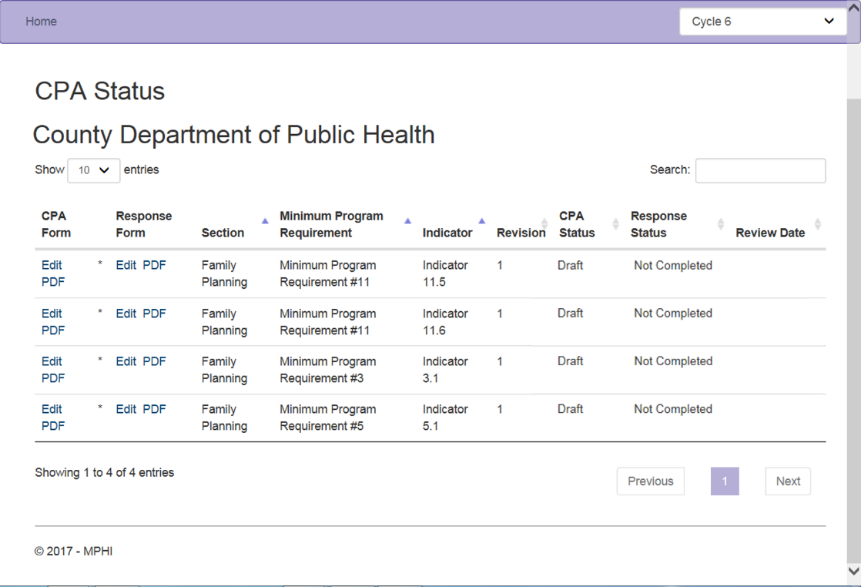

The Corrective Plan of Action Form page will open. On this page, you can edit/create your health departments CPA. On the top of the page includes Instructions and Guidance. Below will be the date of the CPA and your LHD Name. When the CPA is complete the Health Officer will key in their name and title.

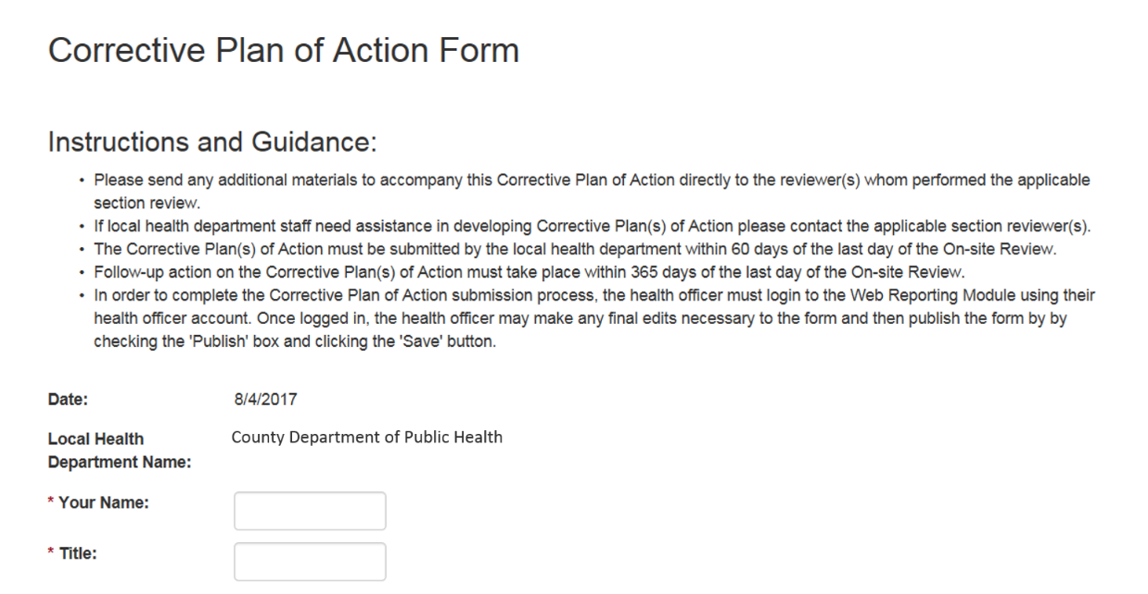

Next, key in the information of the correct LHD staff responsible for implementing the CPA. Include their name, title, phone number, and fax number. The Indicator Not Met and the Indicator Description will display.

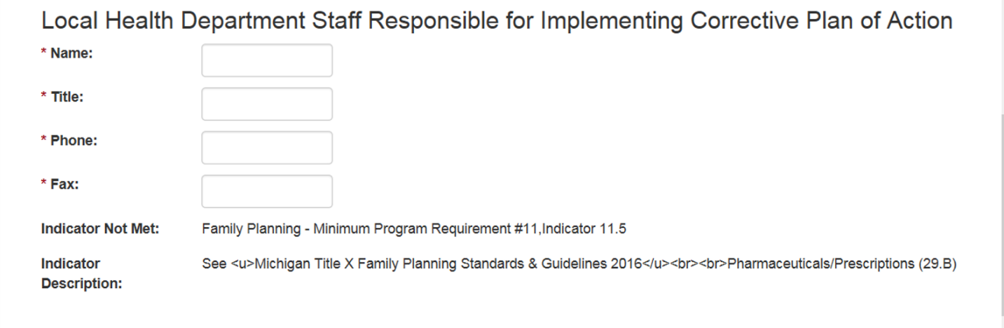

Fields to describe the CPA are available, including a projected completion date.

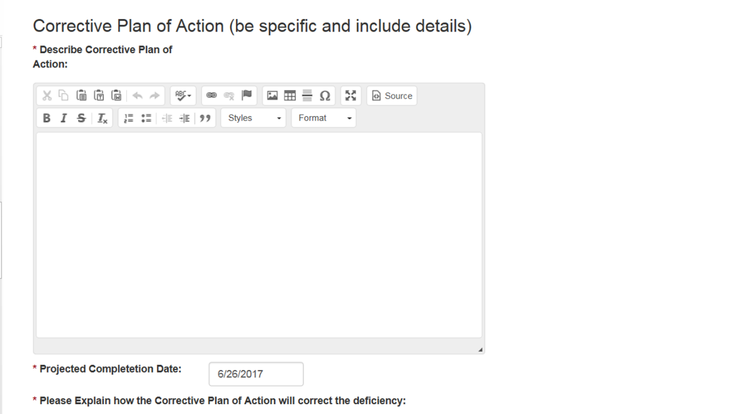

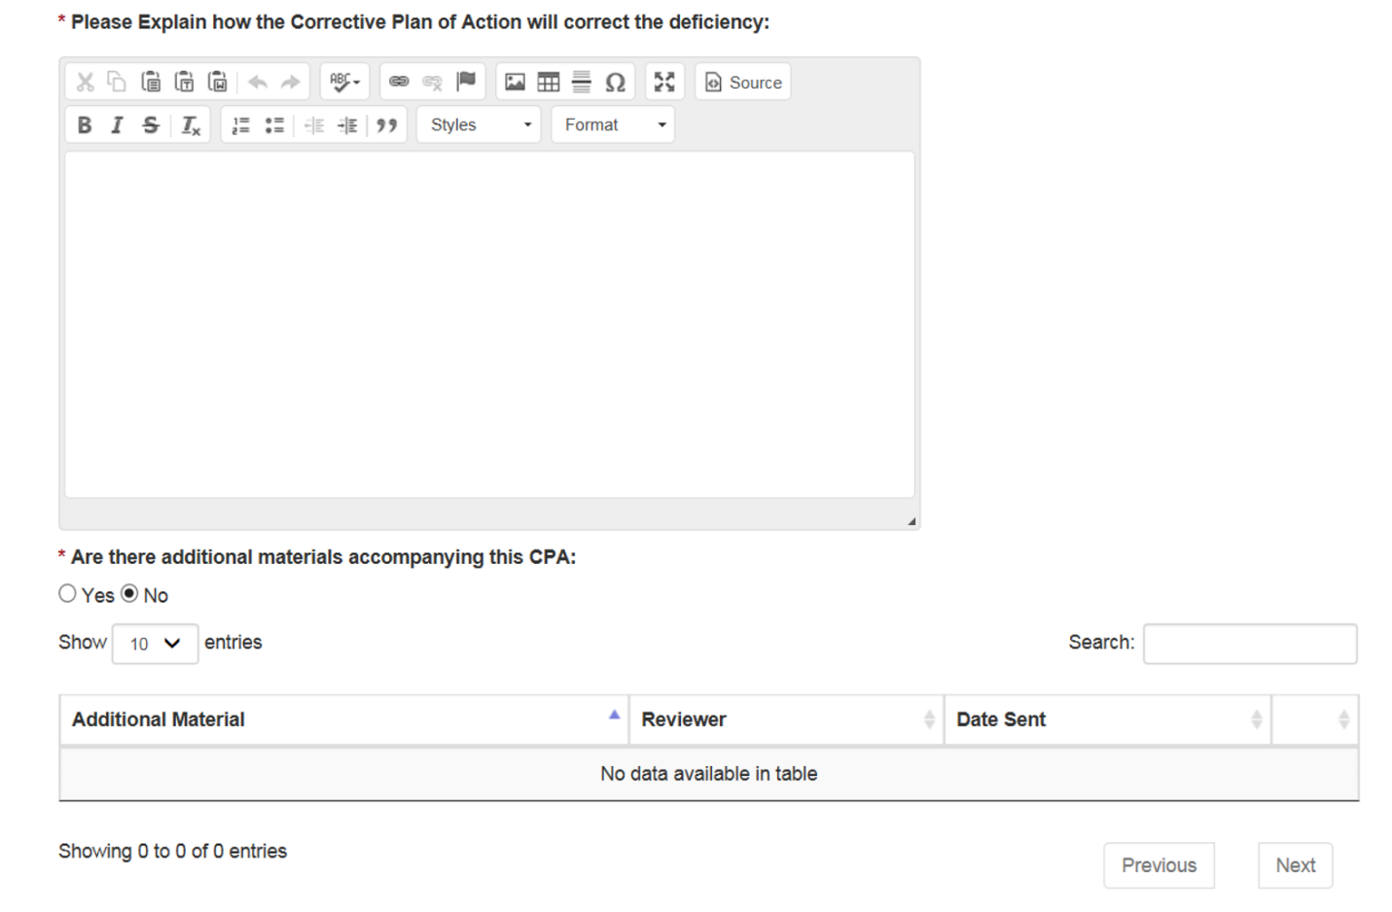
In the next section of the CPA Form, an explanation on how the CPA will correct the deficiency must be provided. In this section, you also have the ability to include additional materials that accompany the CPA.

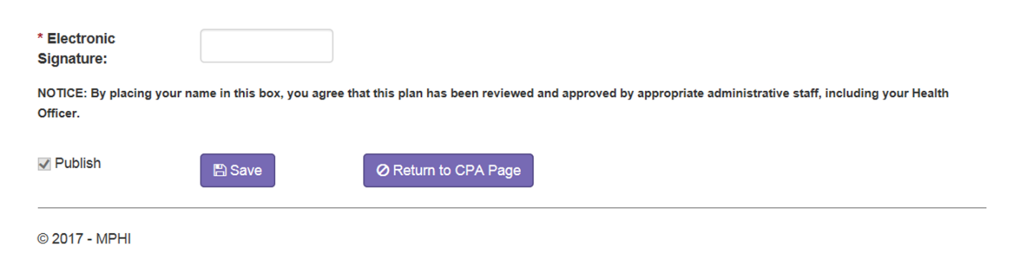
Finally, when the CPA Form is complete, an electronic signature is required. After the CPA is reviewed and ready to be submitted, check the “Publish” checkbox on the bottom of the page and click the “Save” button.

8.2 Next Steps
An automatic email will be sent to the appropriate state agency Reviewer(s). The state agency Reviewer(s) has 30 days from the local health department’s submission date to respond to the plan(s). The options for this response are as follows:

- Yes, with no further action required- This response is used when the local health department has proven compliance simply by CPA submission. This completes the CPA cycle for that indicator.
- Yes, with further action required- This response is used when the Reviewer requires either a site revisit or materials from the local health department. If materials are required, you will see a date by which they should be sent to the reviewer/program area. If your local health department requires a site revisit, you will see a date by which the site visit must be completed. There is also a text field labeled “Please detail actions necessary for compliance.” In this field, you will find any miscellaneous details that you need to know in order to prepare for compliance.
- No- This response is used when the CPA is not acceptable and must be re-submitted.

In the event CPA negotiation is ongoing between the state and local health department (and exceeds the day requirement), the local health department shall have the implementation period extended accordingly. Implementation of approved plans must be in place for ninety days from the date of state agency approval before a local health department may be considered for accreditation.

Please remember: ALL follow-up action after initial CPA response should be between the State agency program and the local health department. However, we ask that Reviewers update CPA responses as necessary to communicate either final sign off or that the local health department has further implementation action to complete.

Responses to CPAs may be viewed and tracked via the Accreditation Web Module. Click on the “View and Track CPA Status” link from the local health department home page. The CPA Status Page will appear and list every CPA associated with your LHD. The list includes the CPA Status, Review Date, and options to view the CPA Form and Response Form.
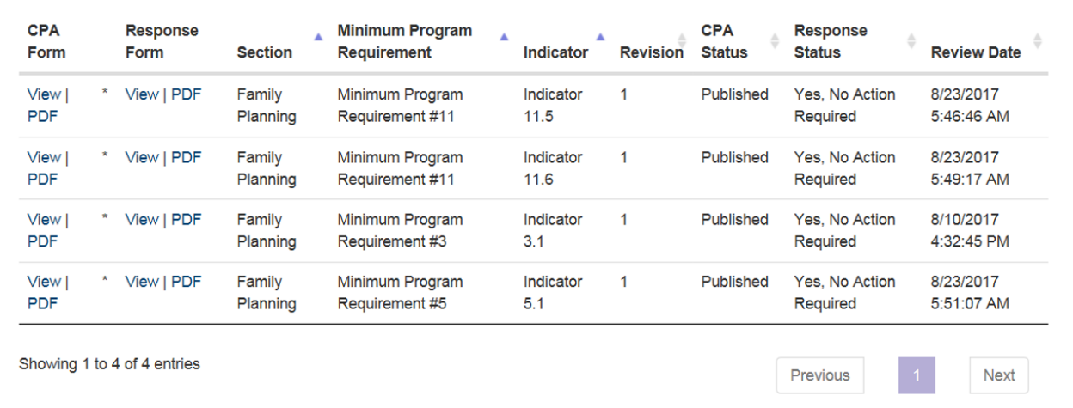

Procedure for Conducting Accreditation Re-evaluations of Local Health Departments

9.1 Purpose
To determine if a local health department has met the minimum program requirements (MPRs)
found to be “Not Met” during the initial accreditation evaluation.

9.2 Background
MLPHAP requires a local health department to request a re-evaluation for all MPR’s and
Indicator’s that were found to be “Not Met” between ninety days of the CPA approval date, and one year of the accreditation evaluation. Failure to request a re-evaluation within one year will result in “Not Accredited” status.

9.3 Policy/Procedure
  - The re-evaluation will assess only those MPR's and Indicator’s found to be “Not Met”
during the initial evaluation.
  - The re-evaluation will encompass the time period beginning with the implementation of the CPA.

9.4 Evaluation
The evaluation will review the following:
  - The deficiencies found in the original evaluation
  - The CPA
  - The action taken to resolve the deficiencies
  - Results of the action

9.5 Extension Policy
If it appears that the local health department will not meet the agreed upon timeframe for
implementation of a CPA(s), the local health department should contact the appropriate state agency as soon as the delay is evident. If necessary, the local health department may request an extension of the CPA implementation date, documenting the extenuating circumstances that threaten the ability to meet the original date. The local health department request must be approved by the local governing entity prior to submission to the appropriate state agency. The state agency will then seek concurrence from other relevant state agencies and has final authority for approval.

180 and 90 Day CPA Process Emails
In order to further facilitate the CPA process between the three state agencies and the local health department, CPA reminder emails will be sent 180 and 90 days prior to the local health department’s CPA implementation date if the agency still has outstanding CPAs. Emails will be sent by MPHI Accreditation staff with follow up response(s) required.

The following emails will be sent at the predefined CPA increments:

10.1 - 180 Day Email

To: Section Reviewer(s)
Cc: LHD Health Officer, LHD Accreditation Coordinator, Program Manager (at the state), and Local Health Services
Subject: Accreditation – Corrective Plan of Action

Hello Reviewer(s),

It has come to MPHI's attention that LHD Name has not completed the Corrective Plan of Action (CPA) process for the following CPAs:

Section:
Indicator:

We ask that you follow up with LHD Name regarding the above CPAs as soon as possible. At this point, the LHD has fewer than 180 days remaining to fully implement the CPAs prior to their 365 day CPA implementation date of date. If the LHD reaches their 365 day CPA implementation date and the above CPAs are not fully implemented, the LHD's Accreditation status will be at risk. If you have already scheduled a re-visit, please let us know the scheduled date of that visit.

If MPHI does not receive communication from you regarding the status of the above CPAs by day, date (3 days from now), the LHD's Health Officer, LHD Accreditation Coordinator, and your supervisor will be contacted to facilitate timely resolution of this matter.

I look forward to hearing from you very soon. Should you have any questions, please don't hesitate to contact me via email or by phone at (517) 324-8387.

Thank you,
Jessie Jones

10.2 - 90 Day Email
To: LHD Health Officer & Accreditation Coordinator
Cc: Section Reviewer(s), Program Manager(s) (at the state), and Local Health Services
Subject: Accreditation - Critical Status

Hello LHD Health Officer and Accreditation Coordinator,

It has come to MPHI’s attention that LHD Name has not completed the Corrective Plan of Action (CPA) process for the following CPAs:

Section: [Program Name]
Indicators: [MPRs and Indicators]

We see from our records that there is further action required before the CPA process for these MPRs is complete. At this point, LHD Name has fewer than 90 days remaining to fully implement these CPAs, including any follow-up visits needed, prior to your 1 Year Post-Review Deadline date. This means that your LHD is fewer than ninety days away from receiving Not Accredited status.

We ask that you communicate with your applicable section reviewers at the state and reply to this email by date, 2 business days from now letting us know of the status of the above CPA and the plan to complete it.

Should you have any questions, please don’t hesitate to contact me via email or by phone at (517) 324-8387.

Thank you,
Jessie Jones

Accreditation Review Evaluation
Following Cycle 1 an ad hoc subcommittee of the Accreditation Commission, known as the
Accreditation Quality Improvement Process (AQIP) workgroup implemented a survey with local health departments as part of an evaluation of the Accreditation program. The AQIP survey produced 44 recommendations to improve the Accreditation process. One of these recommendations identified the need to incorporate a review evaluation component. Feedback from the participants will be used to determine if concerns expressed in the AQIP survey are being addressed. The data will help to identify training needs and aspects of the review process that may require improvement.

11.1 Procedure & Results
- A copy of the Accreditation Review Evaluation form is included in Appendix VIII.

- The survey is completed online, and can be found at this link: https://www.surveymonkey.com/r/QZGVYSH. One survey should be completed per section reviewed after the results of the On-Site Review have been retrieved. Regardless of how many individuals participated in the review, only one form per program is required.

De-identified evaluation results will be shared with the Accreditation Commission and state agency program managers.

Accreditation Commission
Results from local health departments’ On-Site Reviews are presented to the Accreditation
Commission at the first Commission meeting after the health department’s On-Site Review Report is finalized. These meetings occur four times per year, on the second Thursday of January, March, June, and September.

12.1 Initial Commission Review
A local health department retains its official Accredited status from one cycle to the next until
the Michigan Departments of Health and Human Services, Agriculture and Rural Development, and Environmental Quality effect a subsequent decision pursuant to recommendations by the Accreditation Commission. The initial presentation that occurs to the Commission once the On- Site Review is complete is simply to inform the Commissioners of the local health department’s progress. No action is taken at this time. Please see Section 13 – Becoming Accredited – What’s Next for subsequent steps.

12.2 Inquiry Policy
Local health departments that disagree with On-Site Review findings or their Accreditation
Designation may request an Inquiry. If the findings in question relate to Reviewer findings, as opposed to the Accreditation status designation, the local health department is encouraged to first contact the Reviewer to seek a resolution before submitting in writing a request for an Inquiry. The first opportunity for this to occur is at the Exit Conference. However, the Inquiry may be submitted at any time during the three year accreditation cycle.

The purpose of the Inquiry is to convene the local health department and relevant state agency with a third party (Accreditation Commission Chair) to share information, discuss the issue and reach agreement.

If a mutually agreeable solution is not reached during this meeting, the Accreditation Commission Chair will render a decision in the form of a recommendation to the state agency with copies to the local health department. In all cases, final disposition is the responsibility of the state agency responsible for the program under question.

To begin the process, the local health department submits in writing a request for Inquiry with a short explanation that concisely describes what findings occurred and their reasons for taking exception to those findings. The request concludes with the local health department recommending an alternative finding. The request is submitted to the Chair of the Accreditation Commission, and in the case of an Inquiry for an On-Site Review finding(s), copies are sent to the state agency that performed the On-Site Review.

Within two weeks of receipt of the Inquiry request, the state agency that made the original findings will submit to the Accreditation Commission Chair a written summary of their rationale for the findings and an explanation as to why the local health department’s position is not supportable.

Two weeks from receipt of the state agency written summary, the Chair of the Accreditation Commission will convene a meeting (usually by telephone) of the local health department and the state agency(s) involved, plus the MPHI Accreditation Coordinator and a representative from the lead state agency, Health and Human Services. Both the local health department and state agency(s) will present their positions to the Chair. If consensus cannot be reached by all parties during this meeting, within 5 business days the Chair will provide a recommendation and advise both the local health department and state agency(s). In all cases the decision to act upon the Accreditation Commission Chair’s recommendation is up to the involved state agency(s).

Additional actions subsequent to the Inquiry shall be by and between the local health department and state agency(s) only.

Becoming Accredited – What’s Next
Once a local health department has completed the On-Site Review and subsequent CPA process,
the local health department has met the requirements to be recommended for Accreditation. The CPA implementation results are then shared with the Commission at its next quarterly meeting for recommendation to the Michigan Departments of Health and Human Services, Agriculture and Rural Development, and Environmental Quality for approval.

Immediately following the Commission’s recommendation, a letter determining the local health department’s status is then produced by the Director of the Michigan Department of Health and Human Services on behalf of the Directors of the Michigan Departments of Agriculture and Rural Development and Environmental Quality. The letter is sent to the local health department health officer and the chairperson of the local governing entity. A certificate of Accreditation accompanies the letter sent to the local health department.

13.1 Accreditation with Commendation
A local health department is eligible for Accreditation with Commendation when it:
- Meets 95%, cumulatively, of the Essential Indicators within the Minimum Program Requirements during the On-Site reviews for the Powers and Duties and seven (7) mandated services* sections, and
- Misses not more than two (2) indicators in each of the programs cited above, and
- Has zero (0) repeat missed indicators from the previous cycle in each of the included programs, and
- Meets 80% of the Minimum Program Requirements in the Quality Improvement Supplement within the Powers and Duties Section.
- The seven mandated services sections include: Food Service Sanitation, Communicable Disease, Hearing, Immunization, Sexually Transmitted Disease, Onsite Wastewater, and Vision.

13.2 Next steps
It is suggested that local health departments consider taking the following actions upon becoming
Accredited:
- Congratulate staff (breakfast/lunch, reception just for staff, etc.).
- Communicate effort/achievement to local governing entity (invite them to award ceremony, special presentation/update at regular meeting, or call a special meeting to announce).
- Inform the community: media (newspaper(s), local news, public, and newsletters). Include in local health department marketing efforts Accreditation designation; include designation as a tagline on pamphlets and letterhead, multiple certificates for multiple offices, etc.

Appendix I: Scheduling Guidance

- Section I (Local Health Department Powers and Duties) is a one day review, scheduled on Mondays. . The optional Quality Improvement Supplement (QIS) is reviewed remotely.

- Section III (General Communicable Disease) will be reviewed remotely. Please to be sure to indicate a day and time for the reviewers to contact your health department to discuss their review of your materials. Your Reviewer will verify the day and time selected prior to conducting the Exit Conference.

- Section IV (Hearing) as a single half-day review. Please schedule separately from Vision, if possible. Please avoid scheduling this review on Fridays.

- Section V (Immunization) schedule one day for the review at the main local health department clinic (no visits to off-site clinics) on a day when the IAP Coordinator and Immunization Clerk are available for interaction with the Reviewer.

- Section VI (Onsite Wastewater Treatment Management) requests a minimum of two (2) days for the review of a single county health department. District health departments typically require additional days. Consultation with the Reviewer is suggested for confirmation of the actual number of days that are needed to complete the review.

- Section VII (HIV/STD) requests one day for the review of a county health department. If the Reviewer and health department agree on a remote review, at the Reviewer discretion, only a half-day is needed. Please avoid scheduling this review on a Friday.

- Section VIII (Vision) is a single half-day review. Please contact the Reviewer to arrange for scheduling of the site visit prior to completing the Review Schedule in the Cycle 7 Web Module.

- Section IX (Breast and Cervical Cancer Control Navigation Program) will be reviewed remotely. Please to be sure to indicate a day and time for the Reviewers to contact your health department to discuss their review of your materials. Please avoid scheduling this review on Thursday or Friday.

- Section X (Family Planning Program) is a two-day review. Please schedule a family planning clinic on the first day of the review. Agencies should schedule a full clinic with a variety of visit types, especially initial, annual, and adolescent visits.

- Section XII (Children’s Special Health Care Services) Please avoid scheduling on the fourth Thursday of the month.

Michigan Local Public Health Accreditation Program Tool 2018
Users’ Guide

SECTION | TIME  REQUIRED
Section I – Local Health Department Powers and Duties and optional Quality Improvement Supplement (if applicable) | 1day
Section II – Food Service Sanitation Program | 5 days
Section III - General Communicable Disease Control | ½ day Reviewed remotely
Section IV – Hearing | ½ day
Section V – Immunization | 1 day
Section VI – Onsite Wastewater Treatment Management | 2 days
Section VII – HIV/AIDs and Sexually Transmitted Disease | 1 day (½ day if Reviewed remotely)
Section VIII – Vision | ½ day
Section IX – Breast and Cervical Cancer Control Navigation Program | ½ day Reviewed remotely
Section X – Family Planning | 2 days
Section XI – Women, Infant, and Children (WIC) | N/A – no on-site review required
Section XII – Children’s Special Health Care Services (CSHCS) | 1 day

Appendix II: Quality Improvement Supplement Specific Guidance

Quality Improvement Supplement (QIS) Review Process
The Quality Improvement Supplement (QIS) to the Powers and Duties review was revised at the beginning of Cycle 6 of the Michigan Local Public Health Accreditation Program to better align with Domain 9 of the Public Health Accreditation Board (PHAB) national public health accreditation program. If a local health department (LHD) indicates in their pre-materials that they are planning to participate in the QIS, documentation must be submitted ahead of time.

Local health departments (LHDs) participating in the QIS must submit documentation related to the QIS two weeks prior to their scheduled On-Site Review. All documents need to be emailed to Jessie Jones (jjones@mphi.org) and Jeanette Ball (jball@mphi.org) at the Michigan Public Health Institute (MPHI). Please complete the cover sheet included below in order to identify which documents are intended to fulfil which indicator. Please also provide the name and contact information of a staff member who MPHI staff can contact with any questions. MPHI staff will review documentation within one week and send back any questions.

Once all questions have been answered, MPHI will finalize their recommendations and provide them to Local Health Services staff prior to the On-Site review. MPHI will also participate in the LHD’s On-Site review and/or exit conference via conference call or in person.

QIS Documentation
Below is a list of required documentation for the QIS review:

Indicator 1.1: Staff at all organizational levels are engaged in establishing and/or updating a performance management system.
  - Documentation that the agency leadership is engaged in setting a policy for and/or establishing a performance management system for the department, for example: strategic and operational plans; training agendas; meeting agendas, packets, materials, and minutes; draft policies or items discussed with the governing entity, and/or presentations to the governing entity.
  - Meeting agendas, materials, minutes, orientation materials, and/or plans that show staff at all levels are engaged in determining the nature of a performance management system for the department and implementing the system.

Indicator 1.2: The agency has adopted a department-wide performance management system.
  - A written description of the department’s adopted performance management system that includes:
    - Performance standards, including goals, targets, and indicators, and the communication of expectations.
    - Performance measurement, including data systems and collection.

    - Progress reporting including analysis of data, communication of analysis results, and a regular reporting cycle.
    - A process to use data analysis and manage change for quality improvement (QI) toward creating a learning organization.

Indicator1.3: The agency has implemented a performance management system.
  - Agendas, minutes, reports, or protocols from the performance management committee or team.
  - Documentation identifying goals and objectives included in the performance management system, with identified time frames for measurement.
  - Documentation showing how the agency actively monitors performance toward stated goals and objectives.
  - Documentation of how the agency identifies areas for improvement through analysis of performance management data.
  - Documentation of next steps taken when areas for improvement were identified.
  - A completed performance management self-assessment that reflects the extent to which performance management practices are being used.

Indicator 1.4: The agency systematically assesses customer satisfaction with agency services and makes improvements.
  - Description or policy regarding how the agency collects, analyzes, and uses customer/stakeholder feedback.
  - Examples of instruments to collect customer/stakeholder satisfaction including forms, surveys, focus groups, or other methods.
  - Report, memo, or other written document describing how the agency has used results and actions taken based on the collection, analysis, and conclusions drawn from feedback from customer groups.

Indicator 1.5: The agency provides opportunities for staff involvement in the department’s performance management.
  - Documentation of agency staff participation in performance management training.

Indicator 2.1: The agency has established a QI program based on organizational policies and direction.
  - Agency QI Plan, including:
    - Key quality terms
    - Current and desired future state of quality in the organization
    - Key elements of the QI effort’s structure (group or committee, membership, roles and responsibilities, etc.)
    - QI training available and conducted

    - Project identification, and how it is aligned with department’s strategic direction and performance management plan o QI goals, objectives, and measures with time- framed targets
    - How the plan is monitored and evaluated o How QI efforts are communicated

Indicator 2.2: Engage local governing entity in establishing organizational policies and direction for implementing QI.
  - Local governing entity meeting agenda and minutes discussing establishment of QI policies and direction for implementation within agency.

Indicator 2.3: The agency has implemented QI activities.
  - Evidence of QI Plan implementation.
  - Evidence of implementation of QI activities and the agency’s application of its process improvement model.

Indicator 2.4: Assure QI training and technical assistance are available to staff.
  - Copies of QI training agenda, training materials and attendance roster.
  - Evidence of staff availability for QI projects or an external consultant and how they provide employee QI technical assistance.

For Questions
If you have any questions or need further information, please contact Jessie Jones at jjones@mphi.org or 517-324-8387, or Jeanette ball at jball@mphi.org or 517-324-6019.

QIS Cover Sheet Staff Contact Information
Please provide contact information for the person who should be contacted with any questions
regarding the QIS:
Name:
Email:
Phone Number:

MPR 1: Use a performance management system to monitor achievement of organizational objectives

Indicator | File name | Policy Title/ specific page  numbers that address the  indicator
Indicator 1.1
Staff at all organizational levels are engaged in establishing and/or updating a performance management system.

Indicator 1.2
The agency has adopted a departmentwide performance management system.1
Indicator 1.3
The agency has implemented a performance management system.2
Indicator 1.4
The agency systematically assesses customer satisfaction with agency services and makes improvements.
Indicator 1.5
The agency provides opportunities for staff involvement in the department’s performance management.

MPR 2: Develop and implement quality improvement processes integrated into organizational practice, programs, processes, and interventions

Indicator | File name | Policy Title/ specific page  numbers that address the  indicator
Indicator 2.1
The agency has established a QI program based on organizational policies and direction.
Indicator 2.2

Engage local governing entity in establishing organizational policies and direction for implementing QI.
Indicator 2.3
The agency has implemented QI activities.
Indicator 2.4
Assure QI training and technical assistance are available to staff.

- Or is in the process of adopting a department-wide performance management system.
- Or has plans for implementing a performance management system that incorporates the stated requirements.

Appendix III: Communicable Disease Control Specific Guidance

General Communicable Disease Control Remote Accreditation Guidance
Overview
Starting with accreditation Cycle 5, the Section III: General Communicable Disease Control will be conducted via an off-site remote accreditation process. The communicable disease accreditation team is asking local health departments (LHD) to upload all Section III related documents to the MiHAN for the remote accreditation. This will allow a standard system for sharing files during the accreditation process.

The Document Center on the MiHAN has folders for each of the LHDs in Michigan. Within the folder for each LHD there is a folder entitled “LHD name CD Accreditation”. Access is restricted to only those local and state personnel who have been given permission to view the documents within the folder.

In the Accreditation folder on the HAN you will find the “Accreditation Evidence Crosswalk” document. Please complete this document and post it back to the folder as it directs the Reviewer through your evidence. This ensures all documents you feel provide support for a specific MPR/indicator are reviewed. Please post all supporting materials and the completed Crosswalk document to the accreditation folder no later than 8 A.M. on the morning of your scheduled Section III: General Communicable Disease review date. The Reviewer conducting your evaluation will contact you prior to the week of your accreditation to schedule a conference call Exit Conference, if one is requested.

If at any time you have questions or difficulty with the process, please contact the reviewer assigned to your department’s accreditation.

Items to include in the Accreditation folder
Please refer to the Section III MPRs and indicators for specific suggested/required materials and documents to be placed in the folder as evidence. Provided evidence should include:
  - Completed Accreditation Evidence Crosswalk document
  - Electronic copies of all communicable disease policies, procedures, and protocols as specified in the Section III tool
  - Electronic weekly MDSS line lists with documented review and approval (or other electronic logs – e.g., an Excel workbook)
  - Electronic copies of the annual reports, formal summaries, or website address where 3 years of communicable disease trend data is maintained
  - List of stakeholders receiving the annual report or formal summary
  - Electronic versions of quarterly updates or newsletters (Special Recognition)
  - A list of all disease specific protocols maintained by the LHD and 3-5 representative samples of these protocols
  - A sample of 3-5 outbreak summaries for investigations conducted during the previous 3 years
  - A sample of 3-5 fact sheets, educational materials, or guidance documents used by the LHD
  - Electronic copies of presentations given at educational venues (Special Recognition)
  - List of current and up-to-date reference materials maintained by the LHD
  - Logs of professional development activities (CEU, CME, or contact hours) for at least the CD Supervisor and one other CD Nurse during the previous 3 years.
  - Signature pages that represent internal review and approval for all policies, procedures, and protocols

Retrieving a document from the HAN CD Accreditation Folder

- Log on to MiHAN (https://michiganhan.org)
- Select ‘Document Center’ at the top of the page
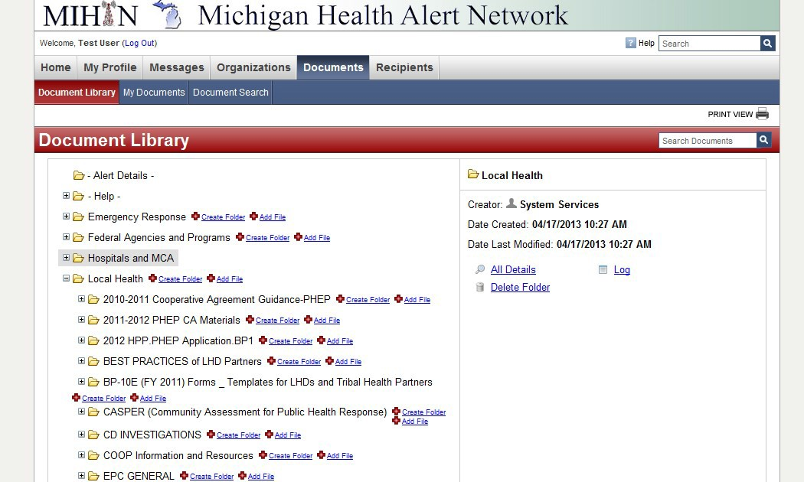
- Select ‘LOCAL HEALTH’ folder

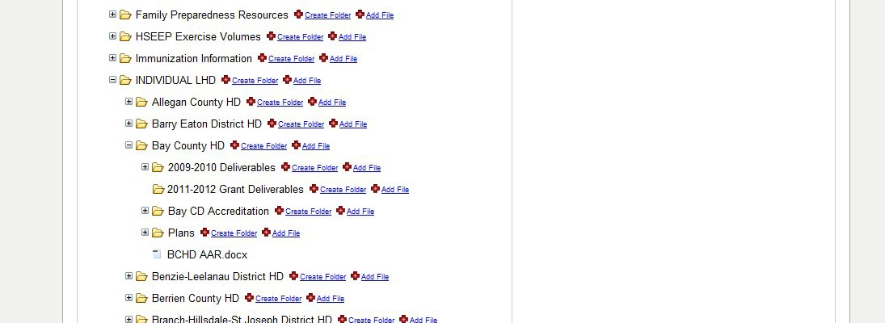
- Select ‘INDIVIDUAL LHD’ folder
- Select your local health department
- Select the folder LHD name CD Accreditation
- Select the document you would like to access

Uploading a document to the HAN CD Accreditation Folder

- Log on to MiHAN (https://michiganhan.org)
- Select ‘Document Center’ at the top of the page
- Select ‘LOCAL HEALTH’ folder
- Select ‘INDIVIDUAL LHD’ folder
- Select your local health department 6. Select the folder LHD name CD Accreditation
- Click on the “Add File” icon.
- If you choose to upload a single document at a time you see the following screen
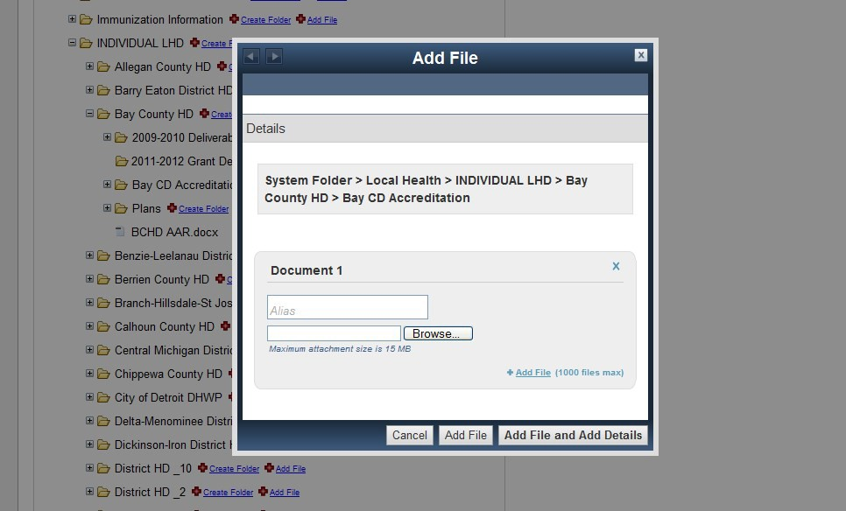
  - Click on the Browse button to search your computer files
  - Once the document is found, select “Add File”

- If you choose to upload multiple documents:
  - Select ‘Add File (1000 files max)’
  - Repeat this process for as many files as you wish to upload.
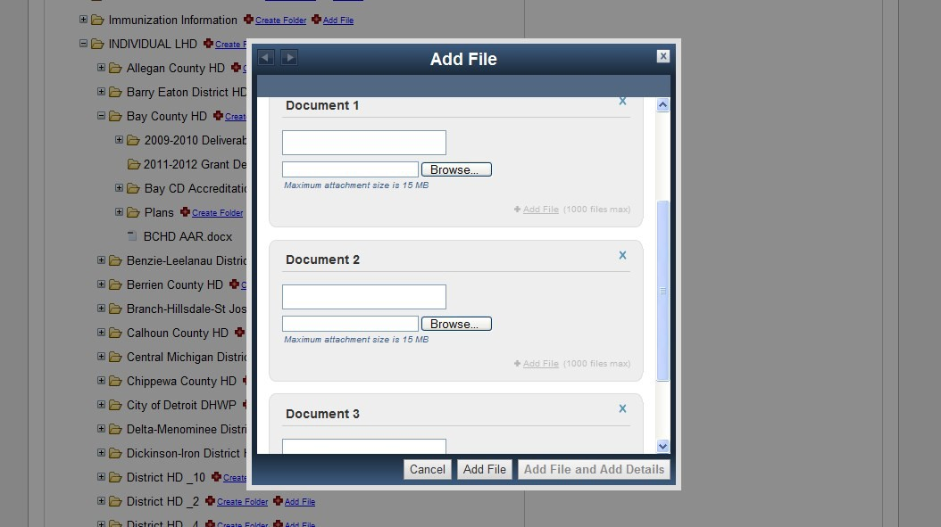
  - When all of the files you wish to upload have been selected click on “Add File.

General Communicable Disease Control Accreditation Evidence Crosswalk
Please complete this document prior to the scheduled review date and post back to your folder on the MiHAN. Completion of this document is important for making the connection between the specific indicator and the supporting documents.

MPR 1
The local health department must have a system in place that allows for the referral of disease incidence and reporting information from physicians, laboratories, and other reporting entities to the local health department.
Indicator | File name / web address LHD  is submitting as evidence for the indicator | Policy title / specific page  numbers that address indicator
Indicator 1.1
The local health department shall maintain annually reviewed policies and procedures.
Indicator 1.2
The local health department collects, collates, and analyzes communicable disease surveillance data that is reported to their jurisdiction by physicians, laboratories, and other authorized reporting entities.
Indicator 1.3  The local health department electronically submits communicable disease cases and case report forms (PDF forms) that are complete, accurate, and timely to MDHHS by utilization of the Michigan Disease Surveillance System (MDSS).  Note: A random sample of case reports will be pulled out of MDSS by the reviewer no additional information is required for this indicator. | Not Applicable | Not Applicable
Indicator 1.4
The local health department shall create an annual report (or formal summary) that includes aggregate communicable disease data for dissemination throughout the local health department’s jurisdiction.

MPR 2
The local health department shall perform investigations of communicable diseases as required by Michigan law.

Indicator | File name / web address LHD is submitting as evidence for the indicator | Policy title / specific page  numbers that address indicator
Indicator 2.1
The local health department shall maintain annually reviewed policies and procedures.
Indicator 2.2
The local health department shall initiate communicable disease investigations as required by Michigan laws, rules, and/or executive orders.
Indicator 2.3
The local health department shall notify MDHHS immediately of a suspected communicable disease outbreak in their jurisdiction.

MPR 3
The local health department shall enforce Michigan law governing the control of communicable disease as required by administrative rule and statute.

Indicator | File name / web address LHD is  submitting as evidence for the indicator | Policy title / specific page  numbers that address indicator
Indicator 3.1
The local health department shall maintain annually reviewed policies and procedures.
Indicator 3.2
The local health department performs activities necessary for case follow-up, which includes guidance to prevent disease transmission.
Indicator 3.3
Presence of adequately prepared staff capable of enforcing Michigan law governing the control of communicable diseases.
Indicator 3.4  The local health department shall complete and submit the necessary foodborne or waterborne outbreak investigation forms.  Reviewer will pull CDC 52.12 and 52.13s submitted by LHD – no action is required by LHD. | Not Applicable | Not Applicable

Appendix IV: Breast and Cervical Cancer Control Navigation Program Specific Guidance

Breast and Cervical Cancer Control Navigation Program Remote Accreditation Guidance Document
Overview
Starting with accreditation Cycle 6, the Section IX: Breast and Cervical Cancer Control Navigation Program will be conducted via an off-site remote accreditation process. The BCCCNP accreditation team is asking local health departments (LHD) to create a binder with all requested information. The binder is to be divided into tabs; one tab per indicator.

Please complete this binder and mail it to the reviewer no later than the Monday prior to your scheduled Section IX: Breast and Cervical Cancer Control Navigation Program review date. The Reviewer conducting your evaluation will contact you prior to the week of your accreditation to schedule a conference call Exit Conference, if one is requested.

If at any time you have questions or difficulty with the process, please contact the Reviewer assigned to your department’s accreditation.

MDHHS BCCCNP Contact Information:
EJ Siegl 517-335-8814 siegle@michigan.gov
Tory Doney 517-335-8854 doneyt@michigan.gov

Michigan Department of Health and Human Services
Washington Square Building
109 Michigan Ave, 5th Floor
Lansing, Michigan 48913

Items to include
Please refer to the BCCCNP Remote Accreditation Guidance Document for specific suggested/required materials and documents.

BCCCNP Remote Accreditation Guidance Document

BCCCNP MPR 1
Coordinate with MDHHS an annual review of minimum program and reporting requirements.
References: PL 101-354, Section 1501 (a)(6); CDC Administrative Guidance; CPBC provision. 2015 CDC Navigation Services Only Policy
Indicator 1.1
Requirements to provide assistance to insured, underinsured, and uninsured eligible women aimed at identifying and addressing barriers which would impede access to receiving timely and appropriate breast and/or cervical cancer screening, diagnosis and/or treatment services.
Documentation Required | Policy title / specific page numbers that address indicator
BINDER – Mailed to MDHHS by time agreed upon. | ALL

BCCCNP MPR 2
Assure that an accurate and integrated system of fiscal management is maintained On-Site for health departments providing and coordinating clinical services; assure that a system of communication is maintained across all other sites of clinical service delivery.
References: PL 101-354, Section 1504 (e); CDC Administrative Guidance.
Indicator 2.1
A procedure for communicating between local health department staff and BCCCNP providers is established to enable accurate and timely processing of clinical service data, and to assure adequate provider training and support in resolving clinical and billing issues.
Documentation Required | Policy title / specific page numbers that address indicator
1. Written policy outlining the procedure for gathering clinical service data from each BCCCNP provider/clinic, verifying the accuracy of the data, and communicating important program information/changes to BCCCNP staff at the local health department and subcontracted provider staff
2. TWO EXAMPLES (minimum) needed of evidence showing correspondence/ emails/ memos/phone calls/meeting minutes to providers within the last 6 months

BCCCNP MPR 3
Establish a media/promotion plan targeted to eligible women that promotes BCCCNP screening and diagnostic caseload services.

Establish a process working with medical and community providers in identifying and recruiting women eligible to receive BCCCNP caseload services based on program criteria (age, income, and insurance status) as defined by CDC and federal law.
References: PL101-354, Sections 1501 (a)(3) and 1504 (a); CDC Administrative Guidance.
Indicator 3.1
Evidence exists that recruitment and promotion efforts, and efforts to expand/maintain the BCCCNP delivery network, are planned and implemented with involvement from other healthcare organizations (E.g. Federally Qualified Healthcare Centers) and community groups representing priority populations*.

* Priority populations for caseload services are defined as uninsured and underinsured women age 40-64 requiring breast/cervical cancer screening, diagnostic and/or treatment services.
Documentation Required | Policy title / specific page numbers that address indicator
1. TWO EXAMPLES (minimum) needed of promotional media aimed at identified priority populations.
2. TWO EXAMPLES (minimum) needed of documentation of meeting minutes, phone calls, emails, written correspondence, etc.) showing collaboration with community/other healthcare organizations representing target populations.
Indicator 3.2
Establish relationships with medical and community providers to assist agency in recruiting BCCCNP eligible women based on program criteria (age, income, and insurance status). This includes women from the following categories:

- Underinsured women (139% - 250% FPL) identified with an abnormal breast or cervical cancer screening result and require diagnostic follow-up but have a high insurance deductible/co-pay.
- Uninsured women (< 250% FPL) requiring breast and/or cervical screening/diagnostic services.
- Women age 50-64 (percentage recruited is based on CDC’s program criteria)
- Women never or rarely screened for cervical cancer (CDC defines never or rarely screened as the number of NEWLY enrolled women requiring caseload services who have never had a Pap test or not had a Pap test in >/= 5 years. Does not apply to women previously screened in the program or only receiving diagnostic services in the program).
Documentation Required | Policy title / specific page numbers that address indicator
1. Written PROCEDURE/PLAN describing agency’s process for identifying and recruiting target populations.

BCCCNP MPR 4
Assure that screening and follow-up services meet program requirements as specified by adherence to the BCCCNP Medical Protocol.
References: PL 101-354, Sections 1501 (a)(5) and 1503 (c)(d)(e); Amended Section 402 (c); State Advisory Committee Policies (WCDC, MCC).

There is a system in place to monitor and to take corrective action as appropriate to assure that each enrolled woman is provided screening, diagnostic, and treatment services as needed, regardless of her ability to pay.
References: PL 101-354, Sections 1501 (a)(1)(2) and 1503 (a)(1)(2)(a)(b); CDC Administrative Guidance; CDC Performance Indicators.
Indicator 4.1
The local coordinating agency has a policy/procedure in place that describes the process implemented to ensure all contracted providers have received and reviewed the current BCCCNP medical protocol.
Documentation Required | Policy title / specific page numbers that address indicator
1. Written policy (procedure):
- Distributing and reviewing the BCCCNP Medical Protocol with contracted providers and
- Addressing non-adherence to the medical protocol in delivering screening and/or diagnostic clinical services.
Indicator 4.2
The local coordinating agency provides evidence describing their role in assisting women diagnosed with cancer in the program to obtain needed treatment services.
Documentation Required | Policy title / specific page numbers that address indicator
1. Written policy (procedure) describing the process for assisting program women with obtaining cancer treatment.

BCCCNP MPR 5
Obtain each woman’s informed consent at the beginning of each annual screening cycle.
References: State Advisory Committee Policy (WCDC).
Indicator 5.1
Documentation exists that describes how the local coordinating agency maintains systems for orienting women to the BCCCNP that includes explaining the process for obtaining the client’s informed consent and release of medical information. The informed consent MUST include the following information:
- Program eligibility statement of health department’s practice for verifying clients’ self-reported insurance coverage and consequences for the client if insurance status is not accurately reported;
- Description of breast and cervical cancer screening/diagnostic tests available;
- Statement that not all screening and diagnostic services are reimbursed by the program and the woman may have to pay for services/procedures not covered by the program;
- Assistance provided by the local coordinating agency in assisting women to obtain follow-up services at the time of initial screening and possibly cancer treatment if the woman is diagnosed through the program.
Documentation Required | Policy title / specific page numbers that address indicator
1. Written policy describing the process for:
- Determining a client’s eligibility for the program
- Assuring completion of all appropriate program paperwork by the client
- Obtaining (and re-verifying) the client’s informed consent on an annual basis
- Scheduling the appropriate screening and/or diagnostic services
- Describing the agency’s availability to assist with seeking follow-up services at the time of initial screening and again, at the time that a woman is informed of follow-up needed for an abnormality.

BCCCNP MPR 6
Assure compliance with the “funds of last resort” requirement in the federal law.
Reference: PL 101-354, Section 1504 (d)(1)(2).

There is a system in place to monitor and take corrective action as appropriate, to assure that the reimbursement amount for each BCCCNP approved service is accepted as payment in full.
References: PL 101-354, amended Section 402 (a)(1)(3); CDC Administrative Guidance.
Indicator 6.1
Each client’s eligibility to receive caseload services reimbursed by the program is reviewed at the time of enrollment. For underinsured clients, a front and back copy of each insured client’s insurance card is made at the time of enrollment.
Documentation Required | Policy title / specific page numbers that address indicator
- Written policy describing the process for obtaining copy of client’s insurance card and for billing client’s insurance first prior to reimbursing for BCCCNP services.
- TWO EXAMPLES (minimum) An example of a front and back of an underinsured client’s insurance card (WITH NAME AND IDENTIFYING INFORMATION BLACKED OUT) that is made at the time of enrollment and each rescreening visit.
  - NOTE: a print-out of the client’s insurance eligibility from an online service, such as CHAMPS, is not acceptable.
Indicator 6.2
Fully executed, current, written arrangements, consistent with BCCCNP requirements, exist for all providers reimbursed by state or federal funds in the last fiscal year that has ended. This requirement is applicable to screening and/or diagnostic providers.
The local coordinating agency maintains, on file, a contract or letter of agreement with each BCCCNP clinical service provider. *Note – this indicator does not apply to instances of one-time use of providers currently contracted with other local coordinating agencies.
The local coordinating agency provides documentation of contract language stating that the provider:
1. Agrees to accept up to the BCCCNP reimbursement rate as payment in full (less insurance payment) for each BCCCNP service; AND
2. Has agreed, to the best of their ability, to not bill any BCCCNP client for any service that is partially or fully covered by the BCCCNP reimbursement amount for that service or similar language; AND
3. That outlines corrective measures that will be implemented when inappropriate billing occurs. Inappropriate billing is defined as the following:
- Billing the BCCCNP for services that are not part of the BCCCNP reimbursement rate schedule
- Balance billing the client for charges above the BCCCNP approved reimbursement rate
Documentation Required | Policy title / specific page numbers that address indicator
1. Five copies of signed BCCCNP clinical service provider contracts or letters of agreement from last fiscal year.
* Note: You may select the 5 contracts for the Accreditation binder, but, at any time, MDHHS may ask to review any contract and your agency should be able to provide it for review.
Indicator 6.3
Assure that providers are provided a copy of the BCCCNP Unit Cost Reimbursement Rate Schedule which indicates the maximum rates for BCCCNP screening and diagnostic services. Providers may bill the MDHHS Cancer Prevention and Control Section billing service up to the usual and customary charge; however, the reimbursement amount will not exceed the BCCCNP approved rates.
Documentation Required | Policy title / specific page numbers that address indicator
TWO EXAMPLES (minimum) of any communications with providers documenting all updates of BCCCNP Unit Cost Reimbursement Rate Schedules

BCCCNP MPR 7
Establish a network of medical and community providers that will assist the agency in:
1. Identifying insured eligible women (≤250% FPL) requiring assistance (navigation-only services) in accessing the health care system to obtain needed breast/cervical cancer services through their insurer
2. Identifying resources available for resolving barriers that may impede the woman from receiving breast/cervical cancer screening services
References: PL101-354, Sections 1501 (a)(3) and 1504 (a); CDC Administrative Guidance.
2015 CDC Navigation-Only Services Policy
Indicator 7.1
A written outreach/recruitment plan is in place listing strategies to be implemented by the agency to identify eligible women requiring navigation-only services only through the BCCCNP. A list of resources available for resolving barriers is included as part of this plan.
Documentation Required | Policy title / specific page numbers that address indicator
1. Written pLAN that describes strategies for identifying women eligible to receive navigation-only services and a list of resources to assist them, if needed, in overcoming barriers.

BCCCNP MPR 8
Maintain, and utilize a computerized system (i.e., Michigan Breast and Cervical Cancer Control Navigation Information System-{MBCIS}, Agency Identified Reports Database) for tracking and monitoring caseload clients and navigation-only clients.
References: PL 101-354, Section 1501 (a)(6); CDC Administrative Guidance; CDC Performance Indicators, BCCCNP Caseload Services and Navigation-Only Services Policies.
Indicator 8.1
- A tracking system is used to monitor all caseload services AND navigation-only services provided to eligible program; AND
- Written process/procedure is in place that describes a plan for utilizing the monthly “Abnormal Result” report and other specific agency reports through a program-approved reporting tool to identify caseload services provided to women with abnormalities requiring immediate follow-up according to the BCCCNP Medical Protocol; AND
- Written process/procedure is in place describing a plan for tracking insured women requiring navigation-only services.
Documentation Required | Policy title / specific page numbers that address indicator
1. Written policy identifying how the agencies monitors care provided to women receiving caseload services or navigation-only services.
2. Name of staff member who is the lead program-approved reporting tool user at the agency responsible for program-approved reporting tool reports
Indicator 8.2
For clients receiving caseload services – review of CDC Timeliness Performance indicator data in BCCCNP database
Evidence is available for clients through analysis of MBCIS data that demonstrates TIMELINESS of clinical service information as defined by CDC:
- 75% of cases in which there is an abnormal screening result (requiring immediate follow-up) should have a final diagnosis within 60 days of that result (for abnormal breast results) and 90 days of that result for abnormal cervical results; AND
- 80% of clients with cancer diagnoses begin treatment within 60 days of the final diagnosis.
Documentation Required | Policy title / specific page numbers that address indicator
NONE. Evaluated separately prior to review by MDHHS Nurse Consultant. | No documentation needs to be sent to MDHHS.
Indicator 8.3
For clients receiving caseload services – review of CDC Completeness Performance indicator data in BCCCNP database
Evidence is available through analysis of MBCIS data that demonstrates COMPLETENESS of clinical service information as defined by CDC:
- 90% of abnormal screenings (requiring immediate follow-up) must have diagnostic work-up, final diagnosis, and treatment disposition documented; AND
- 100% of clients with a cancer diagnosis need to have a treatment disposition recorded in MBCIS within 100 days of diagnosis. (if applicable)
Documentation Required | Policy title / specific page numbers that address indicator
NONE. Evaluated separately prior to review by MDHHS Nurse Consultant. | No documentation needs to be sent to MDHHS.
Indicator 8.4
All individuals that access MBCIS have a completed, signed Secured Application User Agreement Access form on file at MDHHS/Cancer Prevention and Control Section.
Documentation Required | Policy title / specific page numbers that address indicator
Copy of ALL MBCIS user agreements

Appendix V: Family Planning Specific Guidance

Family Planning Pre-materials:
The Family Planning program has requested that protocol manuals and other relevant information be submitted in advance of the review to ensure accuracy and expediency of the review.

Electronic Submission: Judy Stiles (stilesj@michigan.gov) and carbon copy (CC:) Barbara Derman (dermanb@michigan.gov)

Or hard copy materials can be mailed to:
Judy Stiles
Women’s Health Unit
Michigan Department of Community Health
109 W. Michigan Ave., 3rd Floor Lansing, MI 48913
These advance materials must be sent directly to the Family Planning program:

- Current organizational chart with names, positions and FTE’s listed, and curricula vitae or resumes of project director and medical director.
- Clinical protocol manual, including applicable STD protocols.
- Copy of forms/templates used in the client record.

Materials to be available on site: (DO NOT MAIL TO MPHI):

- Client records will be randomly selected based on visit type, abnormal pap follow-up, adolescent status or choice of contraceptive method.
- Family planning administrative, legal and financial policies.
- Roster for the Family Planning Advisory Committee, identifying the type of community representation members hold.
- Meeting minutes from the Family Planning Advisory Committee and Information and Education (I&E) Committee from the last three years.
- Samples of billing, registration, encounter and data processing forms.
- Client charge schedule and current sliding fee schedule.
- Current referral listing.
- Written letters of agreement for paid referrals. Also include your written policy for after- hours emergency contact.
- Documentation of quality assurance activities, including: medical audits, chart audits, and quality assurance committee minutes or staff minutes that address quality assurance issues.
- New staff orientation plan.
- Documentation of clinic in-service training and other staff training, identifying staff attendance.
- A copy of the stock or supply list and the price list for these items.

- Equipment maintenance logs.
- CLIA logs.
- OSHA exposure control policy.
- Copies of medical director’s professional license; drug control license for each service site; nursing licenses; and professional license for each clinical care provider.
- Documentation of client input, such as client satisfaction surveys.
- Educational materials, including pamphlets, tear off sheets and videos.
- Outreach and community education logs.
- Documentation of most recent clinical evaluations/peer reviews for all clinicians.
- Laboratory manual.
- Formulary.
- Appointment schedule.
- Staff evaluations.
- Medication education sheets.
- Staff CPR certification.
- Most current family planning cost study.
- Single Audit Review.
- Copy of the Fiscal Questionnaire completed with the contract (in EGrAMS)

Appendix VI: Children’s Special health Care Services (CSHCS) Specific Guidance

Children’s Special Health Care Services Pre-materials:
All Children’s Special Health Care Services (CSHCS) pre-materials should be sent directly to the CSHCS program using the secure electronic method of communication designated by CSHCS (currently known as DMP).

These advance materials must be sent directly to the CSHCS program:

- Roster indicating the LHD CSHCS staff configuration (Indicator 1.1).

- Dated correspondence that the staff roster was submitted to MDHHS initially and within required time frame following changes to staffing (Indicator 1.1).

- Printed certificates and/or LHD New Staff Orientation Verification form including name and date (Indicator 1.2).

- Previous year’s activities in client charts (individual clients will be specified by MDHHS) to provide physical evidence of comprehensive client records (Indicator 2.3)

- Copy of signed and dated HIPAA agreements to comply form by each staff member Indicator 2.4)

- Written policies and procedures delineating the specified, required procedures (Indicator 3.2)

- Copies of outreach to families e.g., family survey documents and results, satisfaction surveys, focus groups, meeting notes, etc. (Indicator 3.3)

- Copies of agendas for meetings held with hospitals or other community agencies; sign-in sheets including title of meeting, location and date; copies of letter inviting/confirming attendance at community functions or meetings; and log sheet summarizing outreach efforts (Indicator 4.1)

- Copies of all family correspondence and public relation materials (Indicator 4.3).

- Care Coordination and Case Management logs for previous year’s billings (if not previously submitted to MDHHS) (Indicator 6.6).

CSHCS MPRs and Indicators: What LHDs need to know for Cycle 7

Michigan Department of Health and Human Services Children’s Special Health Care Services (CSHCS) program has revised the CSHCS Michigan Local Public Health Accreditation Program Minimum Program Requirements (MPRs) and Indicators for Cycle 7 of Accreditation.

Please be sure to review the 2018 MPR Tool for specific requirements.

This sheet is a summary of Indicators and includes information the Accreditation Review Team will need for your visit.

Our goal is to be more transparent with the necessary information needed for review, and to improve the Accreditation program for you, as the LHD, and also for all of CSHCS and our families.

If you have any questions about the changes, please contact Amanda Larraga at LarragaA@michigan.gov
or 517-241-7189.

Please remember this document is meant for guidance regarding Accreditation. LHDs should consult the MPR Tool for all requirements.

MPR/ Indicator | Description of Change: |  | Additional Guidance (examples):
1.1 | Additional requirement added that position, county assignment (if applicable), start date, end date (if applicable) and FTE amounts also be submitted in advance. |  | Submitting this additional information in advance will allow the reviewers sufficient time to verify staffing levels and required employee training timelines. Documentation required for all staff working within CSHCS from prior Accreditation date – present. Materials are required in advance of the onsite visit.
1.2 | Indicator language has been updated to reference the required courses as listed on the CSHCS website. |  | Certificates, personnel records or the New Employee Orientation Verification form are required for those employees starting within CSHCS from prior Accreditation date – present, or when MDHHS CSHCS updates trainings.  http://www.michigan.gov/documents/mdhhs/LHD_Orientation_543573_7.pdf  Materials are required in advance of the onsite visit.  MDHHS CSHCS has the original sign-in sheets for each regional LHD meeting, so it is not necessary for the LHD to submit verification, unless they neglected to sign-in.
2.1 | Navigation of CSHCS database screens also include where to find TEP information.  Removed “On-Line” (Database is no longer referred to as “On-Line”) |  | Reviewers will conduct a review to ensure all staff listed on the “Contacts At A Glance” who work directly with families have access and can efficiently use the CSHCS database.
2.2 | Removed “On-Line” (Database is no longer referred to as “On-Line”) |  | Reviewers will conduct a review to ensure at minimum that staff listed on the DMP User ID List have access and can efficiently use the DMP.
2.3 | Unchanged from Cycle 6 |  | Reviewers will be requesting up to 30 charts. The chart review will include information/activities within the LHD charts from prior Accreditation date – present (as if looking at a paper chart, for example). LHDs will be notified of the specific client chart list prior to the review. Materials are required in advance of the onsite visit.
2.4 | Removed “On-Line” (Database is no longer referred to as “On-Line”) |  | LHDs need to submit signed HIPAA agreements for all staff working within CSHCS from prior Accreditation date – present. Materials are required in advance of the onsite visit.
2.5 | Unchanged from Cycle 6 |  | Reviewers will be asking to tour the LHD office, from the family’s perspective.
3.1 | Unchanged from Cycle 6 |  | Staff working within CSHCS need to be proficient in accessing both the CSHCS Guidance Manual and the Medicaid Provider Manual. Reviewers may ask for a demonstration of proficiency.
3.2 | A policy and procedure will be required for renewal follow-up, totaling 27 policies and procedures required. |  | LHDs need to provide a signed statement(s), signed by managing/coordinating staff demonstrating CSHCS policies and procedures have been reviewed and updated annually from prior Accreditation date – present. LHDs need to submit 27 items as outlined in Addendum I within policies and procedures. Materials are required in advance of the onsite visit.
3.3 | Unchanged from Cycle 6 |  | LHDs need to submit copies of family surveys, documents, etc., and any follow-up information including results of the survey; or other materials used for family input. Materials are required in advance of the onsite visit.
3.4 | This former indicator has been removed from the Accreditation process. |  | This indicator had addressed informing families of their Rights and Responsibilities (policy and procedure regarding Rights and Responsibilities is still required).
3.5 | This former indicator has been removed from the Accreditation process. |  | This indicator had addressed CPBC reporting requirements (policy and procedure regarding reporting requirements is still required).
4.1 | Removed slash, adding comma between outreach and case finding. |  | LHDs need to submit copies of their outreach materials for activities performed from prior Accreditation date – present. Materials are required in advance of the onsite visit.
4.2 | Unchanged from Cycle 6 |  | Reviewers will be looking for chart documentation regarding referrals for the CSHCS-enrolled clients. During the onsite visit, Reviewers will be discussing with LHDs how they assist CYSHCN who are not enrolled in CSHCS.
4.3 | This former indicator has been removed from the Accreditation process. |  | This indicator had addressed Diagnostic Evaluations (policy and procedure regarding Diagnostic Evaluations still required).
4.3 | Indicator language has been updated to remove the word “all” before “written documents.”  Added examples of further documentation: welcome packet sent to families and information included on LHD website. |  | LHDs need to submit LHD-created CSHCS correspondence sent/given to families. Materials are required in advance of the onsite visit.  This indicator was 4.4 in Cycle 6, but will be 4.3 in Cycle 7.
5.1 | Unchanged from Cycle 6 |  | Reviewers will be looking for application assistance within client chart documentation. If Reviewers are unable to locate application assistance within submitted chart documentation, copies will be requested at the onsite visit.
5.2 | Unchanged from Cycle 6 |  | Reviewers will be looking for application follow-up within client chart documentation. If Reviewers are unable to locate application follow-up within submitted chart documentation, copies will be requested at the onsite visit.
5.3 | Added requirement to specify how families are contacted and number of attempts made to contact families during the TEP period. |  | Reviewers will be looking for follow-up regarding TEP within client chart documentation. If Reviewers are unable to locate TEP follow-up within submitted chart documentation, copies will be requested at the onsite visit.
6.1 | Added examples of further documentation: annual update packet sent to families.  Added evaluation question of how LHD assesses needs annually. |  | Reviewers will be looking for evidence of initial assistance and annual contact to clients/families within client chart documentation. If Reviewers are unable to locate initial and annual assistance within chart documentation, copies will be requested at the onsite visit.
6.2 | Inserted “adding authorized providers” and “language interpretation services” to indicator language. | Reviewers will be looking for assistance documented within the client charts.
6.3 | This indicator now requires the LHD to facilitate transition prior to age 14 (applies to documentation charted 1/1/2018 – forward).  Added examples of further documentation : transition packet sent to families, transition readiness assessment tool, transfer of care checklist or transition plan.  Added evaluation question of LHD providing examples of outcomes related to transition. | Reviewers will be looking for assistance and activities documented within client charts regarding transition services.
6.4 | Added evaluation question regarding staff ability to explain the transportation assistance process. | Reviewers will be looking for documentation within client charts for both IS and OOS transportation assistance provided to families. If the LHD did not have clients/families requesting OOS transportation during prior Accreditation date – present, the LHD needs to be prepared to explain how assistance would be provided during the onsite visit.
6.5 | Added evaluation question regarding staff ability to explain the OOS medical care authorization process. | Reviewers will be looking for assistance provided to families requesting OOS medical care documented within client charts (assistance for OOS medical care is not the same as assistance for OOS transportation). If the LHD did not have clients/families requesting OOS medical care during prior Accreditation date – present, the LHD needs to be prepared to explain how assistance would be provided during the onsite visit.
6.6 | Unchanged from Cycle 6 | Reviewers will be comparing client chart documentation and previously submitted Care Coordination/Case Management logs and CHASS submissions.

Appendix VII: Technical Assistance Contacts

 | SECTION | NAME | TELEPHONE | EMAIL
I | LHD Powers & Duties | Orlando Todd |  | toddo@michigan.gov
II | Food Service Program | Barb Coy | 517-243-8894 (BC) | coyb9@michigan.gov
III | General Communicable Disease Control | Shannon Andrews Johnson  Tim Bolen  Bethany Reimink  Fatema Mamou  Scott Schreiber  Nicole Parker-Strobe | 517-284-4962  989-832-6690  269-373-5293  616-632-7245  906-643-1100 x 208  517-930-6906 | johnsons61@michigan.gov bolenT1@michigan.gov reiminkb@michigan.gov mamouf@michigan.gov  schreibers@michigan.gov  parkerstroben@michigan.gov
IV | Hearing | Jennifer Dakers | 517-335-8353 | dakersj@michigan.gov
V | Immunization | Terri Adams  Barb Day | 517-284-4872  313-770-0381 | AdamsT2@michigan.gov dayb1@michigan.gov
VI | Onsite Wastewater  Treatment Management | Dale Ladouceur | 517-284-6534 | ladouceurd@michigan.gov
VII | HIV/AIDs and Sexually Transmitted Disease | Irda Kape | 517-241-4531 | kapei@michigan.gov
VIII | Vision | Rachel Schumann | 517-335-6596 | schumannr@michigan.gov
IX | Breast and Cervical Cancer Control Navigation Program | Tory Doney  E.J. Siegl | 517-335-8854  517-335-8814 | doneyt@michigan.gov siegle@michigan.gov
X | Family Planning | Barbara Derman | 517-335-8696 | dermanb@michigan.gov
XI | Women, Infants, and  Children (WIC) | Nancy Erickson  Kristen Hanulcik | 517-335-9562  517-335-8545 | ericksonn@michigan.gov hanulcikk@michigan.gov
XII | Children’s Special Health Care Services (CSHCS) | Amanda Larraga | 517-241-7189 | LarragaA@michigan.gov

Appendix VIII: Accreditation Review Evaluation
Local Health Department:_________________________________ Date:_______________
Section Evaluated:_________________________________________________________
Sections include: I=Local Health Department Powers and Duties, II=Clinical Laboratory III=Food Service Sanitation, IV=General Communicable Disease Control, V=Hearing, VI=Immunization, VII=On-Site Wastewater Treatment Management, VIII=Sexually Transmitted Disease, IX=Vision, X=Breast and Cervical Cancer Control Program, XI=Family Planning, XII=HIV/AIDS Prevention & Treatment

Number of Reviewers: (just use one evaluation form for all reviewers in this section)

Directions: Circle the number that corresponds to your response, using the following scale:  1 = Strongly disagree  2 = Disagree  3 = Neutral  4 = Agree  5 = Strongly Agree  NA = Does not apply or leave blank if you prefer not to answer | Strongly Disagree | Disagree | Neutral | Agree | Strongly Agree | Not Applicable
1. Technical assistance was offered to LHD prior to On-Site Review and met need | 1 | 2 | 3 | 4 | 5 | NA
2. A clear overview of “what will occur” and “how the LHD will be evaluated” was provided by the reviewer(s) either On-Site or in advance of the visit. | 1 | 2 | 3 | 4 | 5 | NA
3. Reviewer(s) conduct was professional throughout visit. | 1 | 2 | 3 | 4 | 5 | NA
4. The reviewer(s) maintained a quality improvement focus. | 1 | 2 | 3 | 4 | 5 | NA
5. The reviewer(s) are knowledgeable on the subject of their section. | 1 | 2 | 3 | 4 | 5 | NA
6. The reviewer(s) made judgments consistent with the current Accreditation tool. | 1 | 2 | 3 | 4 | 5 | NA
7. The reviewer(s) allowed for an appropriate amount of interaction. | 1 | 2 | 3 | 4 | 5 | NA
8. The reviewer(s) listened carefully to LHD responses to questions. | 1 | 2 | 3 | 4 | 5 | NA

9. Reviewer(s) conducted an Exit Conference (if no or not requested, skip 10- 13) |  | No |  |  | Yes
 | 10. Program strengths and weakness were discussed. | 1 | 2 | 3 | 4 | 5 | NA
 | 11. Recommendations for improvement were made as necessary. | 1 | 2 | 3 | 4 | 5 | NA
12. The written On-Site Review Report made use of the “Special Recognition” and “Recommendations for Improvement” categories. |  | 1 | 2 | 3 | 4 | 5 | NA
13. The On-Site Review Report provided for this section is very helpful to use to improve the quality of this program. |  | 1 | 2 | 3 | 4 | 5 | NA
14. Overall, the reviewer(s) did an excellent job. |  | 1 | 2 | 3 | 4 | 5 | NA
15. The review findings were compatible with my agency’s self assessment. |  | 1 | 2 | 3 | 4 | 5 | NA

- List the strong points of the review:

- List areas of the review in need of improvement:

- Who may we contact for additional information?

Note: if you would like to be contacted, please include name and telephone number below. Survey Respondent Name: _
Telephone: ( )

Return within 30 days from notification of On-Site Review Report completion to: Michigan Association for Local Public Health (MALPH)
  - Box 13276
Lansing, MI 48901

Appendix VIIII: CPA Status

