Table of Contents

Table of Contents 1
Overview 4
History 4
Process 4
Governance 5
Standards 5
Evaluation 5
Conclusion 5
Customer Service 6
A Customer Service Approach 6
Technical Assistance 7
Self-Assessment. 8
Pre-Materials 9
On-Site Review Schedule 9
Exit Conferences 9
Contact Information 9
On-Site Review 10
The On-Site Review Report 10
Indicator Designations 10
Met 10
Not Met 10
Not Applicable 10
Met with Conditions 11
Program Specific Met with Conditions Language 11
Powers and Duties 11
Food Service 11
General Communicable Disease Control 12
Hearing 12
Immunization 12
Onsite Wastewater Treatment Management 12
HIV/AIDS & STD 13
Vision 13
Breast and Cervical Cancer Control Navigation Program (BCCCNP) 13
Family Planning 13
Women, Infants, and Children (WIC) 14
Children’s Special Health Care Services (CSHCS) 14
Inquiry Policy 14
Exit Conferences 16
Purpose of an Accreditation Exit Conference 16
Reviewer Preparation Prior to an Exit Conference 16
Reviewer Opening an Exit Conference 16
Reviewer Conducting an Exit Conference 17
Reviewer Closing an Exit Conference 17
Corrective Plans of Action (CPAs) 18
The Reviewer’s Role in the CPA Process 18
Annual Reviewer and Manager Meeting 19
Navigating the Web-Module 20
Accessing the Website 20
Logging in to the Web-Module 21
Changing Your Password 21
Reviewer Home Page 23
Pre-materials 23
Data Entry 27
Exiting the Web-Module 28
Entering Data 30
Draft Report Entry 30
Spell Check 34
Accessing and Copying Data from a Previous Report 35
Saving Data 36
Navigating away from the Indicator Data Entry Screen 37
Reports 39
Draft and Final Reports 39
Printing Reports 40
Accessing the LHD’s CPAs 42
CPA State Agency Response 43
Subsequent CPA Responses 45
180 and 90 Day CPA Process Emails 48
Appendix I 50
Scheduling Guidelines 50

Overview

History

The State of Michigan has a mature, organized, and institutionalized local public health accreditation program. The timeline begins with the establishment of the Public Health Code in 1978, followed by the State/local development of Minimum Program Requirements (MPRs) in 1980. During 1989, with State technical assistance, Local Health Departments (LHDs) used the Assessment Protocol for Excellence in Public Health (APEXPH) tool as a means to assess and enhance the core capacities. During 1989 – 1992, Established Committees One and Two (comprising State/local public health leaders) recommended pursuing accreditation. These early collaborative efforts defined the attributes of a LHD and served as the basis for the Michigan Local Public Health Accreditation Program (MLPHAP).

The mission of this living program is to assure and enhance the quality of local public health in Michigan by identifying and promoting the implementation of public health standards for local public health departments and evaluating and accrediting LHDs on their ability to meet these standards. The Program’s goals are to:
- Assist in continuous quality improvement;
- Assure a uniform set of standards that define public health;
- Assure a process by which the State can ensure local level capacity to address core functions;
- Provide a mechanism for accountability.

Process

The Accreditation Program assesses the ability of a LHD to meet minimum administrative capacity requirements. The Accreditation Program also conducts performance reviews for contractual local public health operations services and some categorical grant funded services provided by a LHD. The review process requires a team of approximately 50 State agency Reviewers, of which about 15 are used for each On-Site Review. The review cycle is three years.

There are three steps to the Accreditation process:
- Self-Assessment
- On-Site Review
- Corrective Plans of Action (CPA)

Following the On-Site Review, and CPA processes, there are three Accreditation status options. These are:
- Accredited
- Accredited with Commendation
- Not Accredited

Governance

The governing authority for the MLPHAP is the Michigan Department of Health and Human Services. Three State agencies comprise the accrediting body:
- Michigan Department of Health and Human Services (MDHHS)
- Michigan Department of Agriculture and Rural Development (MDARD)
- Michigan Department of Environmental Quality (MDEQ)
An Accreditation Commission maintained by the Michigan Public Health Institute (MPHI) serves as the
advisory body for Michigan’s Accreditation Program.

Standards

The State health department is responsible for establishing minimum standards of scope, quality, and administration for the delivery of required and allowable services as set forth under the Public Health Code. The current model is based on Minimum Program Requirements (MPRs)
- MPRs are constructed through a formal process (Policy 8000)
- MPRs must be based in law, rule, department policy, or accepted professional standards

Evaluation

MPHI will conduct regular evaluations of the MLPHAP and its components at the conclusion of each three year Cycle. Evaluation results and data will be used to improve the quality of the program.

Conclusion

The work that has been undertaken in Michigan to achieve the goals of building capacity and infrastructure development began with the creation of the Public Health Code (Act 368 of 1978), specifically Section 24, which begins to define the role of LHDs in Michigan. Without this framework, Michigan would have been challenged to establish an Accreditation Program with the depth and breadth present today. Continued commitment and collaboration by the Michigan Departments of Health and Human Services, Agriculture and Rural Development, and Environmental Quality; the Michigan Public Health Institute; Michigan’s 45 local public health departments; and the Michigan Association for Local Public Health will enhance Michigan’s Accreditation Program, improve the quality of local programs and services, and shape the future of public health in Michigan.

Customer Service

A Customer Service Approach

MLPHAP is a service program. Examples of services include resources and information received prior to the On-Site Review, at the On-Site Review, and post review. The success and quality of the program is dependent on these services, but also on interactions that occur between those who supply the services - Reviewers - and those who receive the services - members of the public health community including LHD employees and ultimately Michigan citizens. Our approach to service delivery includes the interface and relationship between Reviewers (suppliers) and the public health community (customers). It also includes a quality service approach when establishing collaborations and communications between suppliers and customers. Since the customers’ voice within the Accreditation Program is central to what is done and how it is done, the development of good customer relations between Reviewers and LHDs is essential. This relationship will assist to maintain and nurture increased quality of public health services provided.

In addition to reviewers, both MDHHS Local Health Services and MPHI are also service suppliers. Their responsibilities as suppliers are to provide Reviewers with timely, accurate, and appropriate information to facilitate quality services.

One mechanism for supporting quality service is through all-reviewers/managers meetings. Through meetings, reviewers experience improved communication and receive timely information and support. LHD representatives are invited to all of these meetings and often attend and actively participate. Sharing their experiences with On-Site Reviews, Exit Conferences, and Accreditation in general has been valuable in improving Accreditation processes and increasing customer satisfaction.

The Accreditation Program will continue to be a customer-oriented program. This will be demonstrated by utilizing comments from Reviewers; integrating feedback from LHD customers; improving and enhancing communication through Reviewer updates; and maintaining and upgrading the Accreditation website and web-based technology.

Technical Assistance

LHDs are advised to contact Reviewers for Technical Assistance when program (section) specific questions arise. The contact should ensure that every Reviewer in that section is informed about incoming Technical Assistance questions and answers. Please keep MPHI up-to-date on who the Technical Assistance contact for your program should be.

Self-Assessment

LHDs receive the Accreditation Tool four months before their On-Site Review. The interim period is known as the Self-Assessment period and serves as an internal review of the department’s ability to meet requirements for the delivery of administrative capacity, local public health operations, and categorical grant-funded services. The Self-Assessment assists LHDs in identifying deficient areas and prepares the department for the On-Site Review.

There are several important pieces that need to be completed by the LHD and delivered to MPHI to officially complete the Self-Assessment phase. All materials will be submitted via the Web-based Reporting Module.

Pre-Materials

On-Site Review Schedule

The LHD will create the schedule for the five-day review while adhering to the Scheduling Guidelines provided in Appendix I of this Reviewer Users’ Guide. Please note that if your program has any special scheduling needs, e.g., the program cannot conduct reviews on a certain day of the week, these needs must be communicated to MPHI to ensure integration into future updates of the scheduling guidance. In the event that either a Reviewer or the LHD need to make changes to this schedule after it is submitted to MPHI, due to extenuating circumstances or unforeseen events, it is critical that either a reviewer or the LHD be contacted as soon as it is evident that a change to the schedule is needed. Either a Reviewer or the LHD will then coordinate the process to arrive at a revision that is mutually acceptable. Any modifications to this schedule must be approved by both the Reviewer and LHD prior to the week of the On-Site Review. Please also notify MPHI of the changed schedule once an agreement is reached.

Upon receipt of the schedule from the LHD, MPHI staff will review for any inaccuracies or omissions. Reviewers will receive an e-mail when a LHD’s pre-materials are ready to view.

Exit Conferences

LHDs are strongly encouraged to participate in Exit Conferences. They are an opportunity to share findings, strengthen local and State Reviewer partnership, answer final questions, and bring closure to the section reviewed.

If the LHD would like assistance in facilitating opportunities for program-specific Exit Conferences with State agency Reviewers, the LHD’s preferences will be communicated to State agency Reviewers via e- mail before the On-Site Review. The following will be submitted:
- Accreditation sections for which an Exit Conference is requested, and
- Identification of LHD representatives to be included in the conference (e.g., Health Officer, Program Director, etc.).
Please note that Reviewers are required to conduct an Exit Conference if requested by the LHD. More
about Exit Conferences may be found on pages 16-17 of this Reviewer Users’ Guide.

Contact Information

Each LHD will complete a form containing names and contact information for key personnel, including the Health Officer, Accreditation Coordinator, and Local Governing Entity. This document will be viewable on the Web-based Reporting Module.

On-Site Review

The On-Site Review Report

Within 30 days of the last day of the week-long review, notification of the On-Site Review Report’s completion and access instructions are sent to LHD (the Health Officer and/or the Accreditation Coordinator) and LHD’s Local Governing Entity Chairperson.

Indicator Designations

Four designations may be utilized by Reviewers in evaluating indicators of the MPRs for a given section:
  - Met
  - Not Met
  - Met with Conditions
  - Not Applicable

Met
Indicators that are marked “Met” meet all of the necessary requirements as described in the guidance document.

Not Met
Indicators that are marked “Not Met” do not fully meet all of the requirements as described in the guidance document. LHDs that do not fully meet all requirements for a specific indicator must develop and submit a CPA specifying actions to be developed and implemented in order to achieve the requirements for this indicator. If an indicator is not met, it is the Reviewer’s responsibility to communicate clearly and effectively why the indicator is not met. There must be a clearly articulated Statement for the “Reason Not Met” field when an indicator is not met.

Once the CPA is reviewed, the LHD will be notified if the plan of action is:
  - Not accepted and will need to be resubmitted,
  - Accepted, no further action required,
  - Accepted with further action required. The type of action required will be dependent on the section, State agency involved, and will be communicated to that LHD. (A follow up review by the State agency may be conducted to verify implementation of the plan.)

Not Applicable
The “Not Applicable” status is used when an indicator is not applicable to a LHD, e.g., they do not participate in a component of the program being reviewed.

Please note: Important indicators should be marked only “Met” or “Not Applicable.” They may not be assessed as “Not Met” or “Met with Conditions”.

Met with Conditions
Each program has the option of awarding a “Met with Conditions” designation for an indicator reviewed during the Accreditation process. This designation serves as an alternative to giving a “Not Met” when a minor, non-critical deviation is discovered in a review that does not warrant the preparation of a formal CPA. An explanation for the decision to mark an indicator “Met with Conditions”, will be included under the heading “Met with Conditions” on the Accreditation On-Site Review Report.

The follow-up for each indicator given a “Met with Conditions” will occur at the next Cycle review. If the indicator remains unmet by the next Cycle review, it will be marked “Not Met”. However, at the Reviewer’s discretion, a “Met with Conditions” may be given on consecutive reviews only when:

- An MPR/indicator has multiple elements
- The originally cited issue(s) has been corrected, and
- A different issue now results in a “Met with Conditions” rating

Due to the variation among the sections, State agencies conducting the reviews, and varying program requirements, it is the responsibility of each program to clearly describe in their guidance document the criteria that will be used for designating an indicator “Met with Conditions”.

Program Specific Met with Conditions Language

Powers and Duties
A designation of “Met with Conditions” for an indicator within the Powers and Duties Program may be used at the discretion of the Reviewer in cases where minor deviations exist. Any indicator marked “Met with Conditions” will be addressed during the Exit Conference and in the On-Site Review Report. Recommendations for improvement will be offered and must be implemented before the next Accreditation Cycle to prevent the subsequent designation of “Not Met.”

Food Service
A “Met with Conditions” may be granted if the department overall meets the MPRs, but occasionally minor deviations or clerical problems might indicate that the requirement is not met. Based on the requirements specified in the guidance document, a “Met with Conditions” may be given with the understanding that this MPR will be required to be met at the next scheduled evaluation. Failure to meet this indicator would result in a “Not Met”.

General Communicable Disease Control
A designation of “Met with Conditions” for an indicator within the General Communicable Disease Control Program will be used at the discretion of the Reviewer and based upon importance of the deviation. When multiple components are needed to fulfill an indicator and the deviation is determined to be a non-critical issue by the Reviewer (i.e., will not affect daily operations, investigations, or reporting of the LHD), the indicator will be marked as “Met with Conditions” and recommendations for improvement will be offered. Corrections to the indicator will need to be made before the next Cycle to avoid being marked “Not Met”.

Hearing
A designation of “Met with Conditions” for an indicator within the Hearing Program may be used at the discretion of the Reviewer in cases where minor deviations that can be immediately addressed exist. This will be discussed at the Exit Interview and the LHD agrees that their current protocol may be changed immediately to reflect the written indicator. The change in protocol will be confirmed at the next Accreditation On-Site Review.

Immunization
A designation of “Met with Conditions” for an indicator within the Immunization Program may be used at the discretion of a joint consensus between the technical manager and the Reviewer in cases where minor deviations exist. All of the indicators under the individual MPRs in the Immunization Accreditation tool are associated with program requirements outlined in the Omnibus Reconciliation Act of 1993, section 1928 and Part IV- Immunizations, Sec. 13631, as well as requirements in the 2007 Vaccines for Children (VFC) Operations Guide; Immunization Program Operations Manual (IPOM, 2008-2012), Chapter 1-11; and Michigan’s Resource Book for VFC Providers.

Indicators must be met in order for the program to be in compliance with the State and federal program requirements. Because some indicators require that report submissions are documented on designated dates, it is difficult to base compliance on a timeframe of 90 consecutive days. In those cases, a “Met with Conditions” mark would apply until the next date for compliance arrives. At this point the LHD is expected to submit timely reports, or the indicator will result in a “Not Met”.

Onsite Wastewater Treatment Management
The appropriateness and basis for granting of “Met with Conditions” will be communicated for each indicator in the guidance document. Where a “Met with Conditions” rating is awarded, the specific conditions required to be met at the next scheduled evaluation will be clearly communicated in the Accreditation report. Where specific conditions have not been satisfied at the time of the next review, a “Not Met” rating will result.

HIV/AIDS & STD
A designation of “Met with Conditions” for an indicator within the HIV/AIDS & STD Program will be used at the discretion of the Accreditation Reviewer and based upon the significance of the deviation.

When multiple components are needed to fulfill an indicator and the components have not all been met, the indicator may be marked as "Met with Conditions" provided that the deviation is determined to be a non-critical issue by the Reviewer (i.e., will not affect daily operations, investigations, reporting of the local health department, or does not violate state law). When a "Met with Conditions" mark is being considered, it will be discussed with the Reviewer's management prior to making this determination.

The Reviewer will State the rationale for this designation in the Accreditation report and recommendations for improvement will be clearly stated. Any further action that is required will occur outside the Accreditation process and in conjunction with recurring quality improvement and program monitoring activities conducted by the State HIV/AIDS & STD Programs. Corrections to the indicator will need to be demonstrated during the On-Site Review or scheduled within four weeks after the On- Site Review to avoid being marked “Not Met”.

Vision
A designation of “Met with Conditions” for an indicator within the Vision Program may be used at the discretion of the Reviewer in cases where minor deviations that can be immediately addressed exist. This will be discussed at the Exit Interview and the LHD agrees that their current protocol may be changed immediately to reflect the written indicator. The change in protocol will be confirmed at the next Accreditation On-Site Review.

Breast and Cervical Cancer Control Navigation Program (BCCCNP)
Several indicators under individual MPRs are linked as part of the overall program evaluation, but due to the complexity of these indicators, they are evaluated separately. Ongoing quality monitoring of these indicators occurs on a yearly basis and are officially reviewed every three years as part of the Accreditation process. Agencies that do not meet indicator requirements (as outlined in the guidance document) but demonstrate development and/or implementation of a process/procedure to meet the indicator requirements will be marked “Met with Conditions.” The BCCCNP Reviewer will State the rationale for designating this indicator “Met with Conditions” in the Accreditation report. Any further action that is required will occur outside the Accreditation process and in conjunction with recurring quality improvement and program monitoring activities conducted by the State BCCCNP.

Family Planning
All of the indicators under the individual MPRs in the Family Planning Accreditation tool are linked to program requirements as they appear in the Federal Title X Program Requirements (42 CFR Part 59, Subpart A). Indicators must be met in order for the program to be in compliance with the federal program requirements. This is also true of the MPRs, which are derived directly from the federal requirements of the program. Family Planning Program Reviewers do not have an option of using a “Met with Conditions” designation, which would not assure correction of the failed requirement until the next review Cycle. Title X Guidelines require that programs are reviewed every three years for compliance with the guidelines.

Women, Infants, and Children (WIC)
A designation of “Met with Conditions” is not applicable for the WIC program.

Children’s Special Health Care Services (CSHCS)
A designation of “Met with Conditions” for an indicator within the CSHCS program will be used at the discretion of the Reviewer and based upon the importance of the deviation. When multiple components are needed to fulfill an indicator and the deviation is determined to be a non-critical issue by the Reviewer (i.e., will not affect daily operations, investigations, or reporting of the LHD), the indicator will be marked as “Met with Conditions” and recommendations for improvement will be offered. Corrections to the indicator will need to be demonstrated during the On-Site Review at the next Cycle to avoid being marked “Not Met”.

Suggestions for using Met with Conditions effectively

- What are the conditions? Provide the LHD with suggestions or resources that will help them meet the indicator fully. Simply naming or listing errors or insufficiencies for that indicator is insufficient.

- What is the time period? Communicate clearly to the LHD that in the event the same or corresponding indicator is found to be in the same State during the following Cycle’s review, it will be designated as “Not Met”.

- Follow-up materials post-review: Should materials, such as documentation, be needed to further determine the status of an indicator after the On-Site Review, the use of “Met with Conditions” field is inappropriate. The indicator should be determined “Not Met” so that the LHD may follow up with a CPA.

Inquiry Policy

LHDs that disagree with On-Site Review findings or their Accreditation designation may request an Inquiry. If the findings in question relate to Reviewer findings (as opposed to the Accreditation status designation), the LHD is encouraged to first contact the Reviewer to seek a resolution before submitting in writing a request for an Inquiry. The first opportunity for this to occur is at the Exit Conference. However, the Inquiry may be submitted at any time during the three year Accreditation Cycle.

The purpose of the Inquiry is to convene the LHD and relevant State agency with a third party (Accreditation Commission Chair) to share information, discuss the issue, and reach an agreement.

If a mutually agreeable solution is not reached during this meeting, the Accreditation Commission Chair will render a decision in the form of a recommendation to the State agency with copies to the

LHD. In all cases, final disposition is the responsibility of the State agency responsible for the program under question.

To begin the process, the LHD submits in writing a request for Inquiry with a short explanation that concisely describes what findings occurred and their reasons for taking exception to those findings. The request concludes with the LHD recommending an alternative finding. The request is submitted to the Chair of the Accreditation Commission, and in the case of an Inquiry for an On-Site Review finding(s), copies are sent to the State agency that performed the On-Site Review.

Within two weeks of receipt of the Inquiry request, the State agency that made the original findings will submit to the Accreditation Commission Chair a written summary of their rationale for the findings and an explanation as to why the LHD’s position is not supportable.

Two weeks from receipt of the State agency written summary, the Accreditation Commission Chair will convene a meeting (usually by telephone) of the LHD and the State agency(s) involved, plus the MPHI Accreditation Coordinator and a representative from the lead State agency, MDHHS. Both the LHD and State agency(s) will present their positions to the Chair. If consensus cannot be reached by all parties during this meeting, within five business days the Chair will provide a recommendation and advise both the LHD and State agency(s). In all cases the decision to act upon the Accreditation Commission Chair’s recommendation is up to the involved State agency(s).

Additional actions subsequent to the Inquiry shall be by and between the LHD and State agency(s) only.

Exit Conferences

Purpose of an Accreditation Exit Conference

An Accreditation Exit Conference is primarily an opportunity for Reviewers to discuss findings with a LHD. These discussions may reflect indicator comment headings (Met with Conditions, Reason Not Met, Additional Information Provided, Special Recognition, Recommendations for Improvement, and Additional Comments) and highlight areas of strengths and weaknesses. The LHD should leave an Exit Conference understanding what indicators they met and where they need to improve.

Exit Conferences are also an occasion to discuss Reviewer findings. To meet an indicator, it is critical that thorough and comprehensive discussions will have taken place during the On-Site Review between a Reviewer and LHD. However, during an Exit Conference, additional information or added clarification may occur, which could change a previous finding from “Not Met” to “Met”.

During the Exit Conference LHDs will have another opportunity, besides the On-Site Review, to ask questions and respond to Reviewer findings. An Exit Conference also provides a forum to close an On- Site Review and thank the LHD for their participation.

Reviewer Preparation Prior to an Exit Conference

During the On-Site Review, Reviewers and the LHD should establish an approximate time when the Exit Conference will occur. This will allow the LHD time to invite appropriate personnel to attend. If Reviewers observe existing and re-occurring problems they may want to suggest that the Health Officer attends the Exit Conference. As the On-Site Review discussions will be thorough, any unmet indicators will have already been discussed with the LHD prior to the Exit Conference.

Reviewers should prepare comments prior to the Exit Conference. Before convening the Exit Conference, take a few minutes to prepare your thoughts, summary notes, paperwork, and approach to be taken.

Reviewer Opening an Exit Conference

Facilitation of an Exit Conference is conducted by Reviewers and they should open with introductions of unknown participants, as needed. This time may be used to explain and clarify the overall purpose of the Exit Conference and what will be covered. You may consider asking the LHD about desired Exit Conference expectations and work jointly to meet both parties' needs.

Reviewer Conducting an Exit Conference

Reviewers should provide an overview of findings relevant to the Accreditation On-Site Review Report and be prepared to answer specific LHD questions. Summarize findings of indicators met, not met, or met with conditions. You may also wish to explain that in some sections (possibly yours), findings made during the On-Site Review are preliminary and subject to management approval.

Discussion of CPA development, timelines, and logistics should follow. Reviewers may wish to review CPA components needed to meet indicators. This is a good time to remind LHDs of their 60 day due date for CPA implementation, and that Reviewers have a 30 day approval deadline. The Reviewer may want to offer assistance with CPA development at a later date after the On-Site Review week. Reviewers may wish to refer LHDs to the online 2016 Accreditation Tool, Local Health Department Users’ Guide, located at http://accreditation.localhealth.net, for specifics.

Reviewer Closing an Exit Conference

The Reviewer may want to summarize Exit Conference discussion and answer any final LHD questions. Extend appreciation for LHD assistance during the On-Site Review and the opportunity to visit the agency.

Corrective Plans of Action (CPAs)

The Reviewer’s Role in the CPA Process

LHDs that do not fully meet all essential requirements must develop CPAs for missed indicators. MPHI serves as the conduit for the CPA process, utilizing a tracking mechanism to ensure consistency. LHDs must submit CPAs to the Accreditation Program within 60 days of the last day of their On-Site Review (e.g., if On-Site Review ends August 4th, CPAs would be due October 4th). All CPAs will be submitted via the Web-based Reporting Module, and supplemental materials (if applicable) will be sent directly to applicable Reviewers.

Upon receipt of the CPAs, MPHI staff will record the date of submission and send a notice via e-mail to applicable reviewers that the CPAs are ready for review. The State agency Reviewer(s) has 30 days from MPHI’s date of receipt to respond to the CPA. Options for responses are as follows:

  - The plan may be approved with no further action by either party required.

  - The plan may be approved with further action required, such as an On-site Revisit or submission of materials to the State agency contact. Please note that all CPA and follow-up reviews must occur within one year from the last day of the LHD’s On-Site Review. Deviation from this timeline would only occur in extenuating circumstances when the Local Governing Entity and the State agencies have approved a LHD request for extension to implement the CPA.

  - The plan may be rejected in which case information will be included instructing the LHD on what revisions to the plan are needed and when those revisions are due (usually within 30 days).

In the event CPA negotiation is ongoing between the State and LHD (and exceeds the 30 day requirement), the LHD shall have the implementation period extended accordingly. Implementation of approved plans must be in place for 90 days from the date of State agency approval before a LHD may be considered for Accreditation. It is the responsibility of the State agency Reviewer(s) to update the online submission system as changes in status are made and follow-up reviews are scheduled and/or conducted. All correspondence with the LHD outside of the system regarding CPA implementation should be copied to MPHI. As with draft report submission, MPHI Accreditation staff will generate and distribute reminder e-mails to all recipients shortly before CPA responses are due.

Annual Reviewer and Manager Meeting

In the Fall of each year, MPHI convenes all State Reviewers and Section Managers for the Annual Reviewer and Manager Meeting. At this meeting, State Agency staff and MPHI discuss emerging issues and trends, and Reviewers may be asked to present on a topic of interest to the group. If Reviewers identify a topic they would like discussed at this meeting, they should contact Jessie Jones at jjones@mphi.org or 517-324-8387.

Navigating the Web-Module

Accessing the Website

Open your Internet browser (this user manual will assume that you are using Microsoft Internet Explorer 8.0 or higher), and type: https://accreditation.localhealth.net/ into the address bar of the browser.

On the left side of the screen, there is a purple bar. Click on the “Reviewers” link. On the Accreditation Reviewer Tools page, click on the “Cycle 6 Web-based Reporting Module” link.

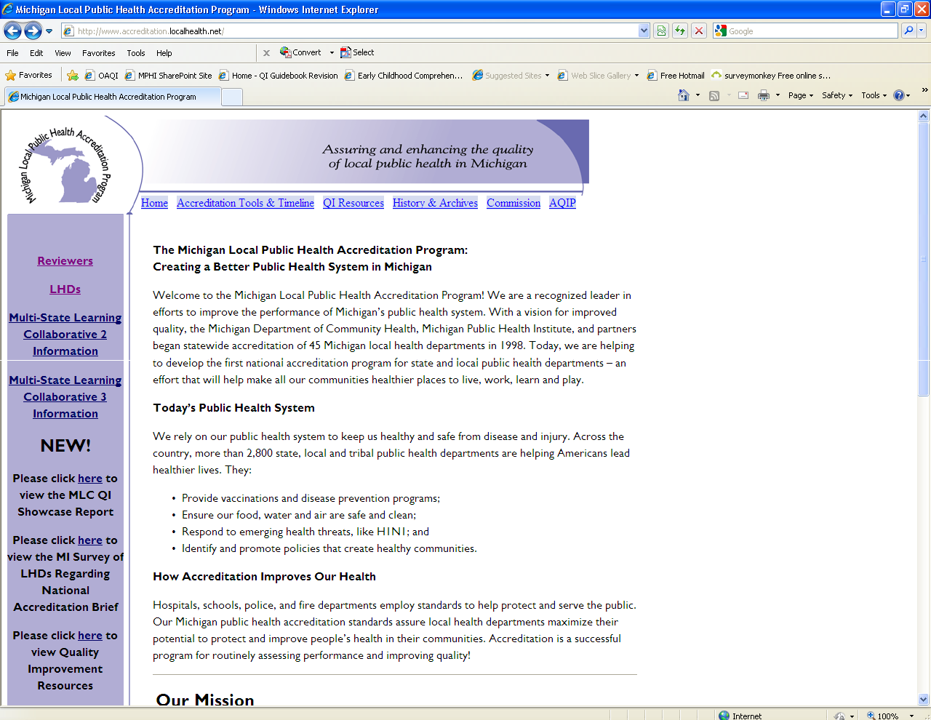

You may also access the Module by typing the following into the address bar:
https://webreport.accreditation.localhealth.net

You may want to create a bookmark for this website so that you can easily access it in the future. Follow your browser specific directions to add a bookmark.

Logging in to the Web-Module

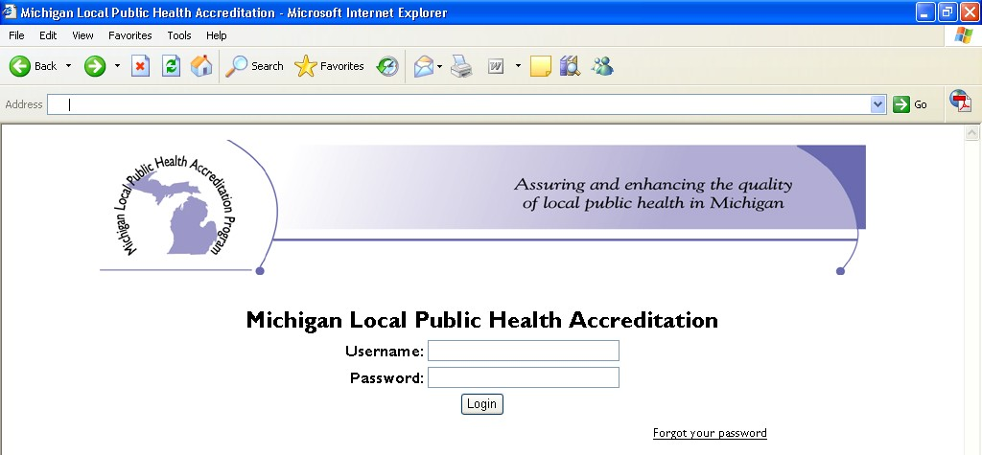The first page of the Web-Module is a system login page. Your username will be sent to you by MPHI staff, along with a link to set your password.

Should you forget your password, you can click the “forgot password” link on the sign-in page of the Web-Module to reset your password. If you have any issues logging into the Web-Module, please contact Hannah Scott at hscott@mphi.org or 517-324-6072.

Changing Your Password
You can only change your password after you have logged into the system. To change your password:
  - Click on the “Change Password” hyperlink located at the top of the Reviewer home page.
This will take you to the Change Password page.
  - Type your old password in the first box.
  - Type your new password in the second box.
  - Re-type your new password in the third box.
  - Click on the “Change Your Password!” button to submit your change.

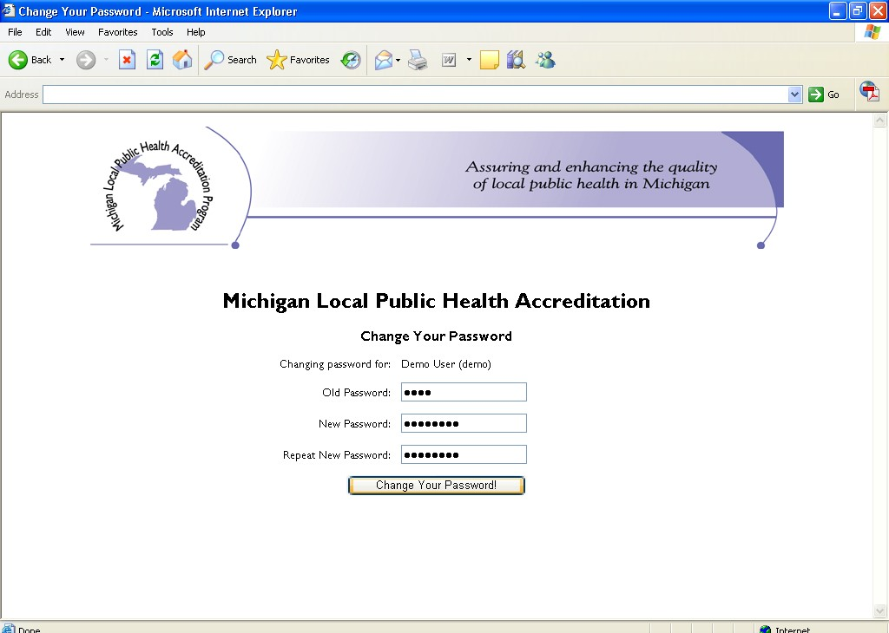

Reviewer Home Page

Upon login, you will be taken to your Reviewer home page. On the left side of the page, you will see a list of upcoming important dates and reminders as well as access links for pre-materials.

Pre-materials

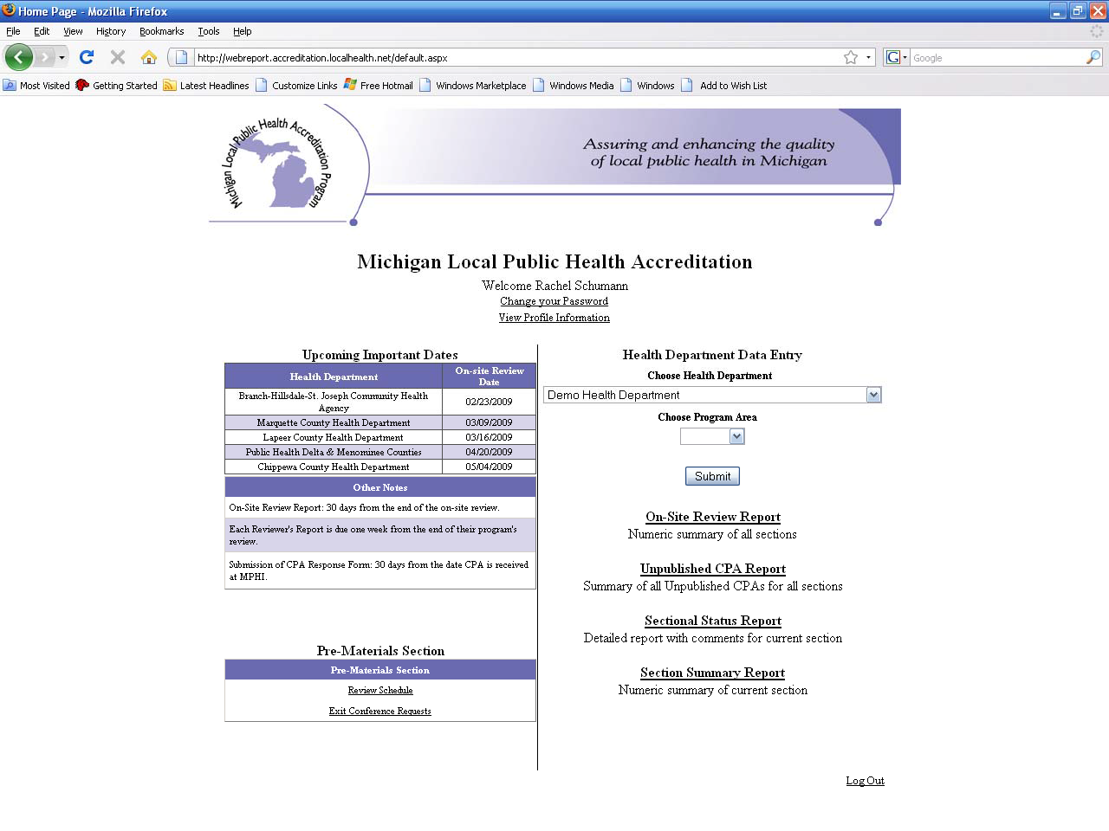

To access pre-materials, you will need to first choose a LHD.

Click on the “Review Schedule” link on the left side of the page to access the LHD’s review schedule. You will be taken to a page that looks like this:

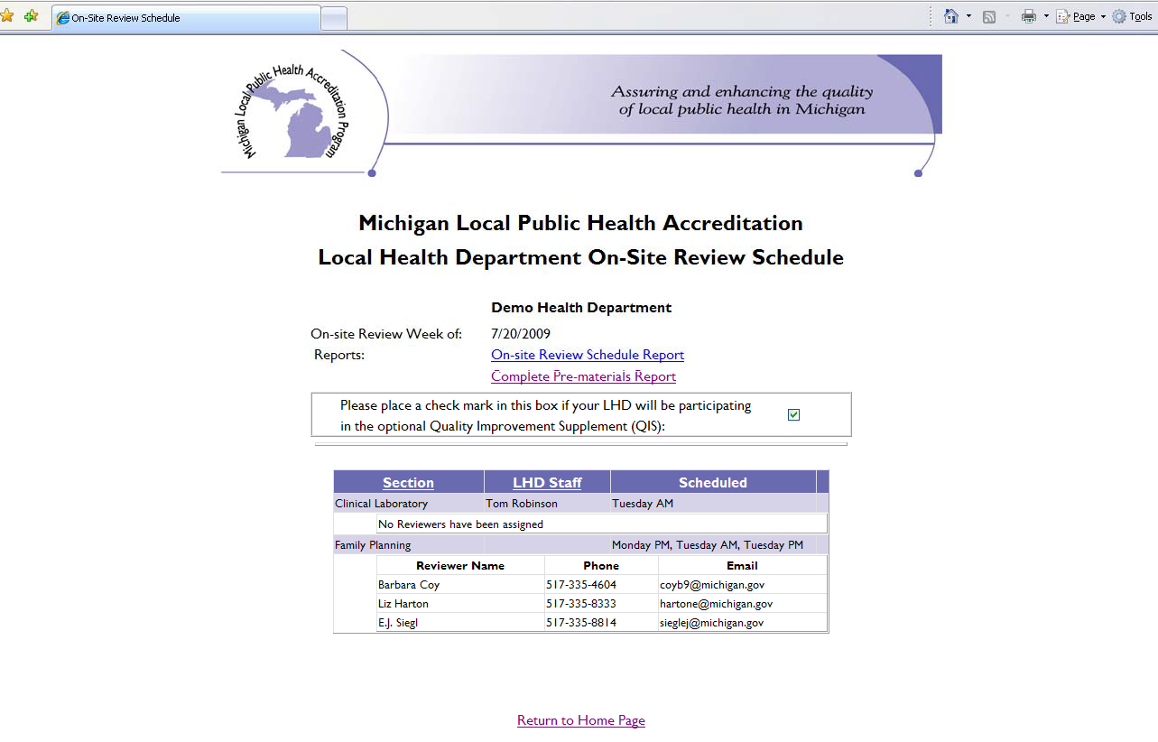

The purple and white table in the center of the page lists the timeslots for each program and the Reviewers scheduled.

If you click on Exit Conference Requests on the Reviewer home page, you will be taken to a screen that looks like this:

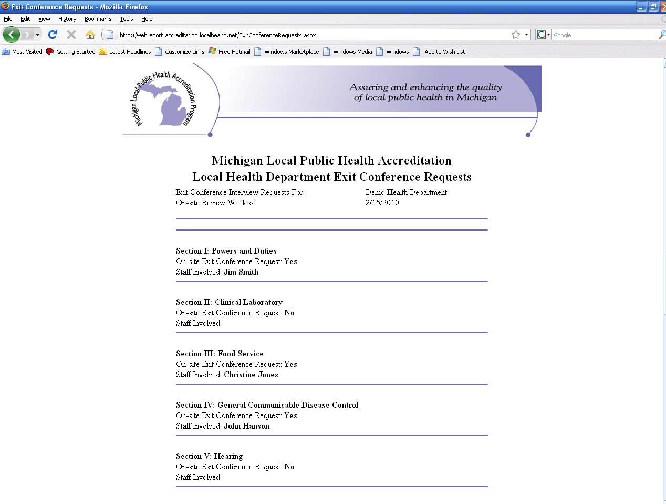

You may scroll down to see if the LHD wishes to have an Exit Conference with your program.

If you wish to view the selected LHD’s contact information, click on the link that says “View Profile Information” located under “Change your Password” at the top of the Reviewer home page. When clicking on this link, you will be taken to the LHD’s Contact Information page. On this page, you will find contact information for the Health Officer, Accreditation Coordinator, and Local Governing Entity.

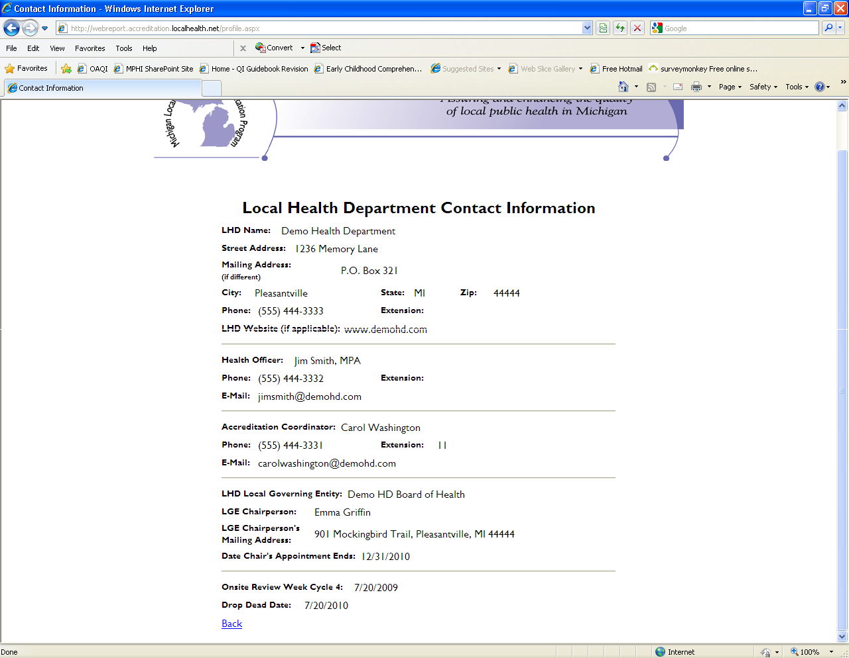

If you wish to access the LHD’s pre-materials all at once, including schedule, Exit Conference requests, and contact information, once you are in the review schedule screen, click on “Complete Pre-materials Report.” If you wish to access a PDF of the schedule only, click on “On-Site Review Schedule Report.”

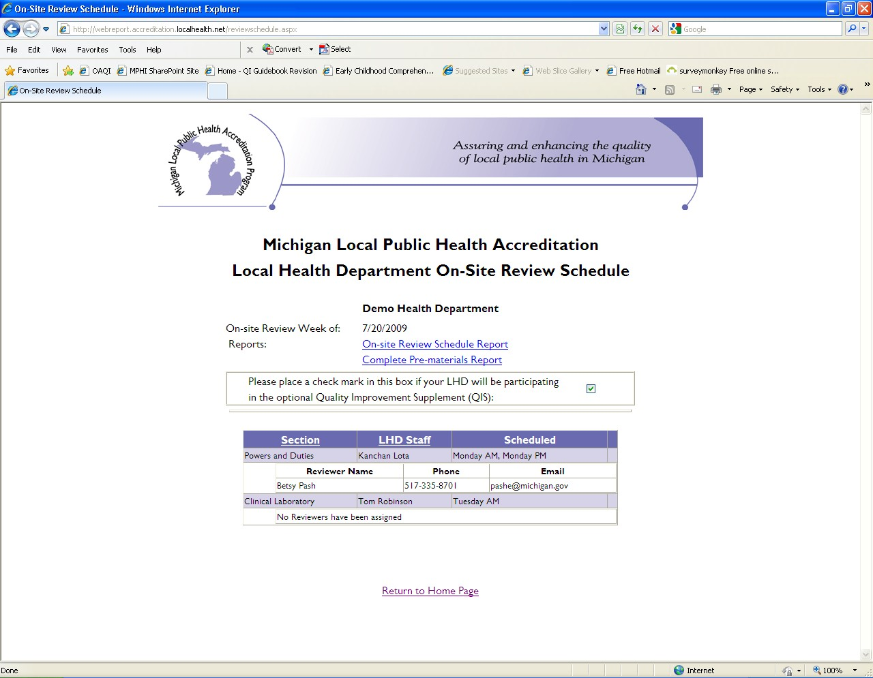Data Entry

Once you have chosen an LHD, the Program Area selection menu will default to your designated program area. If you review more than one program area, you may choose between your designated program areas. Click the “Submit” button to move into draft entry.

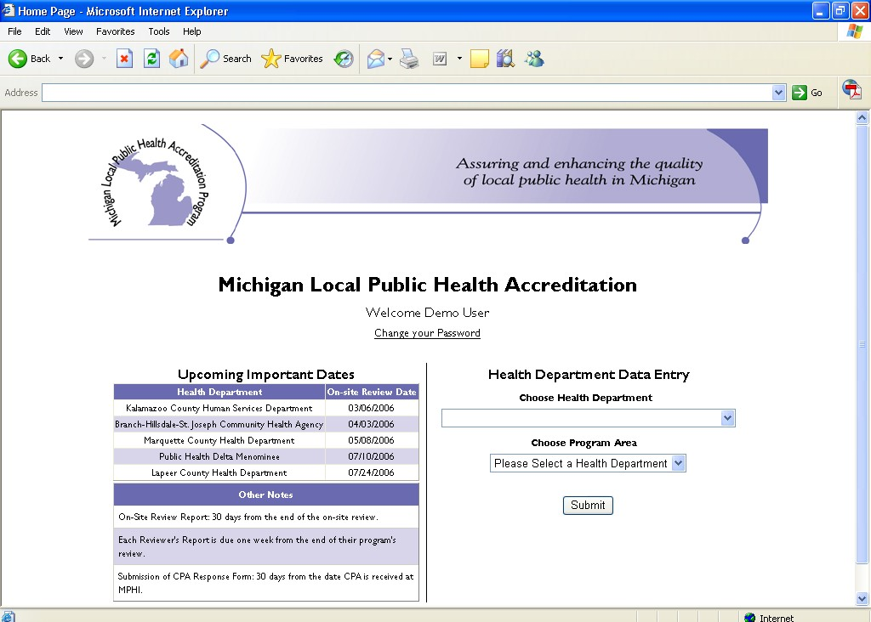

Important! We highly recommend that you avoid using the “Back” button located in the toolbar of your browser while you are in a data entry page. We realize that this is a common habit for all people and difficult to avoid. However, due to the nature of Web Programming, changes to your data cannot be saved if you use the “Back” button.

Exiting the Web-Module

Important! A “Log Out” hyperlink is located at the bottom of the main Reviewer home page. We ask that you use this hyperlink to exit the website before closing your Internet browser.

The reason for this again has to do with the nature of Web Programming. When you simply close your Internet browser, the website cannot detect this type of exit and thinks that you are still logged in. If you simply close the window after finishing work on an indicator, the website will still view you as logged in, working on that indicator, thus “locking” it so that nobody else can edit it while you work on it. Therefore, when you re-enter the site and try to select a locked indicator, you will need to contact MPHI to have the indicator released.

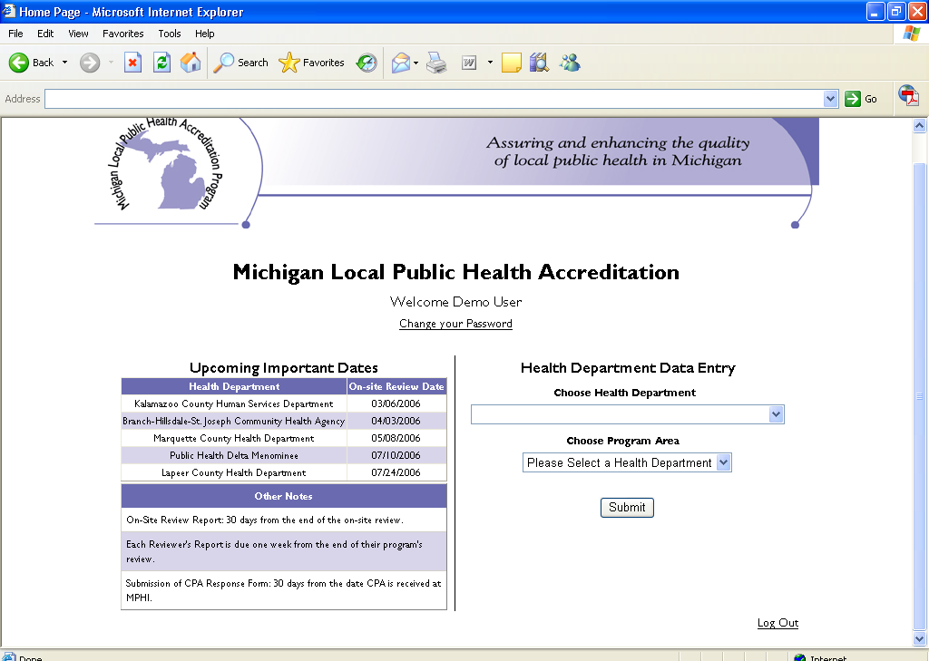

Entering Data

Draft Report Entry

Once you click the “Submit” button after choosing a LHD and Program Area, you will be taken to the MPR Screen.

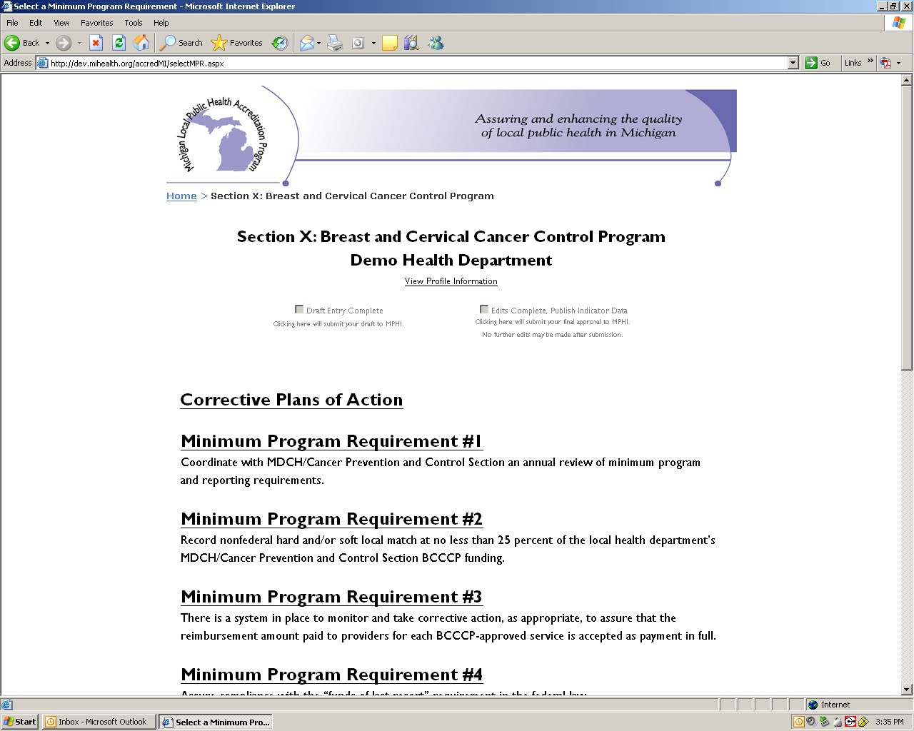

When you click on an MPR, you are then taken to a list of indicators within the MPR. Notice that on the navigation trail on the top of the page, there is an option for “Next requirement.” Clicking here will take you to the next MPR.

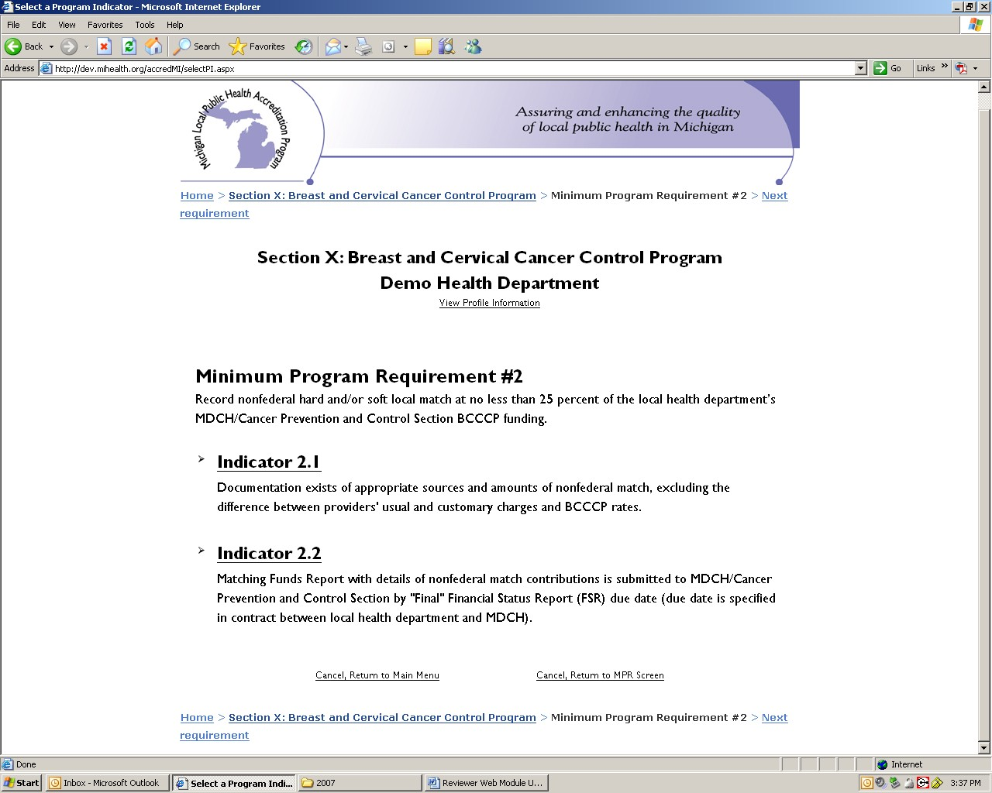Click on an indicator to do data entry. Under each indicator, you will be provided with a checklist of indicator requirements. These boxes do not need to be checked, but are there for your reference and may be filled in if you wish to do so.

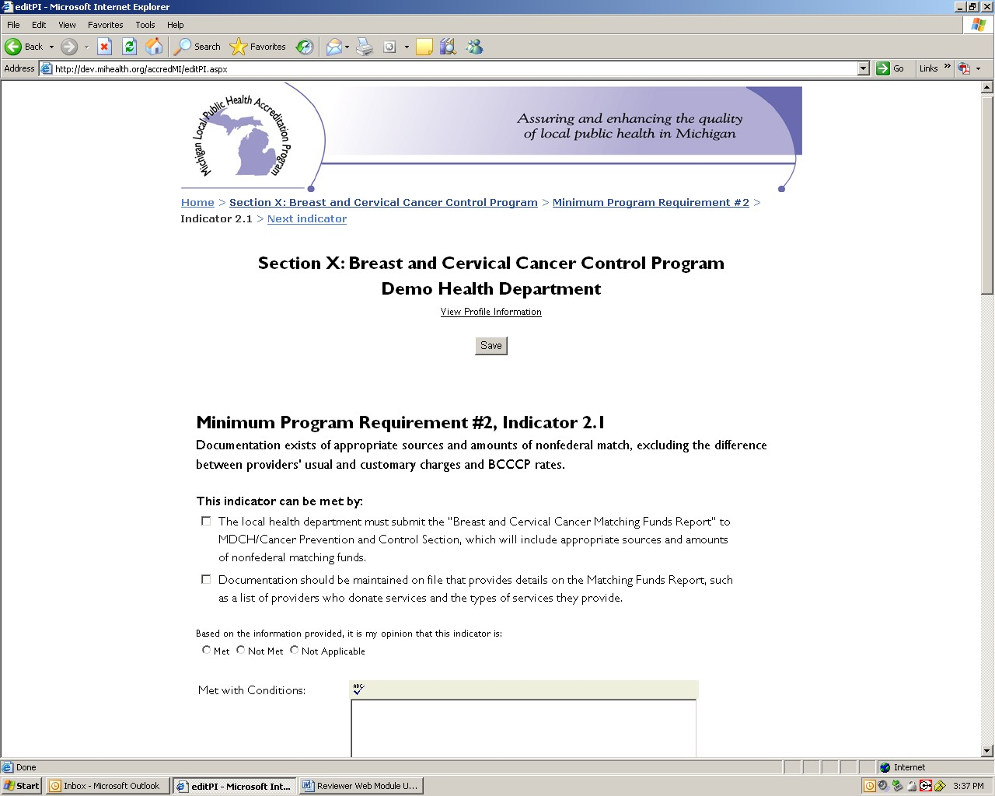You will choose between Met, Not Met, and Not Applicable for each indicator. You will have the ability to enter text in the following fields: Met with Conditions, Reason Not Met, Additional Information Provided, Special Recognition, Recommendations for Improvement, and Additional Comments. Please note that if you select Not Met for any indicator, you will not be allowed to navigate away from the page until you enter text in the Reason Not Met field. If you try to save without entering a Reason Not Met, you will receive an error message. Conversely, you may not enter text in the Reason Not Met field if you have chosen any other designation than Not Met.

We strongly recommend that you initially compose and save your report in a word processing program in order to protect yourself from any sort of web error that may cause data loss.

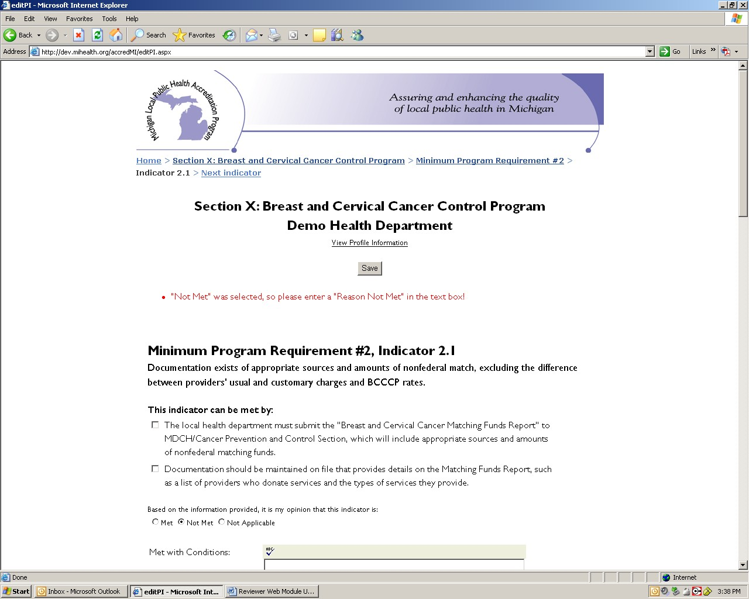

At the end of the navigation trail, you have the option to go directly to the next indicator. Please note: you will still need to click “Save” before going to the next indicator. Simply clicking on “Next indicator” will not save your data.

When you have completed all indicators within an MPR, click on the name of your section within the navigation trail to return to the list of MPRs.

Spell Check

Once you enter text into a field, you will have the ability to spell check that text. Click on the button on the top left hand corner of the field that has the letters ABC and a checkmark on it.

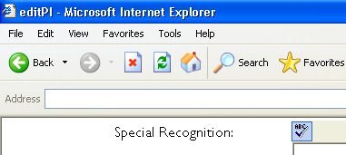

When the spell check tool comes across a word that is spelled incorrectly, you will be given a list of words from which to choose. If the word you are seeking is on that list, simply click on the word and then click “Replace.” If the word is not in the list, you may type it in the “Change To” field and click “Replace.”

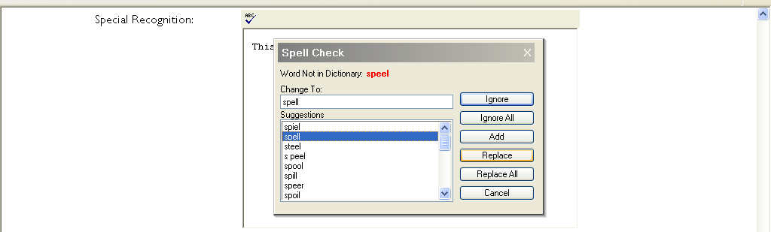

If spell check does not recognize a word you have used, like an abbreviation or terminology specific to your program area, click on “Ignore” to move past the word.

When spell check is finished, a box will come up with the text “Spell check complete.” Click on this to complete the spell check process.

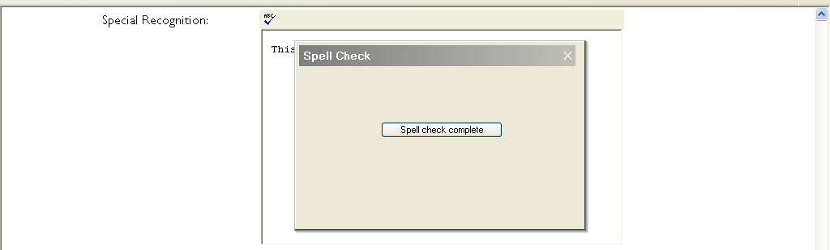

You are encouraged to either print out your draft or check it on the screen, because spell check will only search for words which are spelled incorrectly. It will not distinguish if the wrong word is used (e.g., to, too, and two.)

Accessing and Copying Data from a Previous Report

Data from Cycle 3 and 4 Accreditation reviews reside as PDFs in the Cycle 6 Module at https://accreditation.localhealth.net/accreditation-tools-timeline/reviewers/. Please visit the address to access your submitted reports and CPA responses from Cycles 3 and 4.

Data from Cycle 5 Accreditation reviews reside as PDFs in the Cycle 5 Module at https://accreditation.localhealth.net/accreditation-tools-timeline/reviewers/. Please visit the address to access your submitted reports and CPA responses from Cycle 5.

If you wish to copy text from a previously submitted report, you must open the report in a completely new instance of your web browser. Do not use the “File → New Window” or “File → New Tab” menu items, nor any other shortcuts to open a new window or tab. Instead, return to your desktop or Start menu and re-open another instance of your web browser.

Saving Data

After you have completed text entry, you can click on the “Bottom of Page” link located under each text box in order to move to the bottom of the page and back to the Indicator Screen, MPR Screen, or Main Menu. Additionally, there is a Save button at the top of the page.

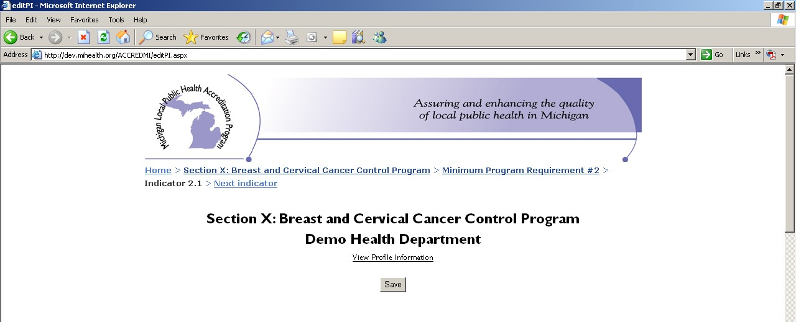

or

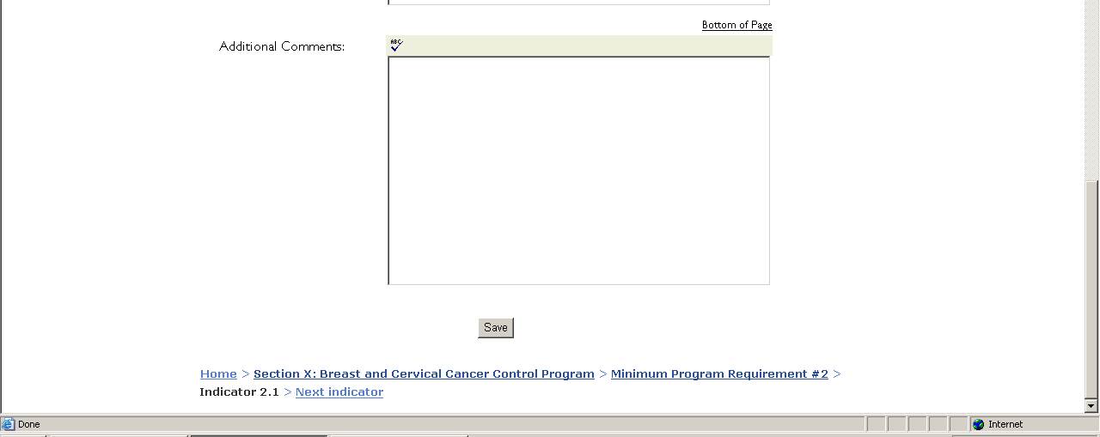
Important! You must click “Save” before navigating away from the Indicator Screen. You must use this button in order to save any changes to your data. A website does not perform like a database, which automatically saves data as you move from question to question.

No changes to a page will be saved if there is even a single error message returned after the “Save” button is used. The website cannot submit the correct answers while holding back the incorrect one. It is an all or none process. Therefore, if you receive an error message, you must address all of the issues in the message and click the “Save” button again to resave your data.

Navigating away from the Indicator Data Entry Screen

To go to the next indicator within an MPR, simply click on the “Next indicator” link within the navigation trail. If there are no indicators left within an MPR, you will not receive the “Next indicator” link as an option. Again, you must click “Save” before going to the next indicator. Simply clicking on “Next indicator” will not save your data.

Clicking on the MPR number on the navigation trail (in this screenshot, “Minimum Program Requirement #2”) will take you back to the list of indicators for that MPR. From there, you can choose a new indicator from the list or click on “Next requirement” to move to the next MPR.

Clicking on the name of your program (in this screenshot, “Section X: Breast and Cervical Cancer Control Navigation Program”) will take you back to the MPR Screen, where you have a couple of options.

- You can click on another MPR to view its indicators and/or complete data entry.
- 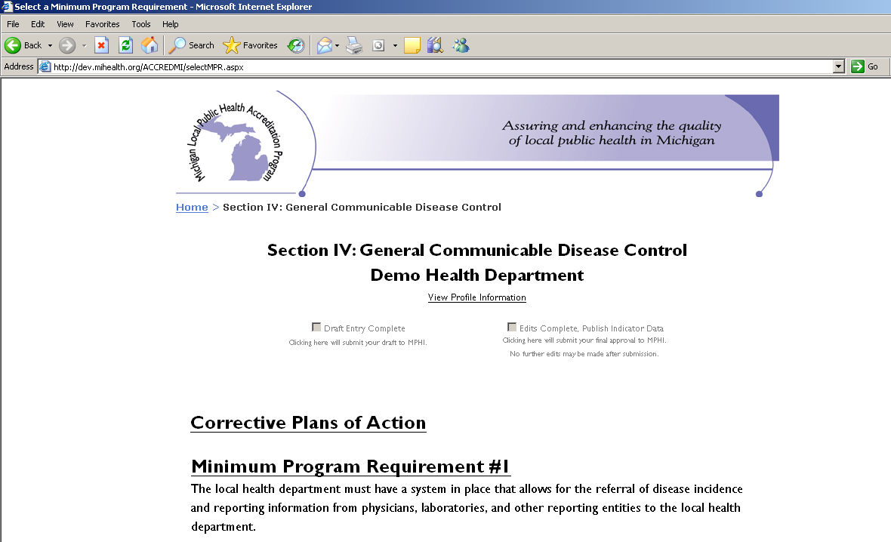If you have finished all data entry for the LHD, you may click on the “Data Entry Complete” checkbox at the top of the page. Doing so will send an e-mail to MPHI staff confirming that your draft entry is complete and ready for edits.

Please note that if all indicators for your section are not completed (a Met, Not Met, or Not Applicable designation has not been chosen), you will not have the ability to submit your draft to MPHI. The selection will remain gray and unavailable. To quickly reference which indicators have been completed, please access the Section Summary on the Reviewer home page.

Clicking on the “Home” link will return you to the Reviewer home page, where you can log out, view reports, or work on another LHD’s data entry.

Reports

Draft and Final Reports

Once you complete your data entry and click the “Draft Entry Complete” option, an e-mail will automatically be generated and sent to MPHI staff informing them that your draft is ready for editing. When MPHI staff finishes editing your report, you will be notified via email.

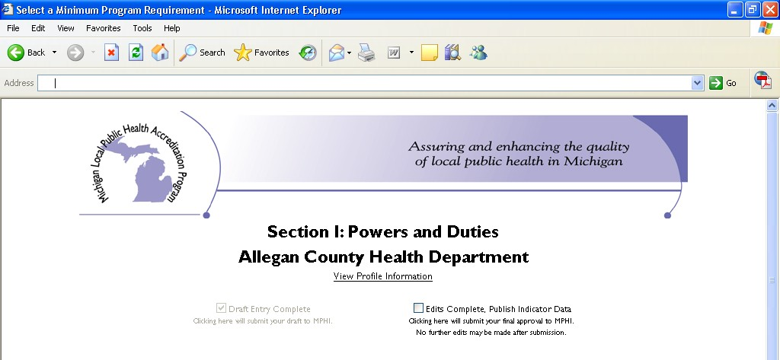As in the previous Cycles, following MPHI’s review of your report, you have three business days to confirm that your edited report is ready for publication. To make any final edits, log in to the system and choose the LHD and program area. Then click on “Sectional Status Report.” This will generate a PDF file which incorporates all changes made by MPHI staff. After reviewing this document for any changes, you may log in and make any necessary edits. Then click on “Edits Complete, Publish Indicator Data.” MPHI staff will be notified that you have approved your report for publication.

Important! After clicking the “Edits Complete, Publish Indicator Data” button, you may not make any changes to your report. MPHI staff members have administrative access, so if you need to make a change to your report after submitting the final version, please contact Hannah Scott at hscott@mphi.org or 517-324-6072.

Printing Reports

From the main menu, you may also print out a draft of your report. To do so, click on the “Sectional Status Report” link. This will generate a printable PDF of your report, which you may print out and proofread. You may generate and print a copy of your report at any time during data entry and after the draft and final reports have been submitted.

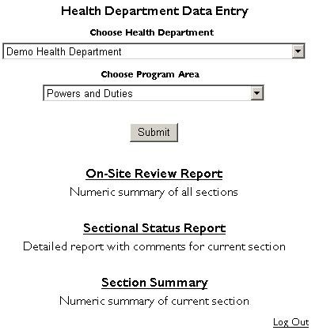

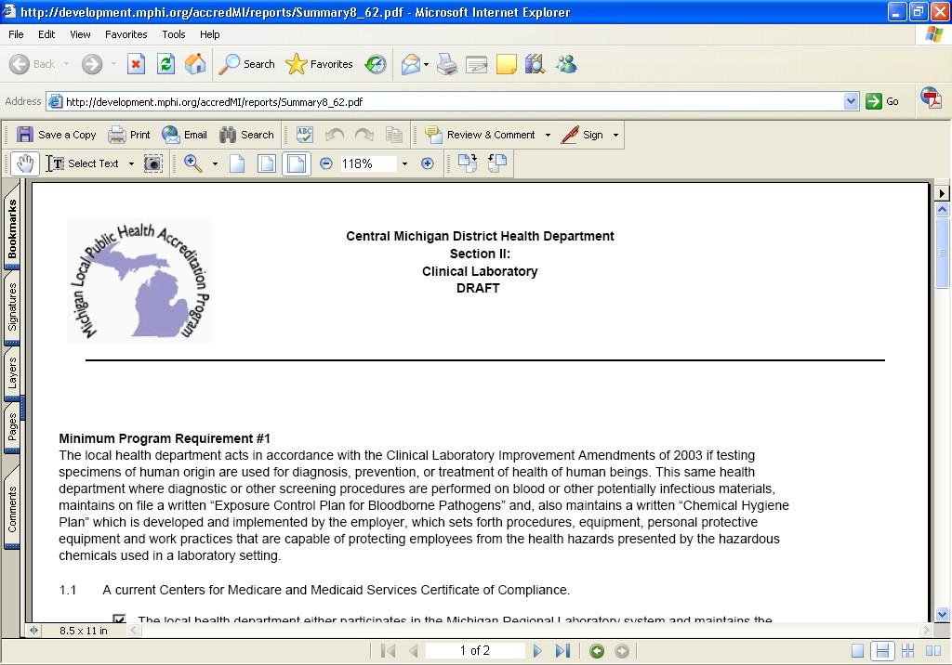

Clicking on the “On-Site Review Report” will generate a printable PDF containing a grid with totals for all Met, Not Met, and Not Applicable indicators which have been entered for all sections.

Clicking on the “Section Summary” will generate a printable PDF containing a grid with totals for all Met, Not Met, and Not Applicable indicators which have been entered for your section only.

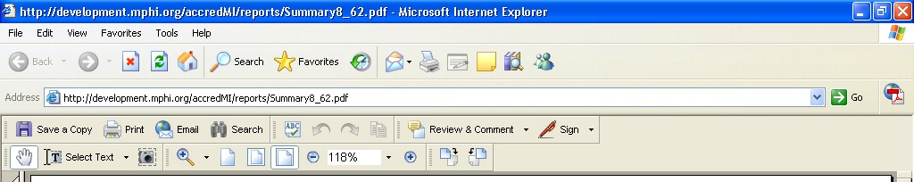To print a PDF file, click on the “Print” button on the upper left side of the screen. This will open a print dialog box where you can choose your printer and printer options. Your version of Acrobat Reader may vary.

Accessing the LHD’s CPAs

When an indicator is marked “Not Met,” a CPA State Agency response form is automatically generated when final edits are submitted. You will receive each LHD’s CPA forms on the Web- Module. In the event that programs request additional CPA information not available in an electronic format, LHDs are asked to send these materials directly to the program contact.

CPAs are due 60 days from the last day of the LHD’s review. MPHI staff will send an e-mail to State Agency Reviewers when all CPAs have been submitted to alert Reviewers that they may view and respond to the CPAs.

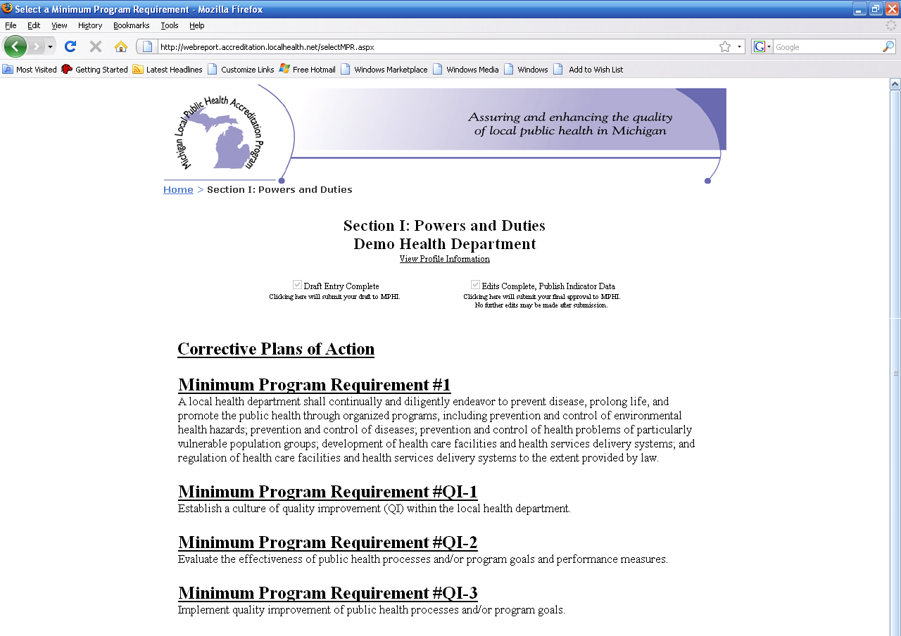To access the LHD’s CPAs, access the Web-Module as if you are completing data entry. On the top of the page, click the link that says “Corrective Plans of Action.”

You will be taken to the following table:

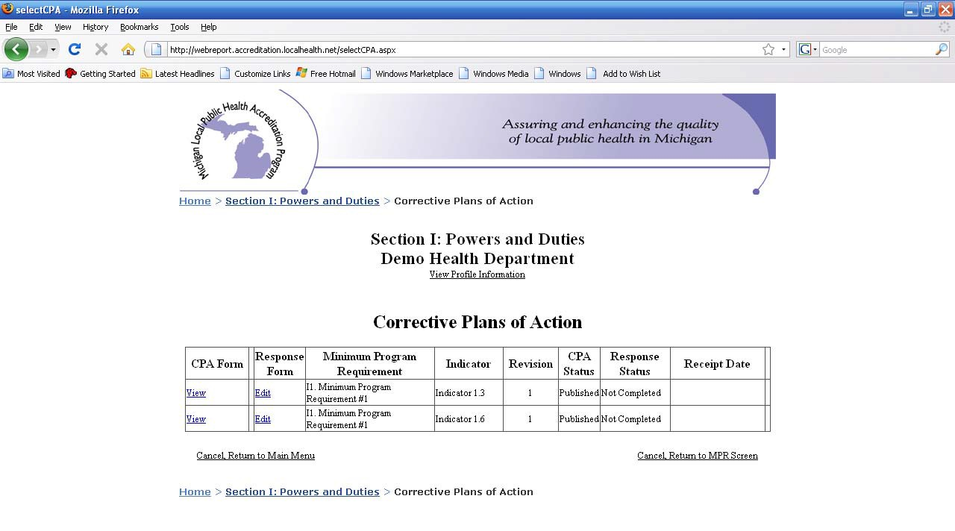

To view the LHD’s CPA, click on “View” under the first column (CPA Form) for the CPA you wish to view. This will generate a printable PDF of the LHD’s submitted CPA.

CPA State Agency Response

Click on the “edit” link under the Response Form column next to the indicator for which you are entering a response.

The initial response form is the same as in the previous Cycles. Your selections for responding are as follows:

- Yes, with no further action required - Use this response when the LHD has proven compliance simply by CPA submission. This completes the CPA Cycle for that indicator.

- Yes, with further action required - Use this response when you require either a site revisit or materials from the LHD. If you require materials, click in the “Materials Required By” field. A calendar will pop up, allowing you to choose the date by which you wish to receive the materials. If you require a site revisit, click in the “Site Revisit By” field. A calendar will pop up, allowing you to choose the date by which the site revisit must occur. There is also a text field

labeled “Please detail actions necessary for compliance.” In this field, enter any miscellaneous details that the LHD needs to know in order to prepare for compliance.

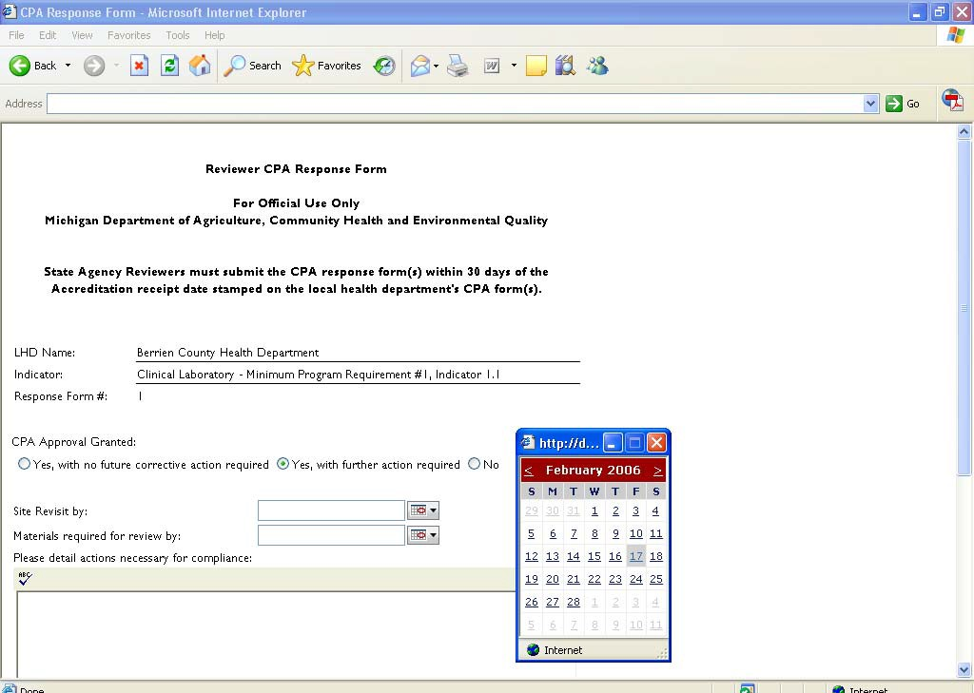

- No - This response is used when the CPA is not acceptable and must be re-submitted.

The official policy on CPA approval States that Reviewers have 30 days from the date that CPAs are received at MPHI to respond.

When you have entered all of the required data, scroll to the bottom of the page. Your name will be pre-filled in. If you need to add additional users (e.g., you are collaborating with another Reviewer on a CPA response), you may click in the “Reviewer Name” field and enter more text. The date field will default to the current date. Click on the checkbox next to “Publish”, then click “Save.” Please make sure you put a checkmark in the “Publish” box. Since LHDs will not know you have submitted a response until you do this, submission is not considered complete.

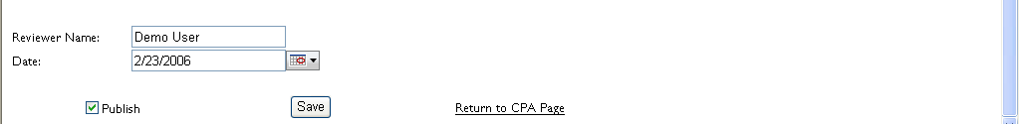

You will receive confirmation that your data has been saved. Click on “Return to CPA Page” on the bottom of the confirmation page to return to the main CPA menu.

Subsequent CPA Responses

If you choose “No” on the initial CPA response form, a new initial CPA response form is automatically generated and labeled sequentially. This is the form you will use for each subsequent response until the CPA is granted initial acceptance.

Please note: If your initial CPA response is “No” and the LHD must re-submit their CPA, the LHD should submit the revised plan directly to their program contact, not online, nor to MPHI.

If you choose “Yes, with further action required” on the initial CPA response form, a follow up form will generate. This is the form you will use for each subsequent response, either to indicate that the LHD has implemented the accepted plan successfully, or that the LHD has not implemented the plan successfully and will need to complete further action in order to meet the indicator.

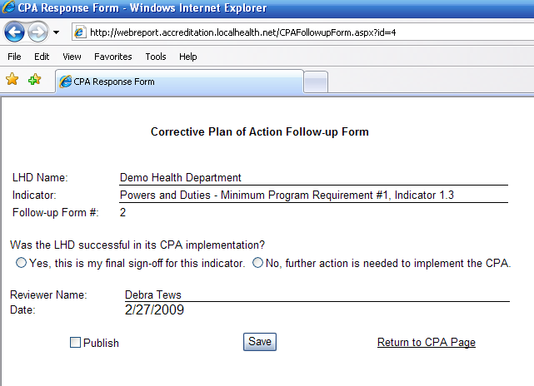

If the LHD has successfully implemented the plan and you are ready to give a final sign off on the indicator, please choose “Yes, this is my final sign-off for this indicator.”

If the LHD still must complete further actions in order to fully comply with the indicator, please choose “No, further action is needed to implement the CPA.” If you select this option, a new follow up form is automatically generated and labeled sequentially. This is the form you will use for each subsequent response.

For all CPA responses, click on the number of the edit you are currently making (e.g., if you have previously submitted a response of “No” and are reporting that the LHD’s re-submitted plan has been accepted, click on “Edit” next to the number 2.) A star will appear next to the most recently updated and published CPA response for your reference. You may click on “View” next to any of the CPA edits in order to view and print the CPA State Agency response.

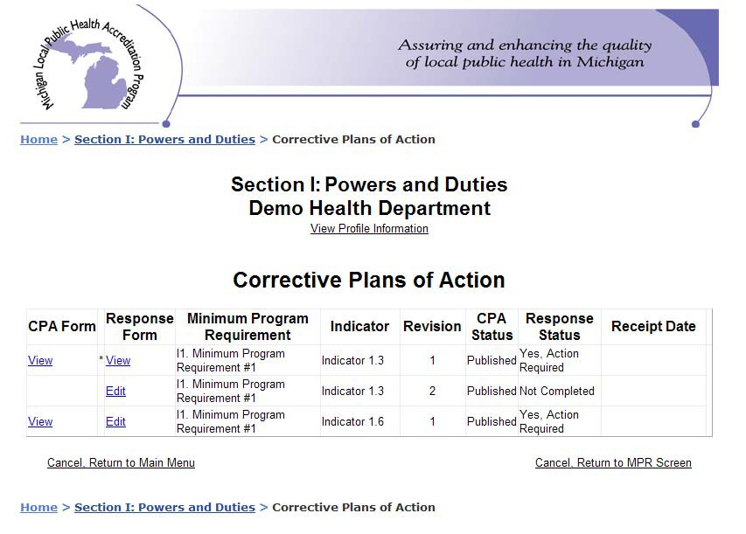

The CPA Status column will show the status of each LHD CPA form currently on the system. When the status is “Draft”, this means that the CPA is still in the editing stage and is not available for reviewers to view. When the status is “Published”, this means that the LHD has submitted a CPA form for that indicator.

The Response Status form lists the responses provided by State agency Reviewers. If the response next to the most recently updated CPA response is “Yes”, the LHD has successfully completed implementation for that indicator and has no further action to complete. If the response is “Yes, Action Required” or “No”, the LHD should work with their program contact to determine follow-up action as necessary.

Please note: ALL follow-up action after initial CPA response should be between the State agency program and the LHD. However, we ask that Reviewers update CPA responses as necessary to communicate either final sign off or that the LHD has further implementation action to complete.

180 and 90 Day CPA Process Emails

In order to further facilitate the CPA process between the three State agencies and the LHD, CPA reminder emails will be sent 180 and 90 days prior to the LHD’s CPA implementation date if the agency still has outstanding CPAs. E-mails will be sent by MPHI Accreditation staff with follow up response(s) required.

The following emails will be sent at the predefined CPA increments: 180 Day Email
To: Section Reviewer(s)
Cc: LHD Health Officer, LHD Accreditation Coordinator, Program Manager (at the State), and Local Health Services
Subject: Accreditation – Corrective Plan of Action Hello Reviewer(s) Name(s),
It has come to MPHI’s attention that Local Health Department Name has not completed the Corrective Plan of Action (CPA) process for the following CPAs:

Section: Family Planning Indicators: 7.1, 11.1, 14.1, 16.1

We ask that you follow up with Local Health Department Name regarding the above CPAs as soon as possible. At this point, the LHD has 180 days remaining to fully implement the CPAs prior to their 365 day CPA implementation date of list date here. If the LHD reaches their 365 day CPA implementation date and the above CPAs are not fully implemented, the LHD’s Accreditation status will be at risk.

If MPHI does not receive communication from you regarding the status of the above CPAs by insert date, the LHD’s Health Officer, LHD Accreditation Coordinator, and your supervisor will be contacted to facilitate timely resolution of this matter.

I look forward to hearing from you very soon. Should you have any questions, please don’t hesitate to contact me via email or by phone at (517) 324-8387.

Thank you, Jessie Jones

90 Day Email

To: LHD Health Officer & Accreditation Coordinator
Cc: Section Reviewer(s), Program Manager(s) (at the State), and Local Health Services
Subject: Accreditation - Critical Status

Hello LHD Health Officer and Accreditation Coordinator Names,

It has come to MPHI’s attention that Local Health Department Name has not completed the Corrective Plan of Action (CPA) process for the following CPAs:

Section: Family Planning Indicators: 7.1, 11.1, 14.1, 16.1
(All sections and indicators will be noted)

Local Health Department Name has 90 days remaining to fully implement the above CPAs, including any follow-up visits needed, prior to your 365 day CPA implementation date of list date here. If a re- evaluation date has been set, please let us know the date of the re-evaluation for our records.

Your LHD is 90 days away from receiving not accredited status.

If you still need to schedule a re-evaluation, we ask that you communicate with your applicable section reviewers at the State and reply to this email by list date here letting us know the status of the above CPAs.

Should you have any questions, please don’t hesitate to contact me via email or by phone at (517) 324- 8387.

Thank you, Jessie Jones

Appendix I

Scheduling Guidelines

- Schedule Section I (Powers and Duties) and the optional Quality Improvement Supplement (if applicable) on Monday. The optional Quality Improvement Supplement is reviewed remotely.

- Section III (General Communicable Disease Control) will be reviewed remotely. Guidance for the remote review begins on page 53 of this guide. Please to be sure to indicate a day and time for the reviewers to contact your health department to discuss their review of your materials. Your Reviewer will verify the day and time selected prior to conducting the exit interview.

- Section IV (Hearing), as a single half-day review. Please schedule separately from Section VIII (Vision), if possible.

- For Section V (Immunization), schedule one day for the review at the main local health department clinic (no visits to off-site clinics) on a day when the IAP coordinator and immunization clerk are available for interaction with the reviewer.

- For Section VI (Onsite Wastewater Treatment Management), schedule a minimum of two days for the review of a single county health department. District health departments typically require additional
days. Consultaion with the Reviewer is suggested for confirmation of the actual number of days that
are needed to complete the review.

6. Section VIII (Vision) is a single, half-day review. Please contact the Reviewer to arrange for scheduling of the site visit prior to completing the Review Schedule in the Cycle 6 Web Module.

- Section IX (BCCCNP) will be reviewed remotely. Please to be sure to indicate a day and time for the reviewers to contact your health department to discuss their review of your materials.

- Schedule a family planning clinic on the first day of the two-day Section X (Family Planning) review. Agencies should schedule a full clinic with a variety of visit types, especially initial and annual visits.

- Please avoid scheduling Section XII (CSHCS) on Monday and the fourth Thursday of the month.

SECTION | TIME REQUIRED
Section I – Powers and Duties and optional Quality Improvement Supplement (if applicable) | 1day
Section II – Food Service | 5 days
Section III - General Communicable Disease Control | ½ day Reviewed remotely
Section IV – Hearing | ½ day
Section V – Immunization | 1 day
Section VI – Onsite Wastewater Treatment Management | 2 days
Section VII – HIV/AIDs & STD | 1 day
Section VIII – Vision | ½ day
Section IX – Breast and Cervical Cancer Control Navigation Program (BCCCNP) | ½ day Reviewed remotely
Section X – Family Planning | 2 days
Section XI – Women, Infants, and Children (WIC) | N/A – no On-Site Review required
Section XII – Children’s Special Health Care Services (CSHCS) | 1 day

